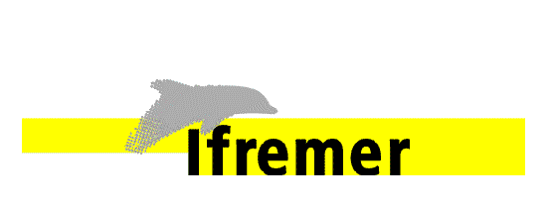**SMOS+STORM Evolution**

Technical, Administrative and Financial response to the European Space Agency **Statement of Work**  entitled **Support To Science Element (STSE) *SMOS+ STORM Evolution* project**

|  |  |
| --- | --- |
| Attention to: ESA |  |
|  |  |
|  |  |
|  |  |

|  |  |  |  |  |
| --- | --- | --- | --- | --- |
|  | Function | Name | Signature | Date |
| Prepared by | Consortium | IFREMER, Met Office, Ocean Datalab |  |  |
| Co-ordinated by | Project Manager | Nicolas REUL (IFREMER) |  |  |

Indexing form

|  |  |  |  |  |  |  |  |  |
| --- | --- | --- | --- | --- | --- | --- | --- | --- |
| **Customer** |  | | | **Contract N°** |  | | | |
| **Confidentiality codes** | | | | | **Document management** | | | |
| Company / Programme | | | Defence | |  | | | |
| Non-protected | | | Non-protected | | None | | | |
| Reserved | | | Limited diffusion | | Internal | | | |
| Confidential | | | Defence confidentiality | | Customer | | | |
| **Contractual document** | | | **Project N°** | | **Work Package** | | | |
| Yes  No | | |  | |  | | | |
|  | | | | | | | | |
|  | | | | | | | | |
| **Summary** | | | | | | | | |
|  | | | | | | | | |
| **Document** | | | | |  | | | |
| File name | | SMOS+STORM_Evolution.doc | | | Nbr of pages | | |  |
| Project | |  | | | Nbr of tables | | |  |
| Software | |  | | | Nbr of figures | | |  |
| Language | |  | | | Nbr of appendices | | |  |
| **Document reference** | | | | | | | | |
| Internal | | SMOS+STORM_Evolution.doc | | | Issue |  | Date | 21/01/2014 |
| External | |  | | | Revision |  | Date | 21/01/2014 |
| **Author(s)** | | | **Verified by** | | **Authorised by** | | | |
| Nicolas REUL | | |  | |  | | | |

Distribution list

|  |  |  |
| --- | --- | --- |
| **INTERNAL** | **EXTERNAL** | |
| **Name** | **Name** | **Company / Organisation** |
| Management by IFREMER  N. REUL  B. CHAPRON  Y. QUILFEN  F. PAUL  J-F. PIOLLE | F. COLLARD  P. FRANCIS  J. COTTON  V. KUDRYAVTSEV  E. ZABOLOTSKIKH  C. DONLON  B. GUEDEL  D.FERNANDEZ | OCEANDATALAB  MET OFFICE  MET OFFICE  SOLAB  SOLAB  ESA  ESA  ESA |
|  |  |  |
|  |  |  |

Document status

|  |  |  |  |
| --- | --- | --- | --- |
| Title | | | |
| Technical, Administrative and Financial proposal for the European space Agency | | | |
| **Issue** | **Revision** | **Date** | **Reason for the revision** |
|  |  | 21/01/2014 | Initial version |

|  |  |  |  |  |
| --- | --- | --- | --- | --- |
| **Modification status** | | | | |
| Issue | Rev | Status * | Modified pages | Reason for the modification |
|  |  |  |  |  |
|  |  |  |  |  |
|  |  |  |  |  |
|  |  |  |  |  |
|  |  |  |  |  |
|  |  |  |  |  |
|  |  |  |  |  |
|  |  |  |  |  |
|  |  |  |  |  |
|  |  |  |  |  |
|  |  |  |  |  |

*\* I = Inserted D = deleted M = Modified*

Table of contents

1. Introduction 8

2. Technical Proposal 10

2.1 Introduction 10

2.1.1 Purpose and scope of the technical proposal 10

2.1.2 Structure of the technical proposal 10

2.1.3 Acronyms and abbreviations 10

2.1.4 Symbols 14

2.1.5 Universal Resource Locators (URL) 14

2.2 An overview of the Proposed Study 15

2.2.1 Background 15

2.2.2 Understanding of the Study Requirements 18

2.2.2.1 Major Objective 1: Improve physical understanding, retrieval algorithm and product quality for SMOS High wind products 18

2.2.2.2 Major Objective 2: Generate & Validate SMOS High Wind Speed Product Databases 19

2.2.2.3 Major Objective 3: Applications in the domain of Ocean-Atmosphere Interactions 19

2.2.2.4 Major Objective 4: Applications in the domain of NWP 19

2.3 Detailed approach 20

2.4 WP1000: Improve physical understanding, retrieval algorithm and product quality for SMOS High Wind Speed products 20

2.4.1 : WP1100: L-band Signal Response over the Ocean in very high wind speed conditions 20

2.4.1.1 Foam Emissivity models 21

2.4.1.2 Foam Coverage and thickness, streaks coverage 21

2.4.1.3 Sea State dependencies 25

2.4.1.4 Rain and spray impacts at low microwave frequencies 26

2.4.1.5 SSS and SST impacts. 28

2.4.1.6 Output 28

2.4.2 WP1200 : SMOS GMF development & surface wind speed retrieval algorithm. 29

2.4.2.1 Expected Multi-parameter dependencies of the L-band wind-induced ocean surface brightness temperature residuals (ΔTB) 29

2.4.2.2 Empirical Refinement of the GMF 29

2.4.2.3 Definition of suitable Quality Indicator (QI) flags 37

A challenging task will be to derive estimates for potential errors in the SMOS products and a filtering algorithm to communicate to users the quality of data. Given our experience with the SMOS-HWS products, we anticipate 2 classes of errors depending on their source : 37

1) instrumental errors and 37

2) geophysical errors. 37

Beyond this two classes, instrumental errors are clearly expected to be the dominant sources of uncertainty for SMOS products in TC & ETC. Nevertheless, geophysical errors (such as rain impact, SST uncertainties) might become non negligible for ETC and weaker TC wind conditions. 37

2.4.2.4 Algorithm Theoretical Basis Description (ATBD) for SHWS 38

2.4.2.5 Outputs 39

2.4.3 WP1300: Foam property retrieval capability from SMOS data 39

2.4.5 WP1400: Merged Multi-mission Wind Speed product Algorithm 43

2.4.5.1) An algorithm for High Wind Speed retrieval under Rain from AMSR-2 data 43

2.4.5.2) Merged SMOS-AMSR2 HWS observations 49

2.5 WP2000: Generate & Validate SMOS High Wind Speed Product Databases 59

2.5.1 WP2100: Data Set collection and Preprocessing 59

2.5.2 WP2200: Building and publishing of a SMOS HWS/BLEND HWS Storm catalog 61

2.5.3 WP2300: SMOS-HWS & BLEND-HWS product validation 64

2.5.4 Output of WP2000 67

2.6 WP3000: Applications in the domain of Ocean-Atmosphere Interactions 67

2.6.1 WP3100 Statistical Analysis 68

2.6.2 WP3200 Impact on Sea Surface Drag parametrization 68

2.6.4 WP3300 Impact on Ocean Responses to storms 70

2.6.5 Output of WP3000 71

2.7 WP4000: Applications in the domain of NWP 71

2.7.1 WP4100 Statistical analysis 71

2.7.2 WP4200 Assimilation 72

2.7.3 WP4300 Tropical cyclone verification 72

2.7.4 Output of WP3000 & WP4000 73

2.8 Study Plan and Logic 74

2.12 References 75

2.13 Technical Proposal Checklist 82

3. Management section 83

3.1. Introduction 83

3.2. Project organisation 83

3.2.1. Objective of the project and knowledge required 83

3.2.2. Consortium organisation 84

3.2.3. Project team 86

3.2.4. Key People 87

3.3. Background and experience of the companies/laboratories 87

3.3.1. IFREMER 87

3.3.2. OceanDatalab Facilities and Resource 89

3.3.3. Metoffice Facilities and Resource 90

3.4. WPM: Project Requirements, Management, Promotion & Reporting 90

3.4.1. Management 90

3.4.2. Requirements 91

3.4.3. Communication and outreach 92

3.4.4. Reporting 93

3.5. WP5000: Project Final Workshop, Scientific Roadmap and Project Closeout 95

3.6. List of Inputs and Deliverables 97

3.6.1 Inputs 97

3.6.1 Documentation 97

3.6.2 Software 97

3.6.3 Data 97

3.6.2 Deliverables 97

3.7. Schedule 99

3.8. Meetings 101

4. Administrative and Contractual section 103

4.1. Introduction 103

4.2. Prime contractor 103

4.3. Correspondence 103

4.3.1. Correspondence toward the Prime Contractor 103

4.3.2. Correspondence toward the Agency 104

5. Financial section 105

5.1. Price 105

5.2. Price summary and geographic distribution 105

5.3. Milestone Payment plan and conditions 106

5.3.1. IFREMER 106

5.3.2. OCEANDATALAB 106

5.3.3 UK- METOFFICE 106

5.4. Travel and subsistence plan 106

6. Appendix A: Storm Tracking Tools 107

A.1 Storm tracking at CERSAT 107

A.2 Storm detection from scatterometer (StormWatch) 107

A.3 Storm tracking 110

A.4 Swell tracking 111

A.5 Cross-source storm database 112

A.6 Storm user interface 113

7. Appendix B: Work Package description 114

8. Appendix C: Companies presentations 130

8.1. IFREMER 130

8.2. UK-METOFFICE 131

8.3. Ocean Data Lab 131

9. Appendix D: Key people CV 133

9.1. Nicolas REUL 133

9.2. Bertrand CHAPRON 138

9.3. Yves QUILFEN 147

9.4. Jean-François Piollé 150

9.5. Peter Francis 150

9.6. DR Fabrice Collard 154

9.7. Dr Gille Guitton 154

9.8. James Cotton 154

10. Appendix E: PSS Forms 158

10.1. Travel and subsistence plan 158

10.2. PSS IFREMER 158

10.3. PSS OCEANDATALAB 158

10.4. PSS UK METOFFICE 158

# Introduction

This document is the response of the following consortium between:

•IFREMER,

•METOFFICE,

•OCEANDATALAB,

to the ESA Statement of Work (SoW) specifying work to be performed by a Contracted team (Contractor) for the Support To Science Element (STSE) SMOS+ STORM Evolution project.

. This document contains four chapters that describe sucessively:

* the technical content of the proposal (§.2),
* the management proposal (§.3),
* the administrative and contractual proposal (§.4),
* the financial proposal of the project (§.5).

# 2. Technical Proposal

## 2.1 Introduction

### 2.1.1 Purpose and scope of the technical proposal

The present project has one overall aim which is to ***Demonstrate the performance, utility and impact of SMOS L-band measurements at high wind speeds over the ocean during Tropical and Extra-Tropical storm conditions.***

The seven specific **objectives** to be addressed within the SMOS+ STORM Evolution project are:

1. Improve and consolidate our theoretical understanding of the L-band signal response and physical properties that can be inferred over the ocean during the passage of Tropical Cyclone (TC) and Extra-Tropical Cyclone (ETC) systems.
2. Consolidate, evolve, implement and validate the STSE SMOS+ STORM feasibility project Geophysical Model Function (GMF) and retrieval algorithm for high wind speed conditions.
3. Systematically produce and validate L-band SMOS high wind speed products with uncertainty estimates/flags for ETC and TC conditions over the entire SMOS Mission archive.
4. Develop, implement and validate new blended multi-mission oceanic wind speed products with uncertainty estimates incorporating SMOS+STORM Evolution L-Band measurements at high-wind speeds for TC and ETC events.
5. Generate a global database of TC and ETC events over the ocean surface and characterize each event using diverse Earth Observation and other observations in synergy.
6. Improve our understanding and parameterization ofocean-atmosphere coupling and mixed-layer dynamics for ETC and TC cases.
7. Demonstrate the utility, performance and impact of SMOS+ STORM Evolution products on TC and ETC prediction systems in the context of maritime applications.

### 2.1.2 Structure of the technical proposal

This section contains:

-an overview of the proposed study (§.2.2)

-the detailed proposed approach to perform this study (§.2.3, 2.4, 2.5, 2.6, 2.7 and .2.8)

-the presentation of the logic of the study (§.2.9)

-a statement of compliance with the SoW requirements (§.2.10)

### 2.1.3 Acronyms and abbreviations

|  |  |
| --- | --- |
| ADB | Actions Data Base |
| ADT | Advanced Dvorak Technique |
| AMSRE | Advanced Microwave Scanning Radiometer – E (of EoS Aqua) |
| AMSR2 | Advanced Microwave Scanning Radiometer 2 |
| AMSU | Advanced microwave sounding unit Radiometer onboard NOAA meteorological sat |
| AOML | Atlantic Oceanographic and Meteorological Laboratory |
| AQUARIUS | Salinity mission (of NASA/CONAE) |
| ASAR | Advanced Synthetic Aperture Radar (of ENVISAT) |
| ASCAT | Advanced SCATterometer (of MetOp) |
| ATBD | Algorithm Theoretical Basis Document |
| ATCF | NOAA Automated Tropical Cyclone Forecast system |
| AVHRR | Advanced Very High Resolution Radiometer |
| BLEND-HWS | Blended multi-mission oceanic wind speed products |
| CATDS | Centre d'Archivage et de Traitement des Données SMOS |
| CBLAST | Coupled Boundary Layer Air–Sea Transfer |
| CDR | Critical Design Review |
| CIMSS | Cooperative Institute for Meteorological Satellite Studies |
| CMIS | Conical Microwave Imager/Sounder |
| CONAE | COmision NAcional de Actividades Espaciales |
| DIR | Directory (of the *SMOS+ STORM Evolution project*) |
| DMSP | Defense Meteorological Satellite Program (of the USA) |
| DPM | DetailedProcessing Model |
| ECMWF | European Centre for Medium-Range Weather Forecast |
| ENVISAT | Environnent Satellite (http://envisat.esa.int) |
| ESA | European Space Agency |
| ESL | Expert Support Laboratory |
| EO | Earth Observation |
| EU | European Union |
| ETC | Extra-Tropical Cyclone |
| FR | Final Report |
| FROG | Foam, Rain, Oil and GPS-reflectometry |
| GFDL | Geophysical Fluid Dynamic Laboratory |
| GFS | Global Forecast System |
| GHRSST | GODAE High Resolution SST |
| GMF | Geophysical Model Function |
| GSFC | Goddard Space Flight Center |
| Hs | Significant Wave Height (also SWH) |
| HRD | Hurricane Research Division (of AOML) |
| H*WIND | NOAA National Hurricane Center Hurricane Wind Analysis products |
| IODD | Input/Output Data Definition |
| ITT | Invitation To Tender |
| IR | Infra Red |
| JMR | Jason Microwave Radiometer |
| JPL | Jet Propulsion Laboratory |
| JRA-25 | Japanese 25-Year *Reanalysis* Project |
| JTWC | Joint Typhoon Warning Center |
| KO | Kick-Off |
| L1 | Level-1 |
| L2 | Level-2 |
| L3 | Level-3 |
| MIRAS | Microwave Imaging Radiometer by Aperture Synthesis |
| MR | Monthly Report |
| MTR | Mid-Term Review |
| NAH | NOAA/NWS/NCEP North Atlantic Hurricane Wind Wave forecasting system |
| NASA | National Aeronautics and Space Administration |
| NCEP | National Centers for Environmental Prediction |
| NDBC | National Data Buoy Center |
| NHC | NOAA National Hurricane Center |
| NOAA | National Oceanic and Atmospheric Administration |
| NOGAPS | U. S. Navy's Operational Global Atmospheric Prediction System |
| NOP | Numerical Ocean Prediction |
| NRCS | Normalized Radar Cross-Section |
| NWP | Numerical Weather Prediction |
| NWS | National Weather Service |
| OSCAT | Oceansat-2 Scatterometer |
| OPS | Observation Processing System (of Met Office) |
| OS | Ocean Salinity |
| PALS | Passive/Active L-band Sensor |
| PM | Progress meeting |
| PMP | Project Management Plan |
| PMR | Passive Microwave Radiometry |
| PMSL | Pressure at Mean Sea Level |
| PSS | Practical Salinity Scale |
| QC | Quality Control |
| RA-2 | Radar Altimeter 2 (of ENVISAT) |
| RD | Reference Document |
| SAR | Synthetic Aperture RADAR |
| SAR | Scientific Assessment Report (of *SOS*) |
| SAP | Scientific Analysis Plan |
| SatCon | CIMSS Satellite Consensus (SatCon) product |
| SFMR | Step Frequency Microwave Radiometer |
| SIAR | Scientific and Impact Assessment Report |
| SLA | Sea Level Anomaly |
| SMOS | Soil Moisture and Ocean Salinity (mission) |
| SMOS-HWS | SMOS High Wind Speed products (surface wind speed and foam-related properties) |
| SoW | Statement of Work |
| SSM/I | Special Sensor Microwave Imager (of DMSP) |
| SSMIS | Special Sensor Microwave Imager Sounder |
| SST | Sea Surface Temperature |
| SSS | Sea Surface Salinity |
| STSE | Support to Science Element |
| TBC | To Be Confirmed |
| TC | Tropical Cyclone |
| TBD | To Be Determined |
| TDP | Technical Data Package |
| TDS | Test Data Set |
| TMI | TRMM Microwave Imager |
| TN | Technical Note (short report 10-50 pages) |
| TR | Technical Report (long report > 50 pages) |
| TRMM | Tropical Rainfall Measuring Mission |
| UM | User Manual |
| URL | Universal Resource Locator |
| WP | Work Package |

### 2.1.4 Symbols

TB : Sea Surface Brightness Temperature

σo : Sea Surface Normalized Radar Cross-Section

θi : Radiometer or Radar incidence angle

ΔTB: sea surface roughness-induced brightness temperature

H*Wind: surface wind analysis products (Powell et al., 1998) from the Hurricane Research Division (HRD) of the Atlantic Oceanographic and Meteorological Laboratory.

CD :Sea Surface Drag Coefficient

### 2.1.5 Universal Resource Locators (URL)

. The following URL links contain relevant information that will be refered to in the document:

1. ESA web site <http://www.esa.int/>
2. STSE SMOS+ STORM Project <http://smosstorm.ifremer.fr/>
3. STSE web site <http://www.esa.int/stse/>
4. ESA Category1 <http://eopi.esa.int/>
5. ESA LPP SMOS webpage <http://www.esa.int/esaLP/LPsmos.html>
6. Aquarius webpage <http://aquarius.nasa.gov/>
7. SMOS Barcelona Expert Centre <http://www.smos-bec.icm.csic.es/>
8. CATDS Expertise Center - OceanSalinity (CEC-OS)   
   http://www.salinityremotesensing.ifremer.fr
9. LOCEAN SMOS <http://www.locean-ipsl.upmc.fr/smos/>
10. ARGANS SMOS L2 Processor <http://www.argans.co.uk/projects.html>
11. SMOS Ice Project <https://wiki.zmaw.de/ifm/SMOSIce>
12. SPURS experiment <http://ourocean.jpl.nasa.gov/SPURS/tindex.jsp>
13. SMOS at ECMWF <http://www.ecmwf.int/research/ESA_projects/SMOS/>
14. SMOS L3 and L4 products <http://www.cp34-smos.icm.csic.es/smos_mission/smos_mission.htm>
15. ESA EarthnetSMOS <https://earth.esa.int/web/guest/missions/esa-operational-eo-missions/smos>
16. SMOS Mode (EU COST action) <http://www.smos-mode.eu/action.html>

[URL-17] AOML/NOAA/HRD H*Wind Project <http://www.aoml.noaa.gov/hrd/data_sub/wind.html>

## 2.2 An overview of the Proposed Study

### 2.2.1 Background

The measurement and prediction of oceanic surface wind speeds in Tropical and Extra Tropical storms is of primary importance, but getting direct measurements over the ocean is very difficult. The preferred way of remotely measuring the surface wind speed from space at lower-than-hurricane wind speeds is based on C, Ku and Ka-bands scatterometry (previously using radars onboard the ERS, ADEOS and QuickScat satellites and now with METOP/ASCAT and Oceansat-2/OSCAT sensors) and C to E bands radiometry (previously with radiometers onboard the Defense Meteorological Satellite Program (DMSP) SSM/I satellite series, AMSR, AMSR-E, and now still with SSM/I, but also with WindSAT and AMSR2 sensors). Nevertheless, satellite estimates do not necessarily provide direct measurements of geophysical parameters and can suffer from strong limitations in stormy conditions linked to the sensor characteristics. With active remote methods of wind measurement saturating in hurricane force winds and being heavily affected in presence of high rain rates, microwave radiometry has played an increasing role in recent years.

Considering microwave radiometer sensing of extreme weather events over the oceans, it has long been known and extensively being studied that whitecaps, streaks and associated foam structures at the ocean surface will markedly enhance the microwave emissivity of the portion of the sea surface they cover, making that portion of the sea surface approximate a microwave blackbody with an emissivity of close to unity. The increase in sea surface emissivity that occurs even though a very small portion of the sea surface within the footprint of a microwave radiometer is covered by whitecaps, is associated with an increase in the microwave brightness temperature as recorded by the radiometer.

For boundary layer wind speeds in excess of 33 m.s-1 or about 64 knots, which is force 11 to force 12 on the Beaufort Scale (Allen, 1983), sea surface conditions are described as follows: Force 11: “Violent storm. The sea is completely covered with long white patches of foam lying along the direction of the wind. Everywhere the edges of the wave crests are blown into froth. Visibility affected.”; Force 12: “Hurricane. The air is filled with foam and spray. Sea completely white with driving spray – visibility very seriously affected.” As the wind speed increases above hurricane force, the entire surface takes on a whitish cast: 50-55% of the surface is white. For wind speeds > 45 m.s-1, the whitish cast covers 100 % of the surface and visually obscures almost all of the surface features (Black et al, 1986). These changes in foam coverage and physical properties at the sea surface as the wind speed reaches gale force are associated with a strong enhancement of the microwave brightness temperature emitted by the ocean surface. This information can be used as a means of remotely measuring surface wind speeds in hurricanes from airborne, or spaceborne, microwave radiometers. The Step Frequency Microwave Radiometer (SFMR) operating at C-band (4-8 GHz), which is NOAA's primary airborne sensor for measuring tropical cyclone surface wind speeds (Uhlhorn et al., 2003; 2007), is based on this principle.

Until very recently, orbiting microwave radiometers (e.g., SSM/I, SSMIS, TMI, TRMM, AMSR, AMSU, CMIS, AMSR-E, and WindSAT) all operated at frequencies higher or equal to C-band. These passive satellite instruments are used to infer cloud liquid water, water vapor, wind speed, rain rate, and, sea surface temperature (SST). At these microwave frequencies, atmospheric absorption, emission and scattering associated with high cloud liquid water content and precipitation prevalent in cylones can have a large impact on brightness temperatures.

Consequently, it is difficult to infer directly ocean surface wind and whitecap properties at the surface beneath TC and ETC at these frequencies. The measurement of ocean surface wind speeds under rain has been a long standing problem for passive satellite microwave radiometers. Algorithms have been developed that are able to measure ocean surface wind speeds with an accuracy of at least 1 m.s-1, as long as the scenes are free of rain (Bettenhausen et al, 2006). Unfortunately, these algorithms break down completely as soon as even only light rain is present. Simulation of the microwave brightness temperatures over the oceans [*Chandrasekhar*, 1960] shows that the brightness temperature increases towards a maximum and then drops off as rainfall rates increase even further. The principle differences between the microwave frequencies are the range of rainfall rates for increase (emission/absorption region) and the range for decrease (scattering region). Lower frequencies including C- and X-bands tend to increase through much of the rainfall range, thus, making them suitable for emission type schemes. Higher frequencies saturate quickly and decrease for much of the rainfall range [*Kummerow and Ferraro*, 2007]. In hurricanes, however, rain intensity is so high that the rain radiation can obscure the ocean surface and saturate the brightness temperature over the ocean even for C- and X-bands, though in no cases rain drops or ice particles in clouds scatter the radiation since the particle size remains much lower than the wave length [*Ulaby et al.*, 1981]. In addition to being a source for the surface foam, oceanic whitecaps mark areas with actively producing sea spray droplets via bubble bursting (film and jet droplets), and via the wind tearing off wave crests (spume droplets). Sea spray yields additional radio-brightness (Raizer, 2007) beyond that generated by ocean surface itself. Macroscopic radiative transfer model simulations reveal that when sea spray droplets are located over any foam surface, negative radio-brightness contrasts can appear for radiometer observations at electromagnetic wavelength within the range of = 0.3 (~100GHz) - 8 cm (~4 GHz), with an intensity depending on the incidence angle and polarization. In gale force wind conditions, a thick layer of spray is filling the air above a 'boiling' wavy air-sea interface. The so-called “cooling effect” induced by the spray-layer itself on the ocean emitted microwave energy is a result of the scattering of microwave radiation on sea spray droplets and can lead to error when trying to estimate surface winds within TC from radiometer operated within the highest microwave frequency bands.

For accurate C to E band radiometer retrievals of wind speeds in rain and storms (Yueh et al., 2008; Meissner and Wentz**,** 2009; El-Nimri et al., 2010, Zabolotskikh et al. 2013), it is essential to use brightness temperature signals at different frequencies, whose spectral signature make it possible to find channel combinations that are sufficiently sensitive to wind speed, and only weakly sensitive to rain. Such a technique has been employed successfully for many years for wind speed retrieval with the SFMR, which operates at six closely spaced C-band frequencies from ~4 to 7 GHz. This becomes a much more difficult task when considering orbiting radiometers such as SSM/I, AMSR-E, or WindSat, which probe the earth at several frequencies but in clearly separate bands (e.g., C-band, X-band, Ka-band, .. ), with each channel having very distinct geophysical dependencies (e.g., C-band channel being significantly less sensitive to atmosphere, roughness and rain than X- or Ka-bands, but more sensitive to SST, etc..).

A new methodology, based on model simulations and neural networks inversion, has been recently proposed by Zabolotskikh et al. (2013) to jointly retrieve sea surface wind speed, sea surface temperature, atmospheric water vapor content, cloud liquid water content, and total atmospheric absorption at 10.65 GHz using Advanced Microwave Scanning Radiometer 2 (AMSR2) measurements. In particular, estimation of the total atmospheric absorption at 10.65 GHz, which can be done with high accuracy due to the not so strong influence of liquid water and especially water vapor, helps to refine a new filter to considerably reduce masking ocean areas for severe weather systems, characterized by high wind speeds and moderate atmospheric absorption, appropriate for studying winter extratropical cyclone and polar low systems. A polar low case study has demonstrated significant improvement in the coverage of the ocean area available for geophysical retrievals: only less than 1% of high wind speed pixels were masked comparatively to the 40–70% masking given by other methods. In addition, beyond an ensemble of channels, AMSR2 operate at two closeby C-band frequencies of 6.925 and 7.3 GHz. The combination of these two channels might be very interesting in the context of rain effects removal for surface wind speed retrieval in stormy situations.

While clear progress has been made in the understanding of the ocean scene radio-brightness contrasts dependencies on sea surface foam, rain and spray droplets properties and distributions, the co-existence of these three phenomena at and above the sea surface in extreme wind conditions makes it a difficult task to individually retrieve either surface winds, rain rates, or whitecap properties from spaceborne radiometer microwave observations acquired over TC and ETC.

SMOS (Soil Moisture and Ocean Salinity) is the European Space Agency’s water mission (Kerr *et al.* 2010, Mecklenburg *et al.* 2009), an Earth Explorer Opportunity Mission belonging to its Living Planet Program and was launched in November 2009. The technical approach developed to achieve adequate radiometric accuracy, as well as spatial and temporal resolution compromising between land and ocean science requirements, is polarimetric interferometric radiometry (Ruf *et al.* 1988, Font *et al.* 2010). The SMOS synthetic antenna consists of 69 radiometer elements operating at L-band (frequency ~1.4 GHz) and distributed along three equally spaced arms, resulting in a planar Y-shaped structure. As compared to real aperture radiometers, in which brightness temperature (TB) maps are obtained by a mechanical scan of a large antenna, in aperture synthesis radiometers, a TB image is formed through Fourier synthesis from the cross correlations between simultaneous signals obtained from pairs of antenna elements. Multi-angular images of the brightness temperature of the earth at such low microwave frequency are now obtained over a large swath width (~1200 kms), with a spatial resolution varying within the swath from ~30 km to about 80 km, and with a revisit time of less than 3 days.

Because upwelling radiation at 1.4 GHz is significantly less affected by rain and atmospheric effects than at higher microwave frequencies, the new SMOS measurements offer unique opportunities to complement existing ocean satellite high wind observations that are often contaminated by heavy rain and clouds. This new capability was first demonstrated in the frame of the ESA [URL-3] STSE [URL-2] SMOS+ STORM Feasibility project [URL-1] begining January 2012 and concluded in September 2013. In Reul et al., 2012, we presented SMOS data over hurricane Igor, a tropical storm that developed to a Saffir–Simpson category 4 hurricane from 11-19 September 2010. Thanks to its large spatial swath and frequent revisit time, SMOS observations intercepted the hurricane 9 times during this period. Without correcting for rain effects, L-band wind-induced ocean surface brightness temperature residuals (ΔTB) were co-located and compared to aircraft and satellite objectively analysed surface wind products (the so called NOOA/HRD H*Wind analysis [URL-17]). It was found that the L-band ocean emissivity dependence with wind speed appears less sensitive to roughness and foam changes than at the higher C-band microwave frequencies. The first Stokes parameter on a ~50 km spatial scale nevertheless increases quasi-linearly with increasing surface wind speed at a rate of 0.3 K/ m.s-1 and 0.7 K/ m.s-1 below and above the hurricane-force wind speed threshold (~32 m.s-1), respectively. These empirically-determined quasi-linear dependencies between the L-band wind-induced ocean surface brightness temperatures (TB) and the surface wind speeds were used to derive a Geophysical Model Function (GMF). The GMF was further used in a wind-speed retrieval algorithm from SMOS brightness temperature data acquired in several storms. In general, the surface wind speed estimated from SMOS brightness temperature images agree well with the observed and modeled surface wind speed features. In particular, the evolution of the maximum surface wind speed and the radii of 34, 50 and 64 knots surface wind speeds are consistent with hurricane model solutions and H*Wind analyses. During the SMOS+ STORM Feasibility project, the wind speed retrieval algorithm developed based on Igor observations was applied to few other storm cases (e.g. Hurricane Sandy in 2012) and validated against NOAA/NDBC buoy data and SFMR flight data.

### 2.2.2 Understanding of the Study Requirements

Given the 9 specific requirements listed in the SoW and to be addressed in the frame of the SMOS+STROM evolution project, we subdivided the study into 4 main objectives as follows

#### 2.2.2.1 Major Objective 1: Improve physical understanding, retrieval algorithm and product quality for SMOS High wind products

The overall objective #1 will be twofolds:

1) to improve the quality of the SMOS high-wind products by refining the first retrieval algorithm version (developed during the feasability study) based on the L-band/high wind speed GMF function.

2) to define merged surface wind products in storms between SMOS data and other already available, or future, satellite observations.

These two objectives include Task 2 and Task 3 as described in the SoW.

The tasks to reach the first objective will include an in depth analysis (through both theoretical and empirical approaches) of the contributions of foam formations (whitecaps, streaks), sea state, rain, spray, SSS and SST on the L-band residual emissivity as function of the sensor probing characteristics (incidence angle, polarization, instrumental noise,..etc). Uncertainities in the geophysical and instrumental corrections included in the algorithm will be analyzed in more depth than during the feasability study. Their impact on the quality of the retrieved surface wind speed shall be assessed and used to defined some quality metrics to be delivered within the SMOS High wind products. In addition, the feasability to potentially retrieve other geophysical products in storms than the surface wind speed such as properties describing the surface foam formations (whitecap & streaks coverage, foam forrmation thicknesses) will be analyzed. The output of these first tasks shall be in the form of several ATBDs definining the products, quality control parameters and associated retrieval algorithms for high wind speed conditions and including the new refined Geophysical Model Function (GMF).

In addition, a second algorithm will be defined and described in another ATBD to produce merged multi-mission oceanic wind speed products based on synergy between SMOS data and other satellite sensors including radiometer data (AMSR2,WindSat, SMAP) and scatterometer ones (ASCAT & Oscat).

#### 2.2.2.2 Major Objective 2: Generate & Validate SMOS High Wind Speed Product Databases

Using the previously derived algorithms, the entire SMOS Mission archive will be processed to systematically produce and validate L-band SMOS high wind speed products globally with uncertainty estimates and flags. This will include High wind speed retrievals from SMOS data alone herefater refered to as the SMOS-HWS products (including surface wind speed and foam related-products) and blended winds (BLEND-HWS) under both ETCs and TCs. The tasks that will be perform to reach this objective will include Task 4 and 5 as described in the SoW.

#### 2.2.2.3 Major Objective 3: Applications in the domain of Ocean-Atmosphere Interactions

From the historical SMOS archive database of storm products (SMOS-HWS and BLEND-HWS), additional geophysical parameters that are key for ocean-atmosphere coupling, such as surface wind stress estimates, radii and areas of wind in excess of 34, 50 and 64 knots, will be derived. Statistical analyses (geographical and seasonal distributions, extreme event distributions,..) for the latter products but also for the SMOS retrieved whitecap and foam properties will then be conducted. The contributions of these new L-band-based products for better estimations of the sea surface drag, air-sea gas-transfer coefficients, swell generation and tracking as well as upper ocean mixed-layer dynamics for ETC and TC cases will be assessed. This objective is a subpart of Task 6 as stated in the SoW.

#### 2.2.2.4 Major Objective 4: Applications in the domain of NWP

Given the historical SMOS archive of storm products (SMOS-HWS and BLEND-HWS), we shall finally demonstrate the utility, performance and impact of SMOS+ STORM Evolution products on TC and ETC prediction systems in the context of maritime applications. To reach this objective we shall first conduct statistical analysis comparing SMOS wind speed data with short range forecasts of 10m winds from the Met Office global model. Assimilation experiments will be further performed to demonstrate the impact of SMOS wind speed observations on Met Office forecasts and analyses. For the tropical storm season, the time period will be chosen to encompass enough storms in order to verify the mean impact on tropical cyclone forecast skill across the whole season. This objective will form the second subpart of Task 6 as stated in the SoW.

## 2.3 Detailed approach

Based on the main objectives stated in the SoW and our understanding of the study requirements (§2.2.2), the scientific work of the present technical proposal is divided into four main scientifc tasks WP1000, WP2000, WP3000 and WP4000.

We present the work to be achieved in these taks in the following sections.

## 2.4 WP1000: Improve physical understanding, retrieval algorithm and product quality for SMOS High Wind Speed products

This section describes the work that will be developed to reach the first major objective of the project. The goals of this task are 1) to consolidate the physics behind the first version of the algorithm for measurements of ocean surface in High winds with SMOS L-band data (SMOS-HWS), 2) to investigate the capability to retrieve new geophysical variables- such as foam properties- from SMOS data in stormy conditions (SMOS-WF), and, 3) To develop an algorithm to produce merged multi-mission surface wind data including the new SMOS HWS products (BLEND-HWS).

Tasks associated with the first objective will be divided into 4 workpackages including

* **WP1100: L-band signal response over the ocean in very high wind speed conditions.**
* **WP1200 : SMOS GMF development & surface wind speed retrieval algorithm.**
* **WP1300: Foam properties retrieval from SMOS data**
* **WP1400: An algorithm/Method for Blended Wind Speed products**

These subtasks are presented in detail in the following.

### 2.4.1 : WP1100: L-band Signal Response over the Ocean in very high wind speed conditions

This task will include **a review of our understanding of the underlying physics responsible for the observed microwave radio-brightness contrasts at High winds and the peculiarities of L-band with respect higher frequencies**. In this review we shall revisit the feasability study review by incuding new and recent scientific developments on wind, wave and foam properties in TC (Holthuijsen et al. 2012); whitecap coverage retrieval from radiometer data (Salisbury et al., 2013, Anguelova and Gaiser, 2012,2013) as well as the increased knowledge recently gained in L-band radiometry thanks to the SMOS and Aquarius mission data.

The focus will be given on

1) foam emissivity modeling,

2) foam and streaks coverage & thickness,

3) Sea state signatures,

4) rain and spray impacts at low microwave frequencies,

5) SSS and SST impacts, and,

6) Foam property retrievals from radiometer data

As shown in the Feasability study, at first order, the L-band radio-brightness contrast measured by SMOS in Tropical Cyclones and storms quasi-linearly increases with the surface wind speed with no apparent saturation at vey high winds and this phenomenon is known to be dominantly associated with the wind-induced growth in the surface coverage and thickness of the foam-layers generated by breaking waves and streaks (Reul and Chapron, 2003; Camps et al., 2005, Reul et al., 2012).

In developing our first version of the L-band GMF function, the wind-induced surface brightness temperature at L-band was calculated and coregistered with simultaneous surface wind speed estimates interpolated from objectively analyzed H*WIND winds up to 45 m.s-1. Note that fundamentally, our model neglected (i) the potential impacts of the varying sea state on the brightness temperature and (ii) the potential impact of rain on the measurements. Both effects can be sources of errors in the wind speed retrieval from SMOS data. Beyond other geophysical factors (SSS, SST,etc..), these two potential contributions will be discussed and analyzed in that task.

A revisit of the theoretical (dimensional) expressions of the expected dependencies between L-band radio-brightness contrast, surface wind speed, foam properties (coverage & thickness), rain rate, SSS and SST will thus be the output of this task.

#### 2.4.1.1 Foam Emissivity models

In this subtask, we will review how the foam emissivity models developed for SMOS prior launch (Reul et al., 2003, Camps et al. 2005) compare to more recent developments and results (e.g., Anguelova and Gaiser, 2012,2013). These recent models are radiative transfer model for the emissivity of vertically structured layers of sea foam at microwave frequencies from 1 GHz to 37 GHz and involve up-to-date developments in the dielectric constant modeling of foam formations. The main features of such model are: (1) Continuous variation in the amount of air in the foam layer depth which affects foam emission through vertically inhomogeneous foam properties. (2) Various radiative terms contributing to foam emissivity, such as upwelling and downwelling emissions within the foam layer, emission of seawater beneath the foam, and multiple reflections of these components at the foam layer interfaces. (3) Distribution of foam layer thicknesses. The dependencies of foam emissivity on foam layer thickness and incidence angle as function of electromagnetic frequency will be reviewed. In particular, importance of the models sensitivity to input parameters such as void fraction value at the air–foam interface will be discussed.

#### 2.4.1.2 Foam Coverage and thickness, streaks coverage

A breaking wave creates a patch of active foam at its crest–the white cap. As the wave moves on, the leading edge of the white cap follows the breaking crest but the trailing edge remains stationary and is slowly replaced by submerged bubbles in wind-aligned streaks. At very high wind speeds the white cap is blown off the crest in a layer of spray droplets. Under such conditions, the ocean-atmosphere interface is a foam, spray, bubble emulsion layer, which acts as a slip layer for the wind, rather than as a liquid surface [Powell et al., 2003; Emanuel, 2003]. At very high wind speeds this layer covers the waves as a high-velocity white sheet, resulting in white out conditions. Such evolution of the surface affects the microwave radio-brightness contrast measured by radiometers in stormy conditions (see Figure 1).

As discussed in Reul and Chapron, (2003), the contribution of foam formations to sea surface brightness temperature can be modeled as function of the 10 meter height wind speed $U_{10}$ by:

$T_{Bf}\left(θ,p,f,U_{10}\right)=\int_{0}^{∞}{F\left(U_{10},\overline{δ}\right)}∙T_{s}∙e_{Bf}\left(θ,p,f,\overline{δ}\right)d\overline{δ}$ (Eq.1)

where *f*, *p* and *θ* are the receiving electromagnetic frequency, polarization and incidence angle of the measuring device respectively, $F\left(U_{10},\overline{δ}\right)$ is the conditional fraction of sea surface covered by foam with average thickness $\overline{δ}$ at the given wind speed $U_{10}$, $T_{s}$ is the physical temperature of foam, usually assumed to be the same as the bulk sea surface temperature, and $e_{Bf}\left(θ,p,f,\overline{δ}\right)$ is the emissivity of a typical sea foam-layer with thickness $\overline{δ}$.



**Figure 1**: reproduction of figure (1) in Holthuijsen et al., 2012.

Based on this formalism, a dedicated radiative transfer model of the effect of foam on the L-band ocean emission has been developed prior to SMOS launch (Reul and Chapron, 2002; Camps *et al.*, 2005. Zine et al., 2008). The complete foam emissivity model was further combined with an emissivity model based on the small-slope approximation theory (Johnson and Zhang, 1999) to account for the contribution of the foam-free rough surface on the L-band emission induced by wind speed changes. Integrating over all breaking wave scales, the model of (Eq.1) predicts that foam layers will only emit L-band radiation if they are thicker than about 10 cm and that in general conditions, such layers will start to appear at the sea surface only for wind speed in excess of about 12-13 m/s. Considering the recent analysis of SMOS observations (e.g. see Tenerelli and Reul, 2010; Boutin *et al.*, 2011), the data show that the foam actually starts to impact the emissivity approximately at the predicted wind speed threshold. However, they revealed that the combined foam and wave-induced emissivity model clearly overestimates the observed rate of growth of the L-band emissivity as the wind speed increases above 12-15 m.s-1, probably indicating weaknesses in the modeling of the statistical distribution of foam properties $F\left(U_{10},\overline{δ}\right) .$ These results were found when considering global data to characterize the wind-excess emissivity and using the European Centre for Medium range Weather Forecast (ECMWF) wind speed products up to about 20 m.s-1. Analysis of the SMOS data for higher surface wind speeds, as can be encountered in hurricanes, cannot be based solely upon ECMWF products because of their known limitations in these severe weather conditions (ECMWF, 2004). A more detailed analysis of SMOS data and the associated validation of the developed forward models at high winds is therefore required.

During the feasability study, we found an average linear increase of the wind induced half total power brightness at L-band of ~0.35 K/ m.s-1 up to the Hurricane Force (~32 m.s-1), followed by a more sensitive quasi-linear growth of ~0.75 K/ m.s-1 as the wind speed exceeds that threshold.

The observation of a step change in sea surface microwave emissivity with wind speed at hurricane force was also reported from SFMR data at C-band by Uhlhorn et al. (2007). As discussed in Chen et al., (2007), there are compelling evidence that the physical nature of air–sea interaction is markedly altered when wind speeds exceed hurricane force. At wind speeds greater than about 33 m.s-1, the drag coefficient reaches a saturation point and remains relatively constant (Powell et al. 2003; Donelan et al. 2004) or even decreases strongly (Jarosz et al., 2007, Holthuijsen et al., 2012). Donelan et al. (2004) attributed a change in flow characteristics leading to saturated aerodynamic roughness to the air flow separation mechanism resulting from continuous wave breaking, where the flow is unable to follow the wave crests and troughs (as shown by Reul et al. 2008). As most of the wind stress is in general supported by surface waves with a wavelength that is less than typically 10-20 m, the “leveling off” of the drag coefficient at hurricane force suggests that the density of surface wave breaking events with wavelength smaller than this cutoff scale is also saturated. Consequently, the change in sensitivity of the SFMR’s C-band and SMOS's L-band emissivity measurements with wind speed at hurricane force may be associated with an increase in breaking wave density of the largest scale waves, or, is also potentially dominated by the growth of the thickness of the foam-layer systems.

According to Eq. 1, the quasi-linear increase in sea surface emissivity at L-band with increasing wind speed above hurricane force is in apparent contradiction with an expected cubic wind speed dependence in the whitecap coverage (Monahan and O’Muircheartaigh, 1980).

Similar linearity in the foam coverage dependence with wind speed was also found indirectly by Quilfen et al, 2006 from altimeter C-band measurements in a hurricane. The foam contribution was identified as the main process to maintain altimeter measurements sensitivity at very high wind speed. This assumption was used to derive an empirical foam coverage from Jason C-band measurements over tropical cyclones Isabel. As found, the estimated foam coverage evolves quasi-linearly as function of wind speed, with a similar magnitude than the empirical foam coverage estimates for actively breaking waves (Bondur and Sharkov, 1982). Note that in establishing their empirical model for the whitecap coverage as function of wind speed, Monahan and O’Muircheartaigh, 1980 considered both "Stage A" feature that are due to actively breaking waves, and "stage B" features consist of the "fossil foam" or "foam rafts" that remained in the wake of a stage A breaker. This further suggests that C and L-band microwave radiation emitted by the ocean surface at high winds is dominated by the impact of actively breaking large scale waves.

From a scientific standpoint, additional understanding of the sea surface radiometric properties can also be gained from the use of the hydrodynamic/electromagnetic model of Eq. (1). As found, when integrating the model over all surface wave scales breaking at the surface, the model of Eq. (1) thus significantly overestimates the reported wind-excess emissivity at L-band. A cutoff wavelength was therefore added in the model to artificially suppress the contributions from the smaller breaking wave scales generating foam layers with thicknesses smaller than a given threshold thickness $δ_{c}$,:

$T_{Bf}\left(θ,p,f,U_{10}\right)=\int_{δ_{c}}^{∞}{F\left(U_{10},\overline{δ}\right)}∙T_{s}∙e_{Bf}\left(θ,p,f,\overline{δ}\right)d\overline{δ}$ (Eq. 2)

The prediction of the model applied at L-band (hereafter denoted L-Model) considering that all breaking surface waves ($δ_{c}$ =0) contribute to the emissivity change or that only breaking waves longer than 15 m ($δ_{c}$ ~0.5m) or longer than 35 m ($δ_{c}$ ~1.2m) will contribute was compared to the SMOS GMF in Reul et al., 2012. As illustrated, the model predictions tend towards the observations when considering that only breaking surface waves longer than 35 m will generate sufficiently thick layers of foam to be detected by the L-band radiometer. In these conditions, the predicted rate of growth of the emissivity is close to the bi-linear trend observed in the GMF. This supports the idea that the emissivity growth at a frequency of 1.4 GHz is dominated by the increase in active breaking density of the longest surface wave scales.



**Figure 2**: reproduction of figure (6) in Holthuijsen et al., 2012.

On the other hand, recent studies with observations in very high winds (Holthuijsen et al., 2012) reveal that at high wind speeds white caps remain constant and at still higher wind speeds are joined, and increasingly dominated, by streaks of foam and spray (see Figure 2). At surface wind speeds of ~40 m/s the streaks merge into a white out, the roughness begins to decrease and a high-velocity surface jet begins to develop. The roughness reduces to virtually zero by ~80 m/s wind speed, rendering the surface aero-dynamically extremely smooth in the most intense part of extreme (or major) hurricanes (wind speed > 50 m/s). If these observations are representative of general situations at very high wind then the linear observed growth of the radio-brightness contrast ΔTB at L-band cannot be explained by the growth in whitecap coverage. As well, the streaks thickness might be insufficient (<10 cm), even at very high winds, to explain the observed trends at L-band above 40 m/s. As scattering by sea spray shall be negligible at L-band (because the wavelength is much larger than the droplets diameters), the only remaining plausible physical mechanism responsible for the observed linear growth of L-band Tb in extreme winds and white-out conditions might be the growth of the vertical thickness of foam layers. In this review, we shall investigate the realism of such hypothetical source for the increase in L-band Tb at very high winds.

#### 2.4.1.3 Sea State dependencies



**Figure 3:** reproduction of figure (3) in Holthuijsen et al., 2012.

The brightness temperature of the ocean is strongly dependent on the foam or whitecap coverage due to wave breaking, which can be related to wind speed, but is also dependent on wave-wave and wave-current interactions, as well as on water depth and turning winds. Thus algorithms for wind retrieval from microwave radiometry must be tested for sensitivity to these effects and corrected if necessary. As the surface roughness generation source, the TC wind field is central to an understanding of the resultant wave field and related radio-brightness contrast ΔTB. The large gradients in wind speed and the rapidly varying wind directions of the TC vortex generate extremely complex ocean wave fields. The wind field is typically asymmetric, with higher winds to the right (northern hemisphere) of the hurricane centre. The wave field has an even greater degree of asymmetry due to the combined influence of the asymmetry of the wind field and the extended fetch which exists within a translating hurricane. The wind vector in the intense wind region to the right of the storm centre (northern hemisphere) is approximately aligned with the direction of forward propagation. Hence, waves generated in this region tend to move forward with the hurricane and therefore remain in high wind regions for an extended period of time (following swell in Fig 3). The highest wind speeds occur in the NE quadrant near the radius-to-maximum-wind where they generate the highest waves. When generated at a southern location at a somewhat earlier time, these high waves propagates as (young) swell (a) to the NE of the eye as following swell, (b) to the NW of the eye as cross swell and (c) to the S of the eye as opposing swell. Some high frequency (slow traveling) swell may be retained as cross swell in the area southeast of the eye. Waves from the other parts of the hurricane radiate away from the hurricane (see Figure 3).

Holthuijsen et al., 2012 recently found that wind speed dependence of the drag coefficient varies spatially around the tropical cyclone in response to sea state caused by wind-swell interactions. Locations with cross swell (wave directional spreading 45°-55°) under high wind conditions experience limited breaking which contributes to larger CD until wind speeds are high enough that the continuous breaking mlechanism [Donelan et al., 2004] predominates, resulting in a thick foam-spray layer with very smooth roughness properties. Estimating the effect of the azimuthal dependency of CD on the wavefield and therefore on the foam coverage & thickness is not trivial. Based on the few available observations at very high winds, in this task, we shall nevertheless aim at tentatively best parameterizing the expected dependencies of the L-band ΔTB as function of the sea state in storm quadrants, extended fetch parameter and wind speed.

It is worth noting also that the effects of wave-current interaction on foam coverage may be of particular importance for TC with landfall in the US and Asia coasts, due to the strong influence of either the Gulf Stream (Western Atlantic), the Loop Current (Gulf of Mexico) or the kuroshio (Western pacific). Respective storm quadrants swell system types and directions relative to the main currents might be also important parameters to consider.

#### 2.4.1.4 Rain and spray impacts at low microwave frequencies

Concerning rain impact, there are basically three reasons why it is difficult to measure radiometer wind speeds in rainy conditions:

1) Rain increases the atmospheric attenuation, especially at higher frequencies. The brightness temperature signal and therefore the signal to noise ratio decreases with the square of the atmospheric transmittance. Therefore under rain the radiometer measurement is less sensitive to the surface wind speed.

2) It is very difficult to accurately model brightness temperatures in rain. Because of the high variability of rainy atmospheres, the brightness temperatures depend on cloud type and the distribution of rain within the footprint (beamfilling). In addition, with increasing frequency and increasing drop size, atmospheric scattering starts to become important. At frequencies higher than L-band, it is not possible to use the simple Rayleigh approximation for cloud water absorption but one rather needs to apply the full Mie absorption theory. This requires additional input such as size and form of the rain drops. However, those parameter are not readily available.

3) The brightness temperature signals of rain and wind are very similar. Therefore the rain free wind speed algorithm tends to treat an increase in rain the same way as an increase in wind speed.

While much less sensitive to rain than at the higher microwave frequencies, the L-band radiation may still be affected in the hurricane rain bands, in particular in the presence of very strong rain rates. Potentially, the SMOS reported enhancement in the emissivity sensitivity to wind speed above hurricane force, that we previously attributed to sea state and associated foam formation changes, could be also associated to the more frequent impact of heavy rain events at the highest winds. Whether a forecaster or scientist can get away with neglecting rainfall at L-band is an important question to investigate.

As described in detail in the Requirement Baseline document [RD.3] of the Feasibility study, an excellent approximation for the increase in TB due to the presence of cloud liquid water and rain at L-band is the following:

${∆T}_{B,liq}=2\left(1-E\right){\overline{T}}_{liq}{\overline{a}}_{ray}L\sec{θ}$

where E is the sea surface emissivity, ${\overline{T}}_{liq}$ is the averaged temperature of the rain cloud, ${\overline{a}}_{ray}$ is the Rayleigh coefficient at temperature ${\overline{T}}_{liq}$, and *L* is the total content of liquid water in the field of view. Thus, the increase in TB due to the presence of clouds and rain at L-band is simply proportional to the total content of liquid water in the field of view. This equation shows that the rain impact shall be about a factor 2 higher at 60° incidence angle than at 10°. As reported in Reul et al., 2012, TB data acquired over the full incidence angle range for the Igor case however all appear to behave similarly above the hurricane wind speed threshold, likely indicating a weak effect of rain on average.

Skou and Hoffman-Bang (2005), Liebe (1992) and Schultz (2001) all proposed several models than can be nevertheless be used to tentatively evaluate the rain impact at L-band. Based on these radiative transfer model and some scaling assumptions, we estimated in [RD3, RD5] that the maximum TB changes induced by rain could reach 4 K in very intense precipitation. If one assume that the GMF function that we found above hurricane force is not affected by rain impact on the mean (as found at lower wind speeds), than neglecting rain effect would translate into a maximum rain-induced wind speed bias of ~5 m/s. Opposingly, if one assume that the step change observed in the GMF sensitivity to wind speed from 0.35K/m.s-1 below hurricane force, to 0.75K/m.s-1 above it is purely induced by rain contributions, than, neglecting the rain effect shall translate into maximum rain-induced wind speed biases on the order of ~10 m/s.

In an attempt to further partially answer this question, in [RD5 and RD6], we analyzed the SMOS and rain data acquired concomitantly within Hurricanes. Unfortunately, most of the brightness temperature data collected above hurricane force are associated with rainy conditions and the contributions to wind and rain-induced emission cannot be separated easily from few observations. Given these few example, it is yet difficult to firmly conclude on the potential rain effect at L-band above Hurricane force. A more important data set of co-registered brightness temperature and rain rate data will be required from an ensemble of TCs to established reliable statistics in these conditions. We shall therefore perform a complementary analysis of this effect using comparisons of SMOS data aquired during storms in rain-free conditions (particularly ETC systems which are "dryer" than TCs) and data samples for which rain bands were clearly identified by other sensors (e.g., TRMM/Precipitation Radar; 85 GHz Tbs on SSM/I, WindSAT or AMSR2) or atmospheric model products (e.g. Weather Reasearch and Forecasting Hurricane models). Variations of the ΔTB along curves of constant wind speed contours intercepting rain-bands can thus be used to tentatively isolate the rain impact, as long as we stay within one quadrant of the storm to minimize fetch effects.

#### 2.4.1.5 SSS and SST impacts.

To estimate the flat sea surface emission contribution, in our first verion of the HWS retrieval algorithm, we use the ECMWF analyzed Sea Surface Temperature daily night-time products and we assumed the sea surface salinity (SSS) can be estimated by interpolating on SMOS data grid the monthly climatology from the World Ocean Atlas 2005 (Boyer et al., 2006).

Note that the sensitivity of the brightness temperature to salinity is in general on the order of ~0.8 K/psu for warm waters above 28°C. The expected climatological variability of SSS in the general ocean area is below 0.1-0.2 psu. Very strong rain rates in calm sea conditions can however generate very significant local drops (4-5 psu) in the surface salinity. Nevertheless, these events are very local, with spatial scales on the order of 1 km and generally below 10 kms. At the spatial resolution of SMOS, the sensed effect would drop to maximum residual errors on the order of ~0.2 psu due to the spatial averaging effect. Moreover, in Tropical cyclone, the surface mixing by breaking waves is very intense so that we expect the freshwater skin layers generated by heavy rainfall to be very quickly disrupted and the SSS to adjust very rapidly with the surrounding water salinity. According to the expected ~0.3 K/(m.s-1) and ~0.8 K/psu sensitivities of the L-band TB to wind speed and SSS, respectively, very large errors in the estimate of SSS on the order of ~0.5 psu shall therefore translate into maximum wind speed biases on the order of 1 m/s in the Tropics.

Under the action of intense wind mixing, the SST is known to significantly drop in the wake of TCs. Despite their inability to retrieve SST data under heavy precipitation (Wentz et al., 2000), microwave radiometers such as TMI and WindSat offer the advantage of providing accurate observations of SST beneath clouds, a few days before and after TC and ETC passage. The inner-core cooling (i.e., cooling under the eye) cannot be assessed confidently with such sensors; data are most of the time missing in a 400 km radius around the current TC position. These data set however provides a reliable estimate of the cooling in the TCs wake, data being typically available 1 to 2 days after TC passage. It has however to be noted that the cooling amplitude in the TCs’ wake may not be fully captured by this data set, especially for slow moving TCs. Errors made in the estimation of SST directly under TC and ETC might impact the quality of the SMOS-HWS products. Based on L-band brightness model sensitivity and reported drops of SST within TCs, we shall try to evaluate potential impact of these uncertainties. In high latitudes and cold seas, where ETC are more generally observed uncertainties in SST and can have a larger impact on the quality of the SMOS high wind produtcs than uncertainties in SSS.

In addition, uncertainties in dielectric constant model (Klein and Swift, 1977 versus Meisner and Wentz, 2012) may generate errors on the ΔTB on order of ~0.35K in cold Waters ~0.1K between 30S-30N. These source of errors will be reviewed in that task.

#### 2.4.1.6 Output

|  |  |  |  |  |
| --- | --- | --- | --- | --- |
| **Short Name** | **Deliverable title and description** | **Date due** | **Number of hard copies** | **Electronic delivery** |
| TR-1 | Technical Report-1 (>50 pages that may take the form of a Peer Reviewed Journal Article(s)) | KO+9 | 0 | Web |

### 2.4.2 WP1200 : SMOS GMF development & surface wind speed retrieval algorithm.

This task will be divided into 4 subtasks

#### 2.4.2.1 Expected Multi-parameter dependencies of the L-band wind-induced ocean surface brightness temperature residuals (ΔTB)

Based on the review WP1100, a dimensional analysis will be performed here to express the expected geophysical and observational dependencies of the radio-brightness contrast **ΔTB** used as input for the SMOS-HWS GMF function. Expression and estimation for the sensitivity of **ΔTB** to the geophysical effects (wind, foam, waves, rain, sss and sst) will be provided and their dependencies with the radiometer observation conditions (polarization, incidence & azimuth angles) will be given.

#### 2.4.2.2 Empirical Refinement of the GMF

The **ΔTB** parametrization which will be derived previously in WP1200 (§2.4.2.1) will be based on theoretical, semi-empirical and previously gathered observation results. It will provide a sound basis for expressing the refined GMF expected parameter dependencies. Nevertheless, theories (e.g. RTM models) often fail to represent the actual conditions in extreme conditions. Only semi-empirical formulations are anticipated and expected to provide more robust and refined version for the GMF. For an ensemble of storms selected in the SMOS database (SMOS-DB) that will be developed in WP2000, multi-sensor data co-localisation will thus be performed to derive statistically reliable empirical models of the contributions of surface wind, rain, sea state, SSS & SST to the L-band radio-brightness contrast measured at High winds. The multi-angular and polarization dependencies of the SMOS GMF will be as well assessed more robustly than it was in the frame of the feasability study .

The empirically refined GMF will be obtained by co-localizing SMOS HWS **ΔTB** datawith the following suite of EO observations:

* Surface Winds: H*WIND data; SFMR retrievals, NDBC buoy data, radiometers (WindSat, AMSR2) and altimeter retrievals,
* Rain rates: SFMR, WindSat, SSM/I, AMSR2, TRMM/TMI,
* Waves parameters: Envisat/RA2, Jason-1& 2, Cryosat Hs altimeter, NDBC buoy & WAM/Wavewatch III models data

A more detail description of the data collection is provided in WP2000.

**Wind Impacts**

An overall empirical relashionships between SMOS averaged ΔTB (after averaging of over all incidence angles, considering only First Stokes parameter, mixing all varying spatial resolutions, ..) and surface wind speeds was found in Hurricane IGOR. Considering GFDL hurricane model winds, we thus found that the wind speed inversion algorithm is very simple and directly derives from the first stokes brightness temperature contrast **ΔTB** rough as follows:

$U_{10}(lat,lon)=\tilde{\frac{ΔI_{rough}(lat,lon)+0.9}{0.35}}$ if $\tilde{ΔI_{rough}}≤10.9 K$

$U_{10}(lat,lon)=\tilde{\frac{ΔI_{rough}(lat,lon)+14.5}{0.758}}$ if $\tilde{ΔI_{rough}} >10.9 K$

This empirical law will form the basis of the GMF used for surface wind speed retrieval algorithm from SMOS data. Nevertheless, more insights on the detailed dependencies of the signal on either instrumental (probing conditions) or other geophyiscal factors (sea-state, rain-rate) are required to better assess the general validity of that law.

As a first guess, wind speed retrievals will be conducted using this first approximation and compared to local H*WIND observation analysis products collocated for all storms intercepted by SMOS from 2010 to 2015. When available, the latter surface analysis products will be temporally interpolated at the SMOS aquisition times and smoothed at the intrinsic SMOS data spatial-resolution. More locally, airborne SMFR wind retrieved transects will be as well compared to the SMOS products, when sufficiently close in time and space observations will be available. Issues pertaining to the spatial resolution differences betwen both sensors will be discussed. For ETC storms, we shall consider co-localized data from scatterometers and radiometers under weak rain rate conditions. Rain-free observations in ETC shall help better separating the rain from the wind impacts in extreme conditions.

Probability matching techniques between SMOS ΔTB and the Surface wind speed products will be as well investigated and compared with the bin-averaged results (linear algorithm). Consistency between the Hurricane high wind speed regime and the roughness-induced impact at smaller winds, but estimated at global scale, shall be as well studied to ensure an all-wind speed value range valid algorithm.

**Sea State Impacts**

Residual differences found between SMOS retrieved wind products and hurricane wind products will be further used as a starting dataset for studying expected secondary-order effects such as sea-state and rain impacts. The latter will be characterized using all available appropriate source of information (North Atlantic Hurricane wave model parameters, altimeter co-localized products, SFMR and TRMM rain rates, SAR wavefield products, etc...).

As shown in Young (1988), the maximum significant wave height $H_{s}^{max}$ and peak wave period $T_{p}^{max}$ can be estimated in the hurricane from a modified form of the JONSWAP Hasselman et al. (1973) fetch-limited relationships:

$\frac{gH_{s}^{max}}{V_{max}^{2}}=0.0016{\left(\frac{gx}{V_{max}^{2}}\right)}^{0.5}$ (1.1)

$\frac{gT_{p}^{max}}{2πV_{max}}=0.045{\left(\frac{gx}{V_{max}^{2}}\right)}^{0.33}$ (1.2)

where $g$ is the acceleration of gravity and $x$ is the so-called 'equivalent fetch' parameter that can be empirically determined given ${ V}_{max}$ (the maximum sustained surface wind speeds), the radii of maximum winds $R_{max}$, and the velocity of forward movement of the storm $V_{fm}$.

This parametric model was tested for a series of wind and storm conditions and gives wave height predictions within 5% error compared with the measured buoy wave data. SMOS data residual dependencies with sea state can therefore be further parametrized as function of an estimate for the 'equivalent fetch' *x* at a given wind speed. We shall test this parametrization for an ensemble of storm cases, using either the empirical law of Young to evaluate *x* from the best-track estimates for ${ V}_{max}$ $R_{max}$, and $V_{fm}$ or by directly estimating *x* from Equations (1.1 & 1.2) above using the maximum significant wave height $H_{s}^{max}$ and peak wave period $T_{p}^{max}$ at each SMOS/TC intercepts, obtained through the NAH/ hurricane, Wavewatch III or WAM wind-wave model products or other wind wave datesets (e.g. SAR, altimeters,..). These empirical laws are still valid when replacing maximum values in Eq (1) by their local values, so that a 2D estimates for the extended fetch can be as well derived from the auxilliary wind and wave estimates (model, analysis) to cover the full spatial domain intercepted by SMOS under the TCs.

During the feasability study, a first analysis revealed a strong variation of sea state during IGOR with very long (more than 350 meters long) and very high waves (significant wave heigt reaching 17 meters) being generated on the Rear Right quadrant of the storm during the highest winds. These very rough sea states were persisting even when the wind damped after the 17th of september. These types of decaying wind speeds with still highly developed sea state conditions will allow us to analyze the potential impact of sea state on the wind speed retrievals from SMOS data. As reported during IGOR intensity decay, the maximum in SMOS brightness temperatures did not drop back to its expected value for the given surface lower wind speed but stayed at some higher level, potentially illustrating the wave-impact on the Tbs. In this context, the evolution of the characteristic thickness δ of dynamic-foam patches generated by dominant breaking waves can be as well estimated and used to tentatively characterize the sea-state effects. According to Reul and Chapron, 2003, for breakers of length c moving at speed between c and c+dc, the latter can be estimated using:

$δ\left(c\right)=\frac{0.1λ}{π}=\frac{0.4c^{2}}{2g}$ (2)

where λ is the wavelength of the breakers. From NCEP/NAH hurricane wave model 2D estimates for λp, the wavelenth at the peak of the wave spectra, the foam-layer thickness δp spatial distribution generated by breaking waves at the peak of the spectrum can be further evaluated and the SMOS ΔTB values at a given wind speed can be further classified as function of such foam parameters. These intrinsic dependencies of ΔTB with the foam-layer thickness δ shall thus be tested on the collected storm cases.

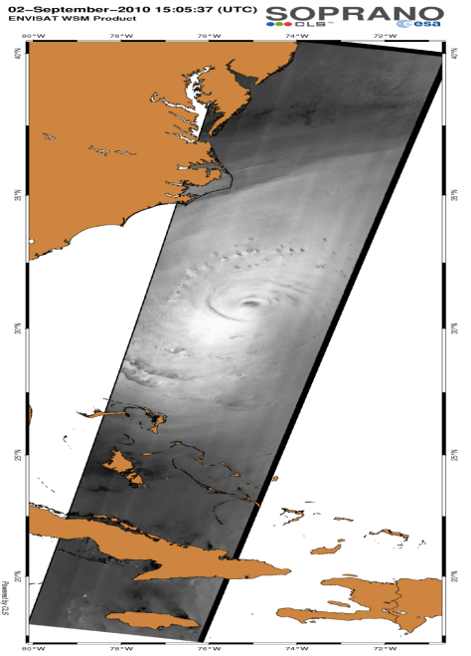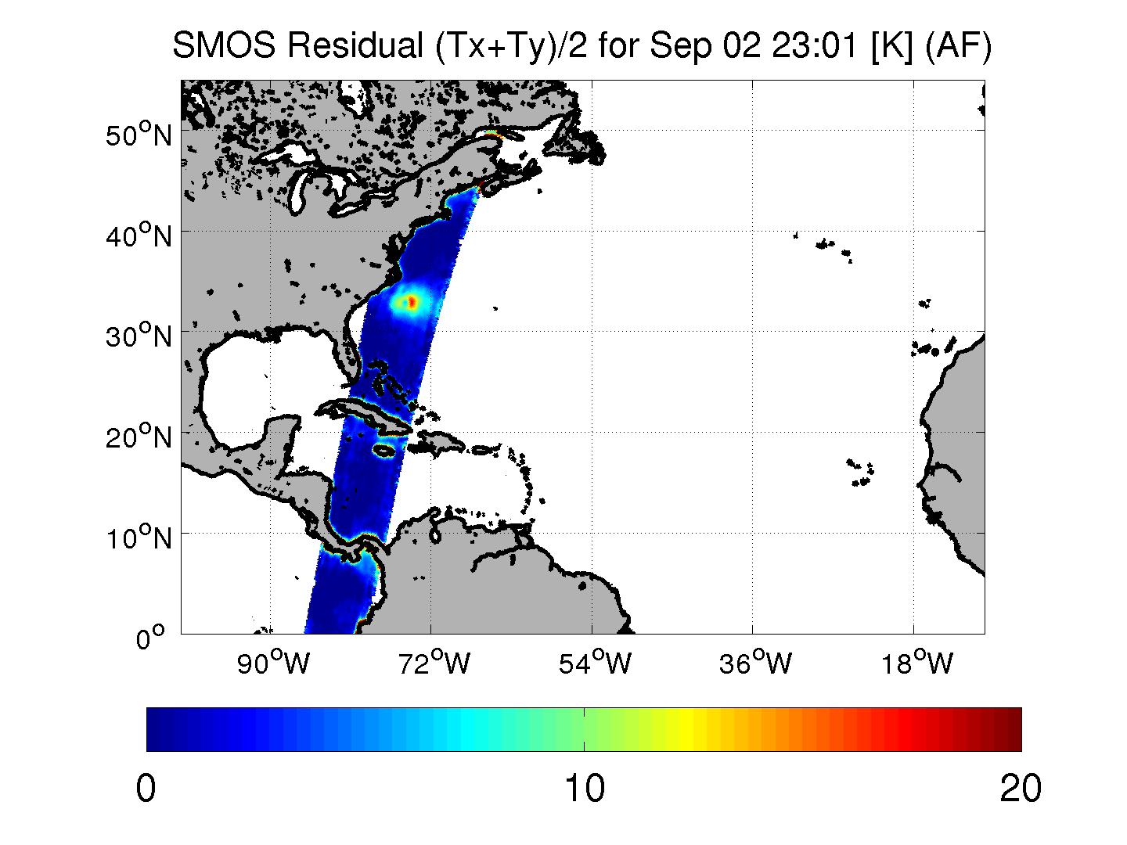

**Figure 4:** Left Envisat/ASAR image of Hurricane EARL the 02 Sep at 15 UTC. Right: Image of the wind-excess SMOS L-band brightness tempature measured over the same storm the 02 Sep at 23 UTC.

Additionally, when available, closeby products between SMOS and Envisat/ASAR or altimeters will be used to characterize the sea states in images as seen by SMOS (see the EARL case example given in Figure 4). Another example is shown in Figure 5 for the sea state impact characterisation considering Cryosat Hs altimeter and SMOS data during super-typhoon Haiyan in 2013. As shown, the sea state was showing a very high degree of asymetry across the storm N and S quadrants with Hs growing from 2 m on the eye track left-hand side to 7 m on its right-hand side. No such asymetry is nevertheless observed in the SMOS **ΔTB** . Statistical analysis of an ensemble of storms data including SMOS data and co-localized auxiliary sea state observations shall help refining the empirical dependencies of the GMF with sea state parameters describing the observed scenes.

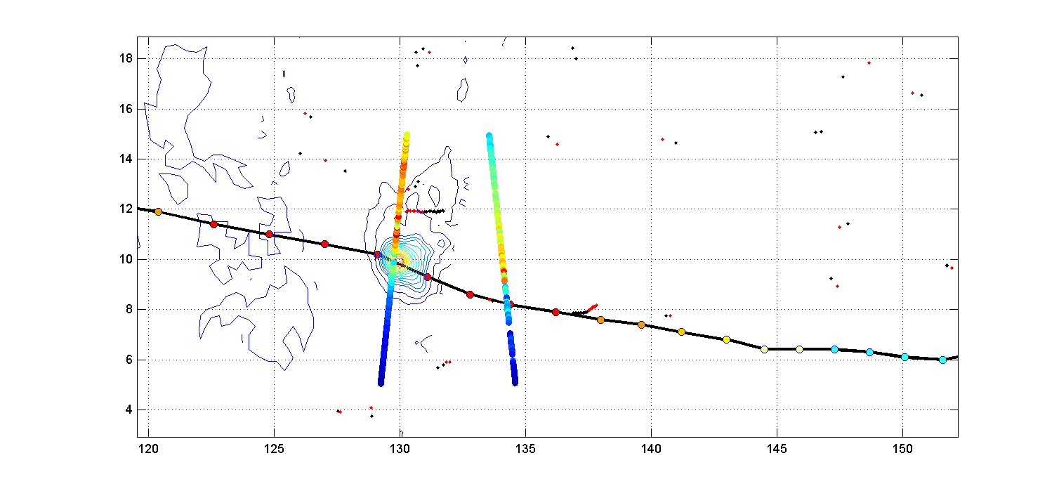

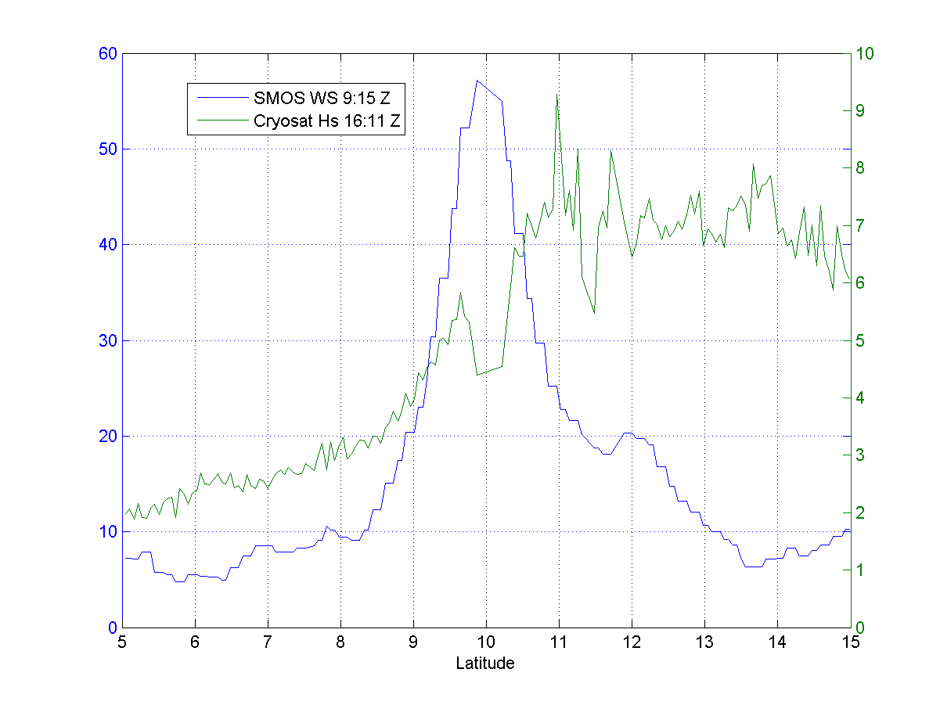

**Figure 5**: Example of co-localisation between Cryosat altimeter data and SMOS **ΔTB** measured during the interception of super Typhoon Haiyan. Top panel: superimposed SMOS retrieved winds and significant wave height along Cryosat altimeter tracks. Bottom panel: section across the typhoon showing SMOS retrieved wind in blue (m/s) and Cryosat altimeter data-derived Hs (green in meters).

**Rain Impacts**

Concerning the evaluation of the Rain impact, the developement of the rain correction is a difficult task because (i) there are no accurate rain estimates in Hurricanes, (ii) it is difficult to account for the spatial variability of the rain events in the context of the SMOS beam filling effects and (iii) because of the high temporal variability in rain events which imposes the need for contemporaneous measurements between SMOS and auxilliary rain rate estimates. Nevertheless, an attempt to estimate the later effect will be performed considering the TC and ETC database and by tentatively co-localizing several available rain rate (*RR*) products with SMOS data, such as :

- TRMM/3B43 25 km res 3-hourly rain rate products

- SFMR rain-rate transects,

- Rain Radar measurements in NOAA/USAFF flights

- WRF model outputs,

- JASON 1,2 and Envisat/RA altimeter rain rate estimates.

-Rain rate estimates from 85-89 GHZ brightness temperature channels of WindSat, AMSR2 and SSM/I sensors

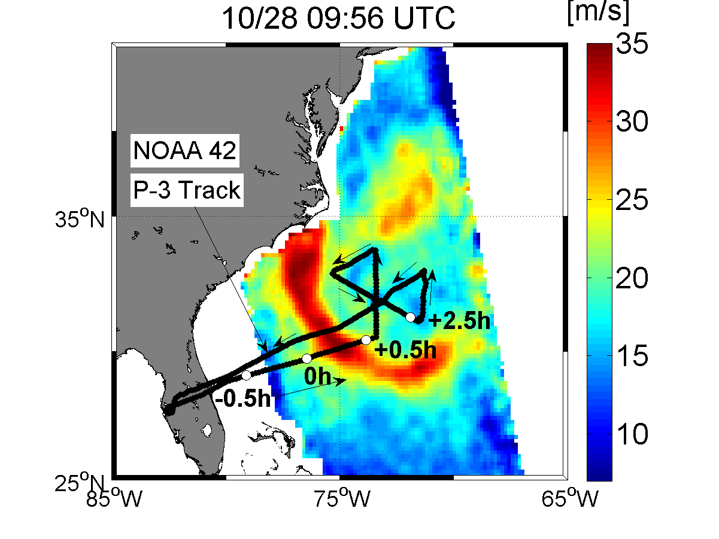

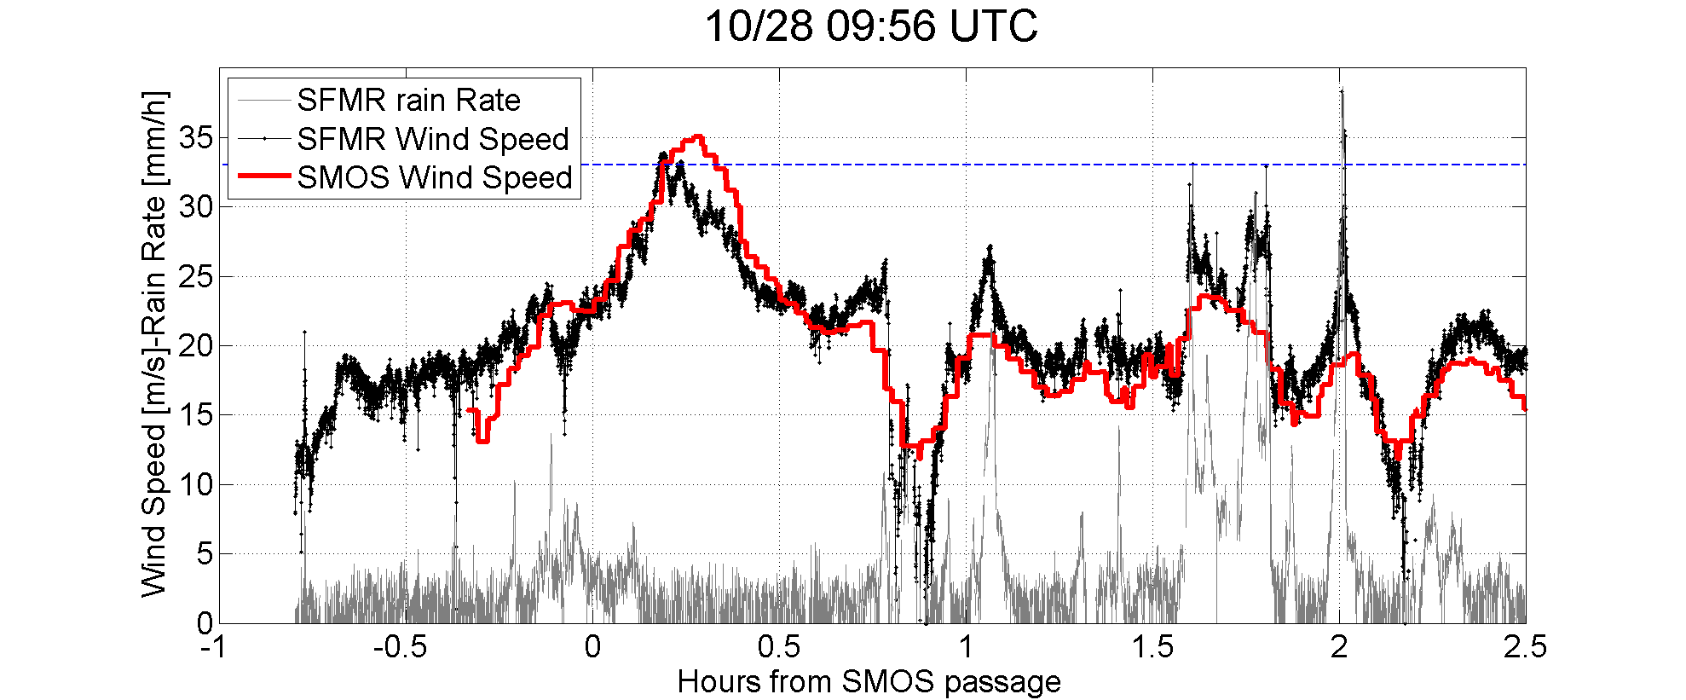

**Figure 6:** *Left: SMOS estimated surface wind speed as the satellite overpassed Hurricane Sandy the 28th Oct 2012 at 09:56 UTC. The track of the NOAA 42 P-3 aircraft flight is superimposed (black curves). White dots indicates the aircraft location at successive times with respect to SMOS acquisition.   Right: Co-located SFMR (black) and SMOS (red) surface wind speed estimates along the P-3 track. SFMR estimated rain rate is also shown in grey [mm/h]. Click on the images to see larger views.*

An example of co-localized SMOS data and SFMR Wind Speed and Rain Rate (RR) retrievals is shown in Figure 6 for the interception of hurricane Sandy in 2012. Co-localized RR Data acquired within less than 1/2 hour from SMOS passage will be collected and used to increase and populate the **ΔTB,** U**10** and RR database**.** Variations of the SMOS ΔTB along curves of constant wind speed contours intercepting rain-bands will then be used to tentatively isolate the rain impact, as long as we stay within one quadrant of the storm to minimize coincident fetch effects.

**Impact of Oceanic thermosaline surface conditions**

As explained in §2.4.1.5, in order to estimate the wind and wave-induced L-band brightness contrats, it is necessary to correct for all other geophysical sources of brightness. Beyond the contributing terms (atmosphere, galactic, etc..), the dominant contribution is the flat sea surface that varies as function of sea surface temperature and salinity. As a first algorithm rule, we chose to estimate the flat sea surface emission contribution using the OSTIA analyzed SST daily night-time products (Donlon et al., 2011) which are contained into the SMOS ECMWF data and we assumed the sea surface salinity can be estimated by interpolating on SMOS data grid the monthly climatology from the World Ocean Atlas 2005 (Boyer et al., 2006). This approach might introduce errors in the high wind product estimates (e.g,. a 1 psu error in the SSS climatology will translate into a 0.5 K error in the estimate of the ΔTB residuals which is about 1-4 m/s error). In this subtask, we will investigate the conditions for which these assumptions might be a significant source of error for the proposed products.

**Multi-sensing dependencies**

An additional source of earth surface emitted brightness modification at L-band as measured from space is the polarization mixing (Faraday rotation), due to the electromagnetic wave propagation through the ionosphere in the presence of the geomagnetic field (Skou, 2003). It can be either modeled from the knowledge of the ionospheric Total Electron Content (TEC) and magnetic field or avoided by using the first Stokes parameter I = Th+ Tv *,* which is basically invariant by rotation.

For the first algorithm version we chose this alternative option and estimated the first Stokes surface roughness and foam-induced brightness temperature residual: ΔI= ΔTh+ ΔTv.

Finally, to reduce the instrument instantaneous radiometric noise which can vary from 2.6 K to 5 K for a single snapshot measurement, we first averaged the SMOS multi-angular measurements performed at a given location on earth to estimate an incidence-angle averaged first Stokes brightness temperature residual generated by surface roughness and foam: $\overline{ΔI}$ = $\int{∆I\left(θ\right)dθ}$, where θ is the earth incidence angle. This noise-reduction approach is justified by the fact that a small incidence-angle dependence of the foam impact is expected at L-band in the range 0°-50° (Camps *et al*., 2005; Yueh *et al*., 2010).

The previously established geophysical dependencies between the SMOS averaged ΔTB (after averaging of over all incidence angles, considering only First Stokes parameter, mixing all varying spatial resolutions, ..) and the wind, the wave and the rain parameters will be re-analyzed here in terms of the SMOS observational dependencies, i.e.,:

- **Multi-angularity** : incidence θ and azimuthal φ variabilities.

Multi-angularity might thus be used :

* to detect either potential rain impacts (exploitation of the different path-length and attenuation across the rain bands for the SMOS multi-incidence data), or
* to separate wind from wave impacts in the Tbs. As illustrated in Figure 7, the Aquarius radiometer observations reveal that low incidence angle ΔTB are much less sensitive to sea surface state changes at a given wind speed (expressed here as function of significant wave height) than the highest incidence angle, angle at which a clear dependence with sea surface state is observed at the lower winds. Analysis of the changes in the spatial patterns of the SMOS Tbs over hurricane from low to high incidence angles shall therefore help in detecting and correcting for potential sea state impacts on the data, particularly in the lowest wind speed regime. These curves derived for Aquarius are based on ECMWF Hs model data in high winds which somehow smoothed out spatially compared to the observed variability in TC as illustrated in Fig 3. A co-localized data set between SMOS data & altimeter data will be obtained in WP2000 and shall help refinining the incidence-angle versus sea state dependencies of the GMF.
* to extract surface directional signatures (use of the multi-azimutal sampling for wind and wave directional impact estimates).

**Figure 7:** Evolution of the roughness-induced excess emissivity at L-band deduced from the Aqurius radiometer as function of surface wind speed and significant wave height. : Incidence angle is given on the top pannels. (Vandemark et al., in preparation 2011).

While a clear > ~0.5 K peak to peak azimuthal variability was found in Aquarius Tb data at winds > 20 m/s, SMOS teams never could identify clearly such signature in SMOS data. Based on the SMOS-DB, the SMOS roughness and foam-induced brightness temperature residual azimuthal variability will be therefore re-analyzed here as function of the dominant wind and wave directions, found in the different storm quadrants.

-**Polarization** dependencies p,

The polarization information in SMOS data might be as well very usefull in the context of the present project as the H-polarization signature at the surface is much more sensible to roughness effects than the V-pol. However, the polarization mixing at antenna level, the badly estimated Faraday effect and the SMOS instrument polarized acquisition cycle render the reconstruction of the polarized signal in the surface basis a difficult task. Nevertheless, we will tentatively investigate the polarization dependence of the ΔTB in TC and ETC using several dedicated datasets (e.g., center of the swaths). In particular, better image reconstruction of the fully-polarimetric information of SMOS is now available in the last L1 processor version. The third Stokes parameter T3 (see Figure 8) can now be considered more robust and could be used potentially to help deriving information on the wind direction in TC and ETCs. This new capability shall be analysed in that task.



**Figure 8**: SMOS third Stokes parameter T3 showing a strong signal across a southern ocean storms

-**Multi- spatial resolution** mixing.

The multiple acquisitions obtained along a SMOS dwell line probe the surface wind gradients with a strongly varying spatial resolution and the combination of multiple observations might induce an important spatial "smearing" effect of the surface structures. Because of the small instrument signal to noise ratio, a compromise between the combined processing of multiple observations to reduce the SMOS data noise level and the extraction of the higher resolution information will be investigated and an optimization criteria shall be here provided.

An important aspect in the context of Hurricane monitoring is indeed the **varying spatial resolution** of the SMOS data. In Quilfen et al., 1988; an analysis of the impact of the spatial resolution of active satellite measurements in Tropical Cyclones was conducted. It was shown that aquisition at 50x50 km2 limits the interpretation of the signals in such mesoscale events. The strong gradients of the surface wind existing at scales of a few kms are indeed smoothed in the measured features such as the intensity and location of the wind maxima, and the position of the center. Enhancing the resolution by a factor of 2 allows location of the wind maxima and minima in a TC with a much better accuracy than at 50 km resolution. In addition, a better resolution reduces the geophysical noise (variability of wind speed within the cell and effect of rain) that dominates the radiometric noise and hence improves the definition of the measurements. SMOS data resolution actually varies from about 30 km at nadir to about 80 km at the high incidence angles. Therefore, the multiple acquisitions obtained along a dwell line probe the surface gradients with a strongly varying spatial resolution and the combination of multiple observations might induce an important spatial "smearing" effect of the surface structures. Because of the small instrument signal to noise ratio, a compromise between the combined processing of multiple observations to reduce the SMOS data noise level and the extraction of the higher resolution information will have to be found and optimization criteria shall be here analyzed.

At the end of this task, a refined empirically-derived surface wind speed retrieval algorithm will be provided in the form:

U10=function (ΔTB(θ,φ,p)+Δ(x,δp)+Δ(RR)) (3)

where the second and third corrective terms in the right-hand side of (3) shall account for potential sea state, foam and rain impacts on the L-band TBs as function of incidence angle, azimut and polarization.

#### 2.4.2.3 Definition of suitable Quality Indicator (QI) flags

A challenging task will be to derive estimates for potential errors in the SMOS products and a filtering algorithm to communicate to users the quality of data. Given our experience with the SMOS-HWS products, we anticipate 2 classes of errors depending on their source :

1) instrumental errors and

2) geophysical errors.

Beyond this two classes, instrumental errors are clearly expected to be the dominant sources of uncertainty for SMOS products in TC & ETC. Nevertheless, geophysical errors (such as rain impact, SST uncertainties) might become non negligible for ETC and weaker TC wind conditions.

1) Instrumental errors

Instrumental limitations and inaccuracies inherent to SMOS sensor include:

- spatial image reconstruction biases,

-solar radiation and RFI impacts

-land contamination

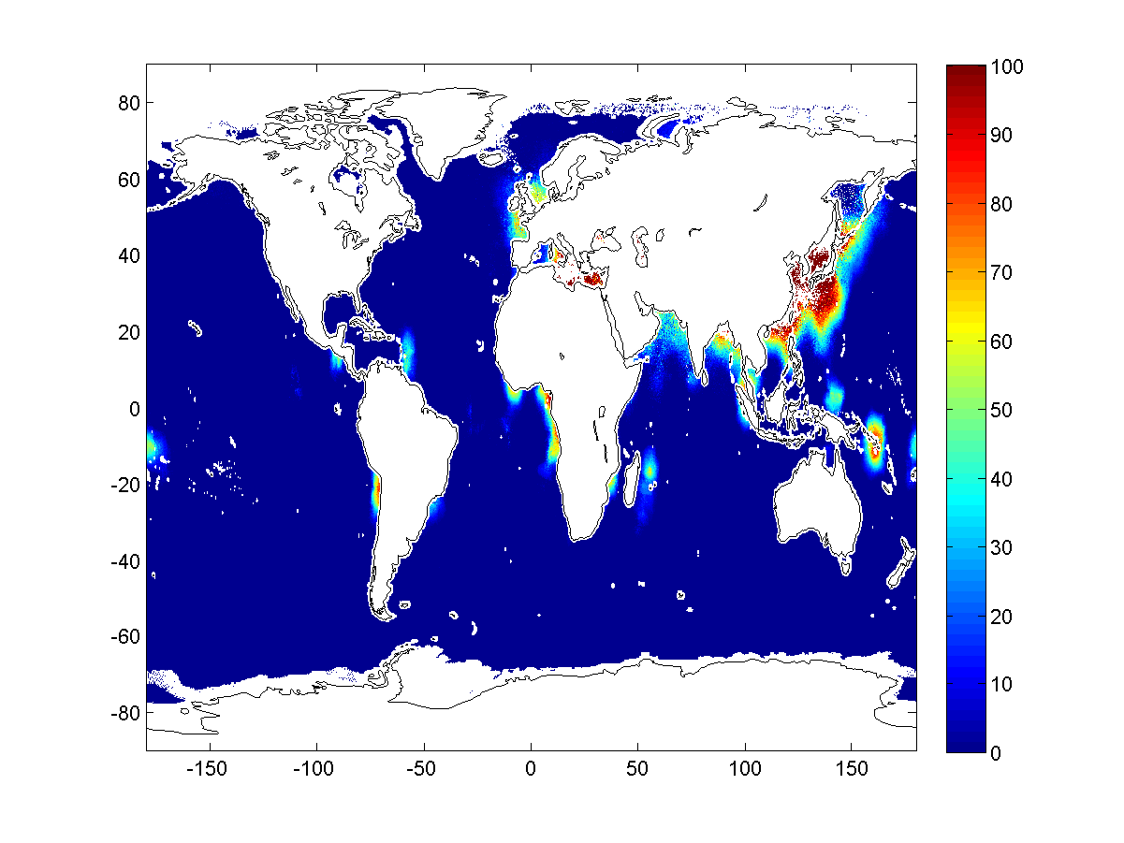

**Figure 9:** *Averaged percentage of SMOS data contamined by RFI over year 2012 combining both ascending and descending passe and all incidences.*

Based on the SMOS-Storm database, an analysis of the instrumental error sources will be provided. RFI and solar radiation contamination exhibit either regional, pass-type dependent, polarization or/and incidence angle dependencies. As shown in Figure 9, RFI contamination probability is clearly regional. It was also shown to strongly depend on the sateliite orbit pass type (ascending or descending) and the incidence angle. In addition to local correction algorithm (described in the feasibility project ATBD), regional, pass-dependent and incidence angle based flags can be raised when SMOS-HWS products will be retrieved in highly contaminated area.

As well, SMOS innovative instrument generate brightness temperature data that can be seriously biased in the **closed proximity of the coasts** because of the badly accounted for impacts of the strong sea-land brightness contrasts on the reconstructed L1 fields. This might severely limits the SMOS monitoring of landfalling Hurricanes and Storms. A dedicated analysis to treat these particular cyclone and ETC cases will be given in this subtask, on the basis of the analysis results for several landfalling TCs. As for the RFI, land contamination can be flagged based on regional, pass-dependent and incidence angle parameters. However, improved processing techniques involving the analysis of TB anomalies with respect the SMOS data aquired 18-days sooner or after the SMOS/TCs intercepts can be also envisaged. The 18-days period is indeed an orbital subcycle, so that the geometry of observations is approximately identical in between two successive 18-days samples. This property can be used to extract the relative anomaly generated by the storm from the previous 18-day observations and therefore better extract the cyclone information while tentatively removing the permanent land-contamination.

2) Geophysical condition errors

Based on the derived empirical dependencies of the GMF, the impact of uncertainties on the characterisation of the SMOS observed geophysical environment in term of auxiliary information (SST, SSS, sea state, rain,..) on the SMOS-HWS products will be as well assessed in this task.

The overall output of 1) and 2) above shall be the definition of retrieval quality flags based on the SMOS radiometer observation conditions (incidence angle, ascending versus descending passes, seasonal cycle of solar contamination, regional & local flags for RFI,..) as well as on the geophysical conditions (varying sea state impact for decaying or intensitying storms, potential rain signatures, presence of sea ice..).

#### 2.4.2.4 Algorithm Theoretical Basis Description (ATBD) for SHWS

Combining the results of the previous tasks, a detailed new "surface wind speed" SMOS-HWS algorithm will then be defined in the form of ATBD/IODD and DPM for L-band satellite High wind speed product. This documents will include:

* An overview description of the background to the algorithm,
* A Mathematical description of the algorithm,
* A description of all related data sources in an Input/Output Data Description (IODD) Chapter,following the template provided in Appendix-1 of the SoW. Any restrictions in the use of any type of data sets (e.g., proprietary campaign data) willbe communicated to the Agency immediately.
* A Detailed Processing Model (DPM) Chapter that can be used to implement the Algorithm.
* A separate chapter documenting the scientific justification for specific development choices and trade-offs (including technical considerations justifying the selected methodologies and approach),
* The design and specification of output product contents and their format. The use of standards based formats will be considered (e.g., netCDF, CF compliant),
* The design and specification of product metadata (based on existing standards) necessary to discover and manipulate data products,
* Identification of risks and proposed solutions.

#### 2.4.2.5 Outputs

|  |  |  |  |  |  |  |  |  |  |
| --- | --- | --- | --- | --- | --- | --- | --- | --- | --- |
| **Short Name** | **Deliverable title and description** | | | **Date due** | | **Number of hard copies** | **Electronic delivery** | | |
| TR-1 | Technical Report-1 (>50 pages that may take the form of a Peer Reviewed Journal Article(s)) | | | KO+9 | | 0 | Web | | |
| SHWS-ATBD | | SMOS-HWS combined ATBD/IODD/DPM | KO+12 | | 0 | | | Web |

### 2.4.3 WP1300: Foam property retrieval capability from SMOS data

Despite decades of effort to accurately quantify whitecap fraction W using in situ photography of the ocean surface, there remains significant scatter in estimates for any given 10 m wind speed (U10). Anguelova and Webster [2006] demonstrated the feasibility of estimating W from routine satellite measurements of TB at 19 GHz, horizontal polarization. This initial algorithm used TB observations from the Special Sensor Microwave Imager (SSMI/I) [Wentz, 1997], a radiometer flown on satellite platforms F8 to F17 of the United States Department of Defense since 1987 and operating at four frequencies between 19 GHz and 85 GHz. The algorithm for estimating W combines satellite TB observations with models for the rough sea surface and foam-covered areas (whitecaps). An atmospheric model is used to remove the influence of the atmosphere from the satellite measured top-of-atmosphere TB, in order to obtain the changes in TB at the ocean surface. Wind speed U10, wind direction Udir, SST at the ocean surface, and atmospheric variables such as water vapor and cloud liquid water are necessary as inputs to the atmospheric, roughness, and foam models.

Although various models and many variables are involved in the algorithm estimating W, for simplicity we denote this the W(TB) algorithm. The algorithm for estimating W has since been improved in several respects [Anguelova et al., 2009]. Notably, more physically robust models for rough and foam-covered surfaces are now employed [Bettenhausen et al., 2006; Johnson, 2006; Anguelova and Gaiser, 2013], as are independent data sources for input variables in the W(TB) algorithm. The use of independent input data sets in the W(TB) algorithm has been possible due to newly available TB observations since 2003—in addition to those of SSM/I— from the microwave radiometric sensor WindSat, onboard the Coriolis satellite [Gaiser et al., 2004]. WindSat operates at five frequencies, from 6 GHz to 37 GHz, thus providing more TB data suitable for remote sensing ofwhitecaps than SSM/I [Anguelova and Gaiser, 2011]. The Coriolis satellite completes 14 orbits per day, with ascending (northbound Equator crossing) and descending (southbound Equator crossing) passes at local times of approximately 18:00 and 06:00, respectively. There are 80 pixels within the WindSat swath with an approximate spacing of 12.5 km across the swath and along the satellite track [Bettenhausen et al., 2006]. At the lowest level, each pixel within the WindSat swath represents a TB (or W) value averaged over an area of 50 km x 71 km. Each W value resulting from such an intrinsic spatial averaging of satellite instantaneous samples is analogous to the temporal averaging required to produce stable W values from instantaneous photographic dataWindSat TB data at higher swath resolutions (i.e., pixel value averaged over an area of 35 km x 53 km or 25 km x 35 km) are also available, but the work in Salibury et al., 2013 uses whitecap fraction estimates at the low resolution. Use of TB data from WindSat in the W(TB) algorithm allows independent use of SSM/I data (water vapor and cloud liquid water) for the atmospheric correction. In addition, the input variables U10, Udir, and SST to the atmospheric, roughness, and foam models in the W(TB) algorithm are also compiled from independent sources.

Following a similar approach, a SMOS by-product in TC and ETC could be an estimate of the whitecap coverage or whitecap volumic fraction at the sea surface. To our knowledge, the only attempt to produce such estimates was published in Anguelova and Webster, (2006) & Salibury et al., 2013 who recently proposed a methodology to globally retrieve whitecap coverage from passive microwave satellite measurements, in the particular framework of the WindSat data exploitation. Details about their methodology, products and further validation excercises (Anguelova et al., 2009) will be given in this section.

The concept of estimating whitecap coverage on a global scale from satellite data relies on changes of ocean surface emission at microwave frequencies induced by the presence of whitecaps. Ocean surface emissivity, e, is a composite of two main contributions: emissivity due to the rough sea surface, er, in places free of whitecaps (1 − W), and emissivity due to foam, ef, in places covered with whitecaps W. The composite surface emissivity therefore can be presented as (Stogryn, 1972)

[](javascript:history.back())

Provided that the emissivities in (1) can be obtained, whitecap coverage can be determined as

[](javascript:history.back())

In (2), e can be retrieved from satellite measurements with appropriate atmospheric correction, while emissivities er and ef can be computed using analytical or empirical models. Since e obtained for each point on the globe is a measure of ocean emissivity as it is created by the specific environmental and meteorological factors at this point, the satellite-measured W values will contain information for the additional factors and be more realistic than W predictions from a model developed from regional data elsewhere.

The surface emissivity model (1) appears deceivingly simple. There are two major requirements for the applicability of (1), which are difficult to fulfill. First, the models for er and ef must clearly separate these two emissivities: er must represent rough sea emission not contaminated by foam emission and ef must strictly represents emissivity of foam. While even simple foam emissivity models can guarantee the latter, existing models for rough surface emission most certainly contain foam contributions making the former the more challenging task. Second, only well validated models for er, ef, and the atmospheric correction of e can guarantee the true utility of (1). However, the existing uncertainty in validation of atmospheric terms, the continuous development of rough surface models, and the insufficient knowledge of foam emission all demand tuning of some parameters in or applying empirical corrections to those models. Moreover, the lack of whitecap coverage values representing a wide range of conditions impedes reliable constraints on such tuning and empirical corrections.



**Figure 10** *from Anguelova et al (2009): Global monthly (March, 2006) distribution of whitecap coverage from WindSat measurements at 10 GHz, H pol. (10H, upper panel) and W(U10) model of Monahan and O’Muirchaertaigh (1980) (lower panel).*

However challenging, these difficulties are by no means prohibitive. In fact, the idea of using a surface emissivity model (1) in combination with satellite data to obtain whitecap coverage is not completely new and has been tried before. In developing forward models of ocean microwave emission for geophysical retrieval algorithms in the early 80s, the remote-sensing community has used (1) and measurements of TB from the Scanning Multichannel Microwave Radiometer (SMMR) to infer foam coverage [Pandey and Kakar, 1982; Wentz, 1983]. The need to measure whitecap coverage on a global scale and model its high variability more realistically clearly calls for a renewed effort aimed at assessing the feasibility of obtaining W from routine satellite measurements.

Though satellite-based whitecap observations need further development and improvement, the retrieved data are useful for gaining first insights about the variability of the whitecap fraction. Thus, Anguelova et al (2009) compiled a whitecap database with the current version of the *W* estimates (see Figure 8). For the *W* entries, the whitecap database uses all available WindSat orbits (ascending passes) at swath resolution of 50×70 km2 for 10 GHz and 37 GHz, horizontal polarization (10H and 37H, respectively). The choice of these frequencies is based on the conclusion of Anguelova et al (2009) that *W* from 10 GHz, similarly to the photographic *W* data, would capture all active and partially decaying whitecaps, while *W* from 37 GHz is good in “seeing” even the thinnest decaying foam patches. The H polarization is used because it is more sensitive to changes of wind speed and breaking-wave events than the vertical polarization. It is therefore anticipated that W from L-band would mostly capture all active whitecaps. As found by Salisbury et al. 2013, global spatial distribution of satellite-based values of *W* differ from those obtained with conventional *W*(*U*10) relationships. The differences could be explained with the influence of additional meteorological and environmental factors on whitecap formation. Correlation analysis helps mapping the contribution of various additional factors to the *W* variance in various geographical regions. Principal component analysis corroborates the results of the correlation analysis and helps narrow the range of additional factors necessary to parameterize *W* variability. Besides wind speed, Salisbury et al. 2013 have indeed shown that wave field—represented with significant wave height—and SST are the factors that need to be considered when parameterizing whitecap fraction. It is believed that the resulting, commonly used, W(U10) parameterizations do not fully account for the true variability in W, by failing to incorporate the impact of the wavefield and other environmental conditions. This was recently discussed in Salisbury et al. 2013 and Holthuijsen et al., 2012. In particular, commonly used cubic-wind speed dependencies for W seems to be strongly erroneous in very wind speed and extreme hurricane conditions where the surface white-out is dominated by streaks more than whitecap, per see.

Based on the output of WP1100, an algorithm will be proposed here to retrieve directly foam formation properties : whitecap coverage and foam-layer thickness as a geophysical product instead of wind speed at the surface of TC and ETC from SMOS radio-brightness contrasts in storms. We anticipate the potential retrieval of both whitecap & streak coverage but also of foam-formation layer thicknesses.

A detailed SMOS foam-property retrieval algorithm will be defined in that subtask the form of ATBD/IODD and DPM. This documents will include

* An overview description of the background to the algorithm,
* A Mathematical description of the algorithm,
* A description of all related data sources in an Input/Output Data Description (IODD) Chapter,following the template provided in Appendix-1 of the SoW. Any restrictions in the use of any type of data sets (e.g., proprietary campaign data) willbe communicated to the Agency immediately.
* A Detailed Processing Model (DPM) Chapter that can be used to implement the Algorithm.
* A separate chapter documenting the scientific justification for specific development choices and trade-offs (including technical considerations justifying the selected methodologies and approach),
* The design and specification of output product contents and their format. The use of standards based formats will be considered (e.g., netCDF, CF compliant),
* The design and specification of product metadata (based on existing standards) necessary to discover and manipulate data products,
* Identification of risks and proposed solutions

**Output**

|  |  |  |  |  |  |  |  |  |  |
| --- | --- | --- | --- | --- | --- | --- | --- | --- | --- |
| **Short Name** | **Deliverable title and description** | | | **Date due** | | **Number of hard copies** | **Electronic delivery** | | |
| WF-ATBD | | SMOS-WF combined ATBD/IODD/DPM | KO+12 | | 0 | | | Web |

### 2.4.5 WP1400: Merged Multi-mission Wind Speed product Algorithm

With the recent developments of new methodologies to better retrieve surface wind speed in all weather conditions from X, C and L-band radiometer measurements from Space (Meissner and Wentz**,** 2009; El-Nimri et al., 2010, Reul et al., 2012, Zabolotskikh, 2013) the synergy of passive low-microwave frequency observations from space operating within the X to L-bands (AMSR2,WindSat, SMOS and SMAP) can now be envisaged. The complementarity and added-value with scatterometer ones (ASCAT & Oscat) and NWP products (ECMWF & NCEP) will be studied with the aim to produce new blended surface wind speed products including the SMOS high wind speed data. Such capability will be analyzed in detail in this task, blending methodology will be studied with the aim of defining an algorithm to generate such blended wind products.

As a first objective we plan to merge SMOS data and AMSR2 wind speed retrievals and probably further add the WindSat data and the future SMAP sensor ones. For AMSR2 high wind speed retrieval under rain, we will rely on a new methodology currently being developed by *Zabolotskikh et al.*, 2013 which is partly described in 2.4.5.1.

#### 2.4.5.1) An algorithm for High Wind Speed retrieval under Rain from AMSR-2 data

AMSR-2 is the Advanced Microwave Scanning Radiometer 2 on board GCOM-W1 satellite which substituted Aqua AMSR-E and was launched mid-may 2012. The antenna of AMSR2 rotates once per 1.5 seconds and obtains data over a 1450 km swath. This conical scan mechanism enables AMSR2 to acquire a set of daytime and nighttime data with more than 99% coverage of the Earth every 2 days. The AMSR2 sensor characteristic for each frequency channel is given in Table 1.

|  |  |  |  |  |  |
| --- | --- | --- | --- | --- | --- |
| **Center Freq.** | **Band width** | **Pol.** | **Beam width** | **Ground res.** | **Sampling interval** |
| **GHz** | **MHz** |  | **degree** | **km** | **km** |
| 6.925/7.3 | 350 | V/H | 1.8 | 35 x 62 | 10 |
| 10.65 | 100 | 1.2 | 24 x 42 |
| 18.7 | 200 | 0.65 | 14 x 22 |
| 23.8 | 400 | 0.75 | 15 x 26 |
| 36.5 | 1000 | 0.35 | 7 x 12 |
| 89.0 | 3000 | 0.15 | 3 x 5 |  |

**Table 1.** AMSR2 channel Set

The idea of sea surface wind speed retrieval in hurricanes under precipitation conditions from AMSR2 measurement data relies on the suggestion that in C and X-bands brightness temperature is not only uninfluenced by rain scattering but far from saturation which is the physical reason to “see” the ocean surface and derive its properties. The general problem is to separate the ocean radiation from that of the precipitating atmosphere.

Many investigators have been studying the sensitivity of brightness temperatures (TB) to cloud and rain microphysical properties for the application to passive microwave soundings from satellite [*Bauer and Schluessel*, 1993; *Kummerow et al.*, 1996; *Lin and Rossow*, 1997], but no study related to rain has ever concerned C- or X- band since these bands are typically used for the ocean parameter retrievals, meaning that the atmosphere is significantly transparent for the radiation at such microwave frequencies.

Simulation of the microwave brightness temperatures over the oceans [*Chandrasekhar*, 1960] shows that the brightness temperature increases towards a maximum and then drops off as rainfall rates increase even further. The principle differences between the microwave frequencies are the range of rainfall rates for increase (emission/absorption region) and the range for decrease (scattering region). Lower frequencies including C- and X-bands tend to increase through much of the rainfall range, thus, making them suitable for emission type schemes. Higher frequencies saturate quickly and decrease for much of the rainfall range [*Kummerow and Ferraro*, 2007].

In hurricanes however rain intensity is so high that the rain radiation can obscure the ocean surface and saturate the brightness temperature over the ocean even for C- and X-bands, though in no cases rain drops or ice particles in clouds scatter the radiation since the particle size remains much lower than the wave length [*Ulaby et al.*, 1981].

In modeling TB over rain the vertical structure of the precipitation, in particular the height of the freezing level and the rain drop distribution along the height become extremely important. In rain retrieval algorithms, using higher than C- and X-band frequencies a great variability of the hydrometeor profiles is handled by either usage of profile probability and a priori databases along with Bayesian retrieval scheme [*Kummerow et al.*, 2001; *Kummerow and Ferraro*, 2007; *Petty and Li*, 2013] or by complex parameterization of rain parameters [*Hilburn and Wentz*, 2008].

Having in mind inconceivable complexity of the atmosphere-ocean system in hurricanes and corresponding complications in adequate brightness temperature modeling, *Zabolotskikh et al.*, 2013 nevertheless endeavored an attempt to discriminate the rain part of C- and X-band measured brightness temperature over the ocean from the other part including ocean radiation and the radiation of the atmosphere without rain.





**Figure 11:** *Brightness temperature fields measured by AMSR-2 on november 2013 at ~4:20 UTC over the Typhoon Haiyan (a) at 10.65 Ghz, vertical polarization and (b) at 89 GHz, vertcial polarization. Area A, marked by dark greeen line, corresponds to rain-free region. (c) Aqua MODIS visible image taken on November 2013 at ~4:23 UTC over the Typhoon Haiyan.*

To demonstrate such new capacity, we analyzed AMSR2 TB fields over the hurricane Haiyan on 7 November 2013. Figure 11 shows two brightness temperature fields measured by AMSR2 at 10.65 GHz, vertical polarization and at 89 GHz, vertical polarization. Black circles shown on the Figure 11(a, b) are plotted at a radius of 200 km from the center of the hurricane. According to the definitions of [*Jiang et al.*, 2013], most part of the circles goes over the inner rainband (IB) region whereas some part (at least, area A, marked with thick dark green line) covers typical for IB rainfree region adjacent to the outer rainband.

Analyzing the corresponding TB field for 89 GHz, vertical polarization (TB89V) Figure 11(b), along with almost coincident Aqua MODIS visible image (Figure 11 c), we obtain the confirmation of the absence of precipitation for the area A by the absence of ice or rain scattering concluded from TB89V field and by dark clouds seen on MODIS image.

Stating the absence of rain for the area A, we postulate that the brightness temperatures measured over this area in C- and X-bands (TB at 6.9 GHz, 7.3 GHz, 10.65 GHz, vertical and horizontal polarizations – further TB06V, TB06H, TB07V, TB07H, TB10V, TB10H correspondingly) is the TB of the ocean and atmosphere without rain. These TB will be denoted as TB06V0, TB06H0, TB07V0, TB07H0, TB10V0, TB10H0. Our final purpose is to find the rain constituent of TB in C- and X-bands for those channels which are used in the sea surface wind speed (SWS) AMSR2 retrieval algorithm [*Zabolotskikh et al.*, 2013] (these will be denoted as TB06VR, TB06HR, TB10VR, TB10HR) and express them in terms of some measured values so that then we could subtract TB06VR, TB06HR, TB10VR, TB10HR from the total measured radiances and apply the algorithm as if there were no rain.

Analyzing extracted brightness temperatures from the measurement pixels along the black circle we make two assumptions:

1. Atmospheric parameter variations influencing TB in C- and X-bands are negligible. Strictly speaking this is not correct. But the influence of total atmospheric water vapor content (TWV) and cloud liquid water content (CLW) on TB in C- and X-bands is considerably lower than on TB at higher frequency channels. Numerical simulations show that increase in TWV of 10 kg/m2 or in CLW of 0.1 kg/m2 will lead to TB increase of ~0.4 K in C-band and ~1 K in X-band TB measurements at vertical polarization. So the assumption of constant atmospheric radiation in its part which does not relate rain can be supposed justified for the area of equal distance from the cyclone center.
2. Though wind speed variations influencing TB in C- and X-bands cannot be priori considered negligible (wind field can be significantly asymmetric), wind dependency in C- and X-bands is very similar. So to some extension ⋅ΔTBV7,6 = TB07V ‑ TB06V and ⋅ΔTBV10,7 = TB10V ‑ TB07V don’t depend on the sea state but are rather functions of rain rate.

Under assumptions formulated above, we can write:

TB06VR = TB06V ‑ TB06V0;

TB06HR = TB06H ‑ TB06H0;

TB10VR = TB10V ‑ TB10V0;

TB10HR = TB10H ‑ TB10H0;

where TB06V0, TB06H0, TB10V0, TB10H0 – are the TB of the ocean and atmosphere without rain taken from the area A in Fig. 11, TB06V, TB06H, TB10V, TB10H – brightness temperatures measured over the rest part of the circle.

After having calculated TB06VR, TB06HR, TB10VR, TB10HR, we parameterize (using statistical regression) these radiances as functions of differences in measurements in C- and X-band channels at vertical polarization:

TB06VR =*a0* + *a1*⋅ΔTBV7,6 + *a2*⋅ΔTBV10,7;

TB06HR =*b0* + *b1*⋅ΔTBV7,6 + *b2*⋅ΔTBV10,7;

(1)

TB10VR =*c0* + *c1*⋅ΔTBV7,6 + *c2*⋅ΔTBV10,7;

TB10HR =*d0* + *d1*⋅ΔTBV7,6 + *d2*⋅ΔTBV10,7;

Thus, knowing ΔTBV7,6  and ΔTBV10,7 and derived coefficients *ai, bi, ci, di* we can calculate rain radiances for any pixels, not only along the circle.

It is obvious that the ocean-atmosphere systems under hurricane conditions are extremely complicated both in the ocean state and precipitating cloud systems. Thus, once derived statistical relations may not be valid for the whole range of atmospheric and oceanic states. Thus, we will derived in this task the sets of the coefficients *ai, bi, ci, di* using series of storm measurements.

As a demonstration, this analysis was already performed for 8 typhoons in 2013 over the North Pacific: Danas, Francisko, Hayian, Lekima, Soulik, Usagi, Utor and Wipha (35 appropriate for analysis fields altogether). The fact that derived coefficients proved to be almost the same for these different cases allows concluding general nature of suggested parameterization and possibility to relate ΔTBV7,6  and ΔTBV10,7 (or the rain radiation at any channel, say TB10VR) to rain rate RR.

For the derivation of dependency TB10VR(RR) , we will use the data of the Tropical Rainfall Measuring Mission's (TRMM) Microwave Imager (TMI) - multi-channel, dual polarized, conical scanning passive microwave radiometer designed to measure rain rates over a wide swath under the TRMM satellite. TRMM semi-equatorial orbit ensures for TMI to sample the surface at all times of day as opposed to twice-per-day sampling of AMSR2 in its near-polar orbit. That is why it is principally possible to find the precipitation images with reasonably small time difference in measurements.

One of the considered typhoons satisfies the conditions under which the rain field over the typhoon has not changed significantly during the time passed between TMI and AMSR2 measurements. Fig. 12(a) illustrates the rain rate field for the typhoon Danas on 7 October 2013 imaged by TMI (product of Remote Sensing Systems) at ~ 18:36 UTC (time of measurements over the typhoon center), whereas Fig. 12(b) shows the rain brightness temperature TB10VR at 10.65 GHz vertical polarization, estimated from AMSR2 measurement data at ~ 17:14 UTC, using ⋅ΔTBV7,6 and ΔTBV10,7 with (1). Red dots on Fig. 12(a) and Fig. 12(b) indicate the center of the typhoon at ~ 17:14 UTC – time of AMSR2 measurements. It is seen that during about an hour and a half the typhoon has moved north and the rain field structure has also changed



**Figure 12***: (a) TMI rain rate field (mm/h) for the typhoon Danas on 7 october 2013 (http://www.remsss.com/) at 18:36 UTC; (b) AMSR2 derived rain brightness temperature at 10.65 GHz vertical polarization at ~17:14 UTC. Red dots indicate the center of the typhoon at ~17:14 UTC.*

Nevertheless we have considered it possible to match both fields after shifting AMSR2 measurements according to Danas center shift and gridding of both TMI RR and AMSR2 TB10VR onto the same grid. The dependency of RR on TB10VR derived after such manipulations is shown on Fig. 13.



**Figure 13.** *TMI RR as function of AMSR2 derived rain brightness temperature at 10.65 GHz vertical polarization.*

From this analysis, we deduced the following empirical relation :RR =0.27 TB10VR (2)



**Figure 14***. (a) TMI gridded (10 kmx10km) RR field (mm/h) 7 october 2013, 18:36 UTC; (b) AMSR2 derived gridded (10 kmx10km) RR field (mm/h) 7 October 17:14 UTC, shifted yo spuerposed the typhoon center; (c) RRAMSR2-RRTMI*

Fig. 14 illustrates TMI RR field after 10 km×10 km gridding (a), corresponding AMSR2 RR field on the same grid, shifted north (b) and the difference ΔRR between AMSR2 RR and TMI RR (c). Maximum ΔRR of 3 mm/h over the typhoon area can be associated both with method inconsistency and with intensification of rain occurred in 1.5 hour.

Applying such methodology, SWS algorithm will be then applied to TB without rain radiation. The algorithm is described in [*Zabolotskikh et al.*, 2013]. Example as applied to SWS in Danas is shown in Fig.15.



**Figure 15:** *Typhoon Damas. SWS fields derived with AMSR2 High wind and Rain algorithm.*

In this task, the "surface wind speed" AMSR2-HWS algorithm will be defined in the form of ATBD/IODD and DPM. This documents will include

* An overview description of the background to the algorithm,
* A Mathematical description of the algorithm,
* A description of all related data sources in an Input/Output Data Description (IODD) Chapter,following the template provided in Appendix-1 of the SoW. Any restrictions in the use of any type of data sets (e.g., proprietary campaign data) willbe communicated to the Agency immediately.
* A Detailed Processing Model (DPM) Chapter that can be used to implement the Algorithm.
* A separate chapter documenting the scientific justification for specific development choices and trade-offs (including technical considerations justifying the selected methodologies and approach),
* The design and specification of output product contents and their format. The use of standards based formats will be considered (e.g., netCDF, CF compliant),
* The design and specification of product metadata (based on existing standards) necessary to discover and manipulate data products,
* Identification of risks and proposed solutions.

#### 2.4.5.2) Merged SMOS-AMSR2 HWS observations

SMOS data provide a global coverage about every 3 days. During fast evolving storm events, SMOS swath can however miss interception with such fastly evolving storms or just capture a portion of the storm. In addition, SMOS data can be heavily contaminated in some areas by RFI (see Fig 9), solar effects or land contamination. RFI are particularly problematic in the North west Pacific and in the Bay of Bengal. Combining SMOS and AMSR2 retrievals shall definitively help better characterizing high wind speed and storm events over the globe.

To illustrate this new capability that we plan to develop in the frame of the SMOS+STORM evolution project, we show here below two illustrative examples of the scientific benefit of the combined SMOS+AMSR2 data. The first case consider the sampling of super typhoon Haiyan in November 2013. The second example illustrate the potential interest to characterize an extratropical storm in the North Pacific, also in November 2013.

**An illustrative example of SMOS/AMSR2 synergy: the case of the Super Typhoon Haiyan**

Typhoon Haiyan (known in the Philippines as Typhoon Yolanda) slammed into the Philippines in Nov 2013 with sustained winds of 310 kilometers per hour, making it one of the strongest tropical storms to date and the second-deadliest Philippine typhoon on record. Haiyan originated from an area of low pressure in the Federated States of Micronesia on November 2. Tracking generally westward, environmental conditions favored tropical cyclogenesis and the system developed into a tropical depression the following day. After becoming a tropical storm and attaining the name Haiyan at 0000 UTC on November 4, the system began a period of rapid intensification that brought it to typhoon intensity by 1800 UTC on November 5. By November 6, the Joint Typhoon Warning Center (JTWC) assessed the system as a Category 5-equivalent super typhoon on the Saffir-Simpson hurricane wind scale; the storm passed over the Palau shortly after attaining this strength.

SMOS intercepted the typhoon several times along its track. We selected only those passes were the signal was well detected and not too contaminated by RFI or land masses. As illustrated by Figure 16, this let one pass on the 4 as Haiyan was still a Tropical Storm, two on the 6th Nov (with the morning pass capturing only a small portion of the typhoon), one on the 7 prior landing towards Philippines and one interception on the 9, just before it passed over Vietnam.

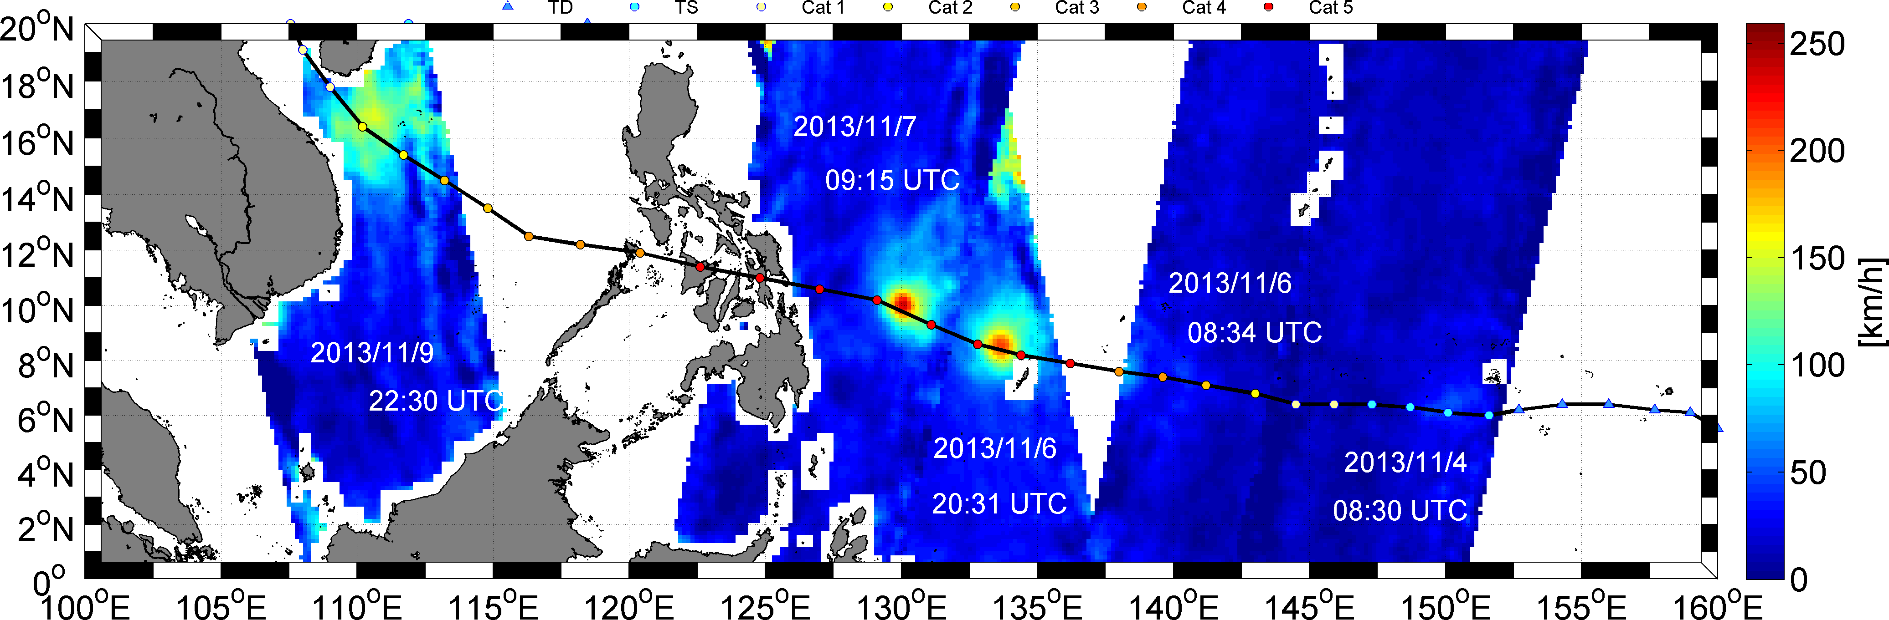

**Figure 16:** *SMOS retrieved surface wind speed [km/h] along the eye track of super typhoon Haiyan from 4 to 9 Nov 2013.*

Passes on the evening of the 6 and during the 7th morning were close in time from the maximum intensity reached by that super storm (reached on the evening of the 7th).

As illustrated by Figure 17 left panel, the estimated excess brightness signal (First stokes parameter/2) due to surface roughness and foam-formation processes under the cyclone on the 7th morning overpass (i.e., after correcting for atmosphere, extra-terrestrial sources, salinity and temperature contributions) reached a record value of 41 K. To put such value in perspective of other natural oceanic signals, we plotted together the Tb jump measured during the passage of Hurricane Category 4-5 Igor in 2010, which was only 22 K! In contrast, global changes of surface salinity (32-38 pss) and temperature (0°C-30°C) only modify the Tb by ~5 K. So we believe such signal is very likely a natural extreme of sea surface emission at L-band over the oceans.

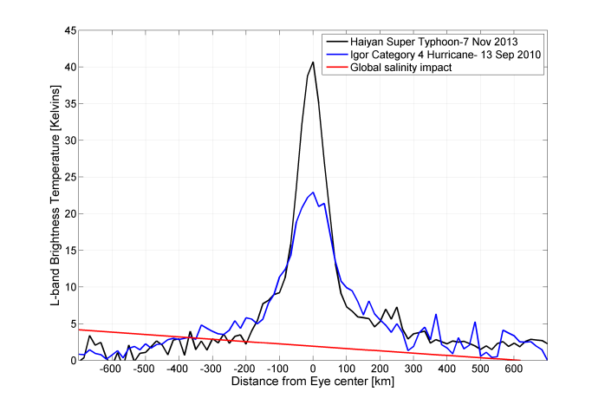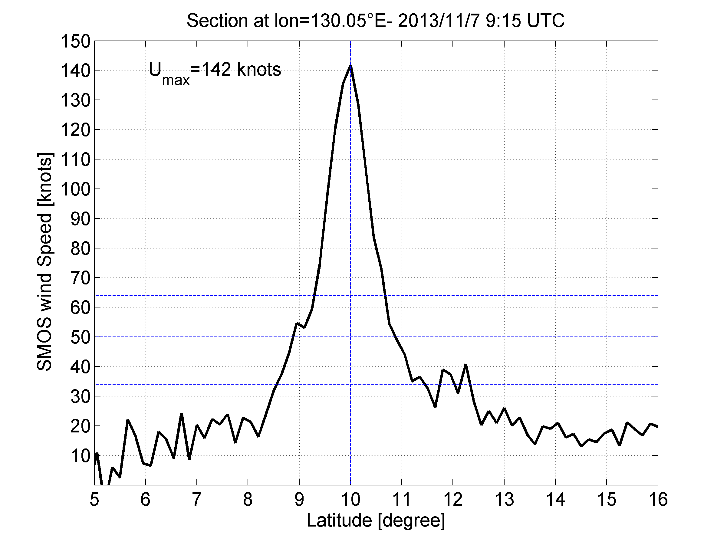

**Figure 17:** *Left: North-south section trough the Haiyan Typhoon showing the change of residual brightness temperature (Th+Tv)/2 reconstructed from SMOS data at longitude of 130.05°E on the 7 Nov 2013 at 09:15Z Typhoon (black). The Blue curve is showing an equivalent section through the Igor Category 4 hurricane in 2010. The red line is illustrating the range of brightness temperature variation expected on earth due to sea surface salinity and temperature changes. Right: surface wind speed deduced from the excess brightness temperature.*

Application of the wind-speed bi-linear retrieval algorithm that we derived in 2012 based on the established GMF relationship between surface wind speed estimates during IGOR and the excess brightness temperature, we obtained the wind speed module shown in Figure 17, right panel. One can easily see that around the cyclone eye, wind speeds largely exceed the 64 knots threshold for typhoons within a more than 50 km radius. The spatial resolution of SMOS however does not allow to resolve the detailed wind speed structure around the eye. The maximum wind estimated from SMOS nevertheless reaches here 142 knots !

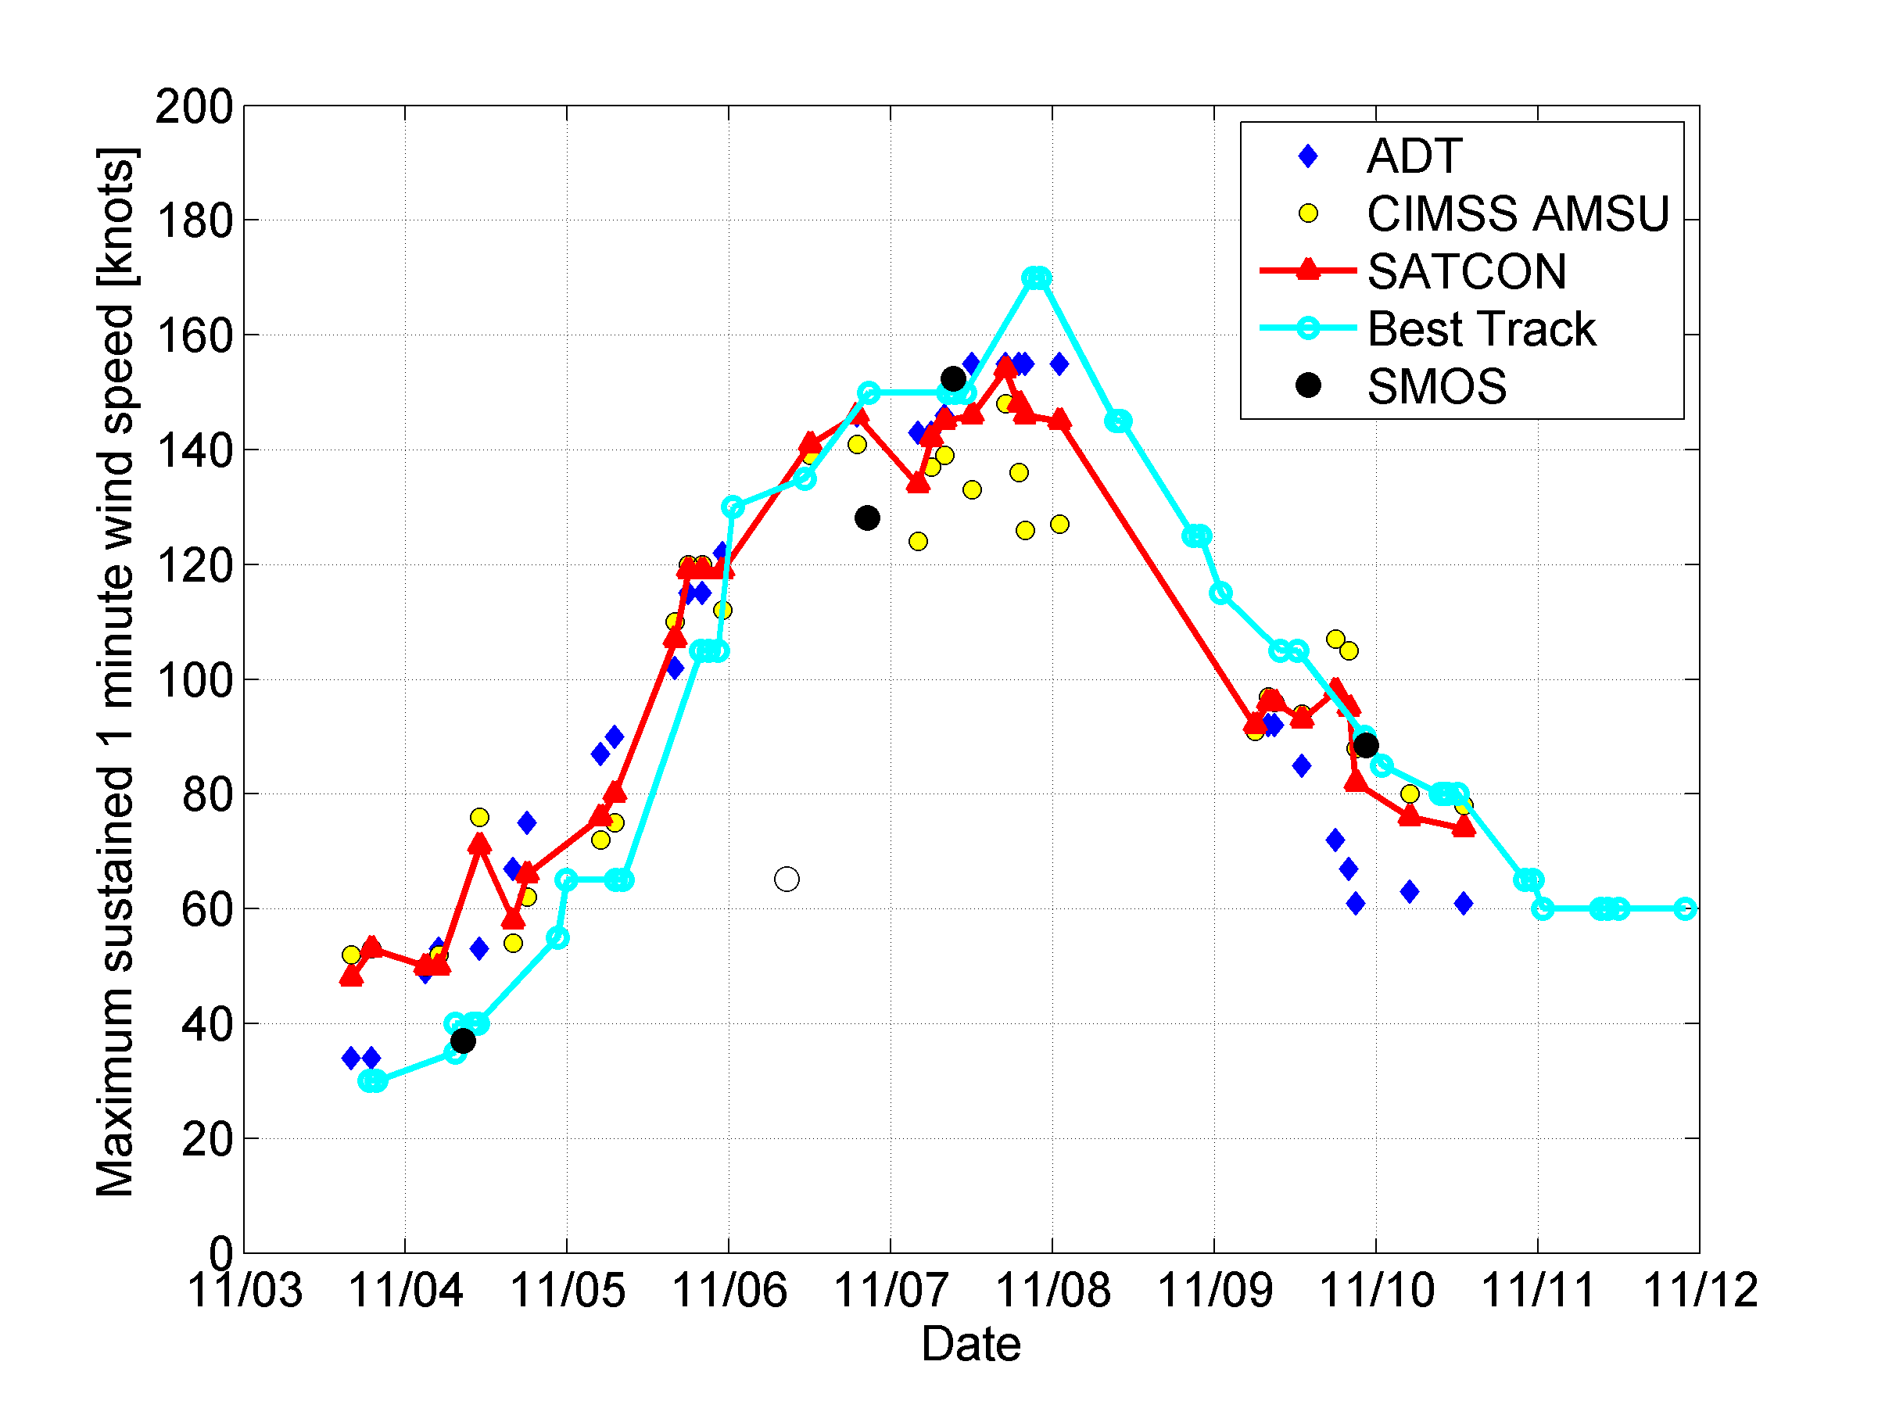

**Figure 18:** *Maximum sustained 1 minute wind speed estimated during Haiyan Typhoon. From SMOS data (black filled dots) compared to Advanced Dvorak Technique (ADT=blue diamond), CIMSS (yellow filled dots), SATCON (red) and Best Track from NHC (cyan). Note the empty circle correspond to the SMOS measurements for the 11/06 morning for which only a small portion of the cyclone signal was intercepted. Maximum 10 minutes wind speed deduced from SMOS algorithm were multiplied by 1/0.93, adopting the conversion factor proposed in (Harper et al., 2010) between one minute winds and 10 min winds.*

Given the spatial resolution of SMOS, the wind speed measured is more equivalent to a 10 minute sustained wind than to a 1 minute one, traditionally used by forecasters in the US. Using a 0.93 conversion factor from 1 mn to 10 mn winds (Harper et al., 2010), 1 minutes sustained winds can be estimated from SMOS. The evolution of the maximum sustained wind speed deduced from SMOS is compared to other estimates traditionally used by forecast centers in Figure 18. SMOS estimate compares very well with standard methods. Nevertheless, the SMOS sampling along the complete life cycle of the storm is limited to 4 usefull overpasses. Complementing the SMOS sampling with other sensors would be therefore certainly beneficial.

An example of AMSR2 interception with Haiyan is shown in Figure 19 on 7 November 2013 at ~ 4:22 UTC.



**Figure 19:** Rain effects removal algorithm applied to AMSR2 X-band Tb for an overpass of super Typhoon Haiyan as the surface wind speed reached maximum values of 150 knts on the 7 Nov 2013.

SMOS intercepted Haiyan on the 7 Nov 2013 at 09:15Z while AMSR2 intercepted the Typhoon the same day about 5 hours sooner at ~ 4:22 Z. To compare the surface wind speed retrieved from both sensors, we recentered the eye estimated from each sensor data set based on the location of the maximum wind. Comparisons between both sensor surface wind retrievals are shown in Figure 20.

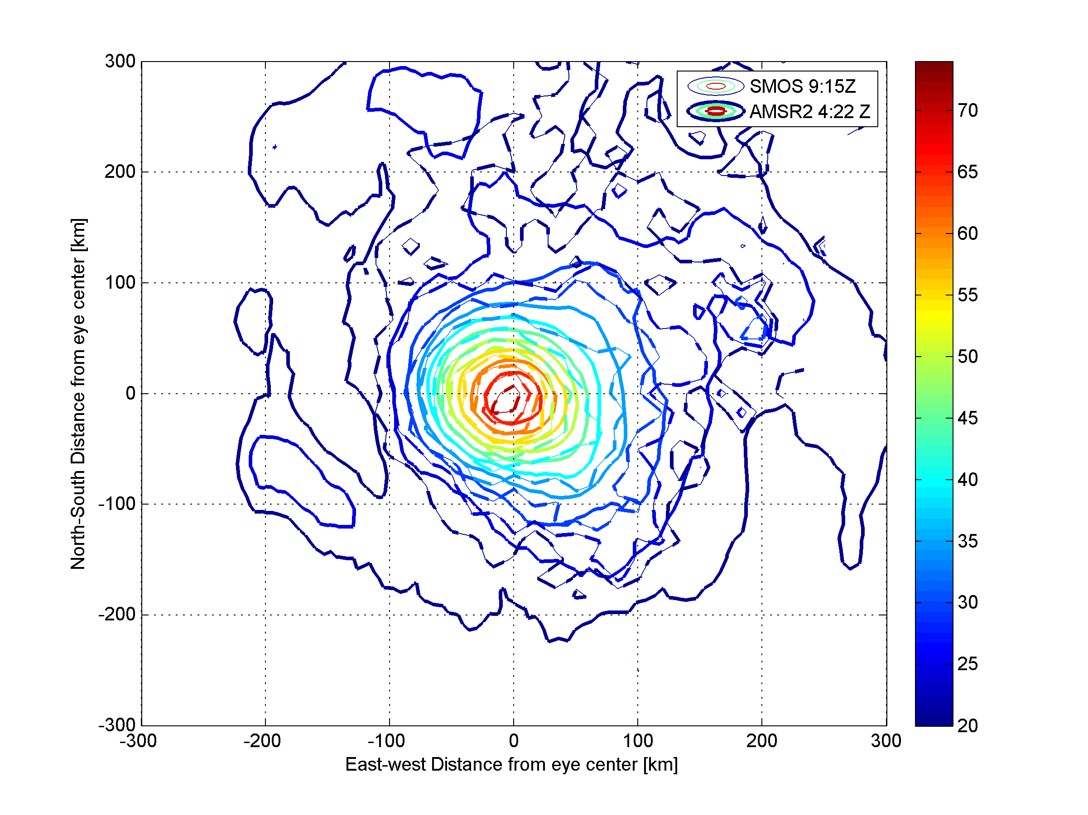

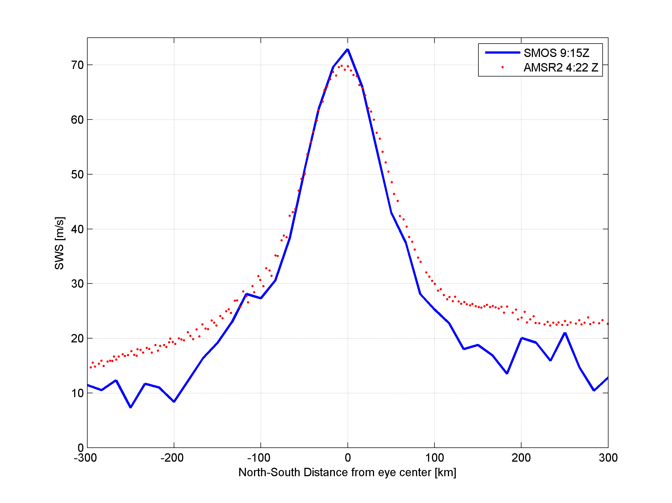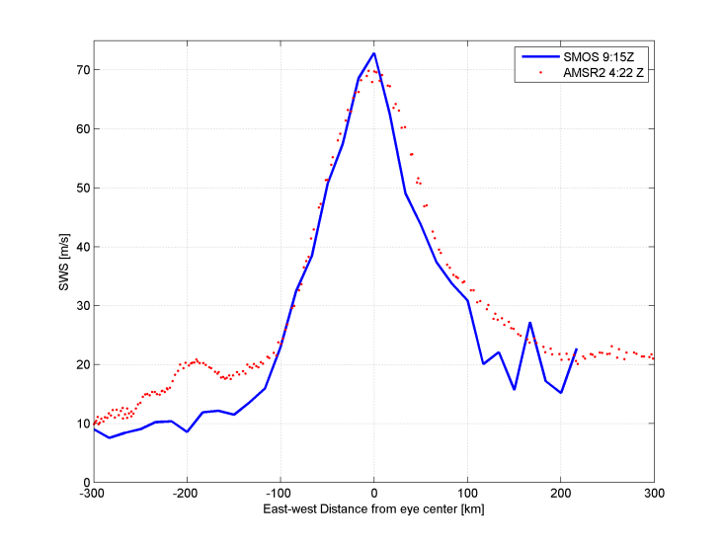

**Figure 20: Top:** *Superimposed contrours of SMOS (dashed) and AMSR2 (filled) surface wind speed fields estimated 5 hours apart as the sensors overpassed the super Typhoon Haiyan on the 7 Nov 2013. Bottom: North-South (left) and East-West (right) sections of the retrieved wind speed through the storm (blue=SMOS; red=AMSR2).*

SMOS is operated at 1.4 GHz while data used from AMSR2 involve 7 and 11 GHz channel data and the respective algorithms used to retrived surface wind speed are very different in nature (mono-frequency and no rain correction for SMOS, rain and multi-frequency data fro AMSR2). Nevertheless, the comparisons shown in Figure 20 reveal that above hurricane force (>33 m/s) both instrument see very similar wind speed structures. Major differences are observed in the lowest wind speed range below hurricane force. It can be due to temporal evolution of the wind field in between the two observations or to differences in the breaking wave, sea state, spray or other geophysical impact on the brightness temperatures. Nevertheless, the consistency between both sensors in the high wind speed regime is very impressive and promising for the generation of new low-frequency microwave radiometer merged high wind products.

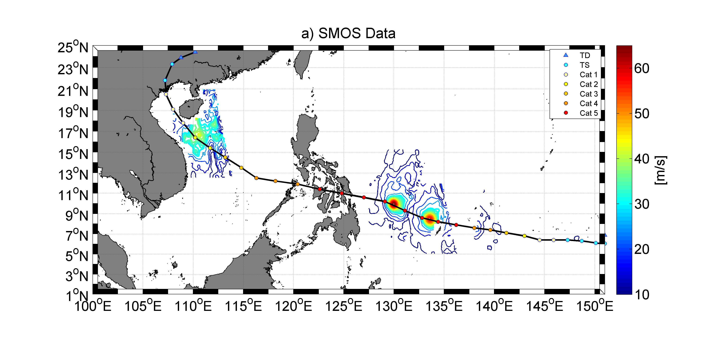

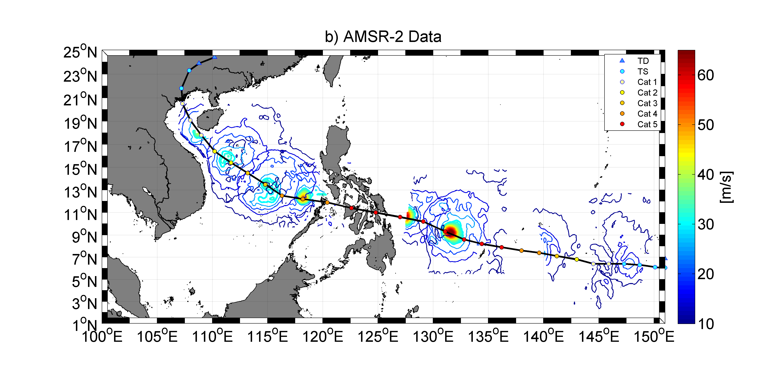

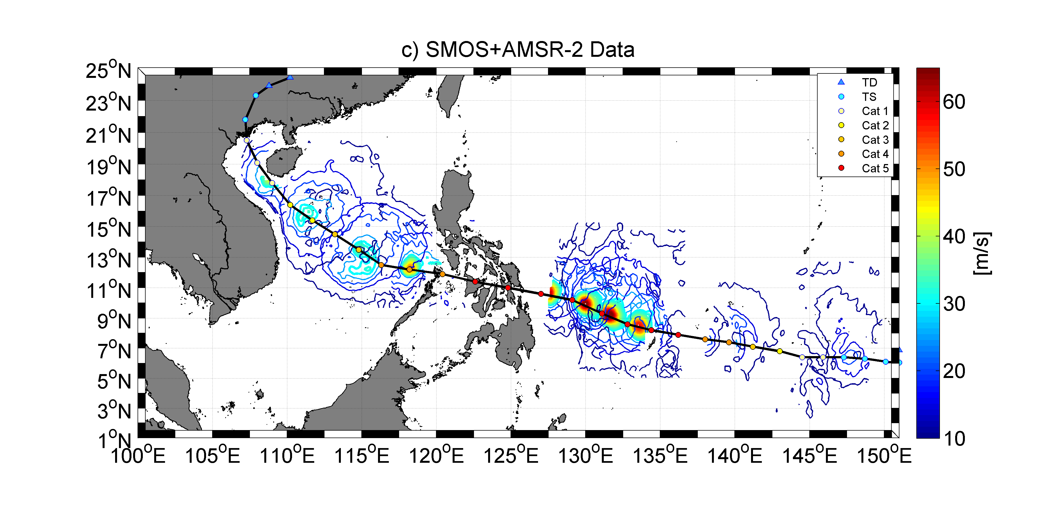

**Figure 21:**a) *Contours of surface wind speed at 34, 50 and 64 knots retrieved during the passage of super Typhoon Haiyan in Nov 2013 a) from SMOS sensor, b) from AMSR-2 and c) by merging SMOS and AMSR-2 data.*

Figure 21 is further illustrating the strength of the synergies and data merging between these two sensors in term of increased spatial and temporal coverage for rapidly evolving and intense storms such as Haiyan typhoon.

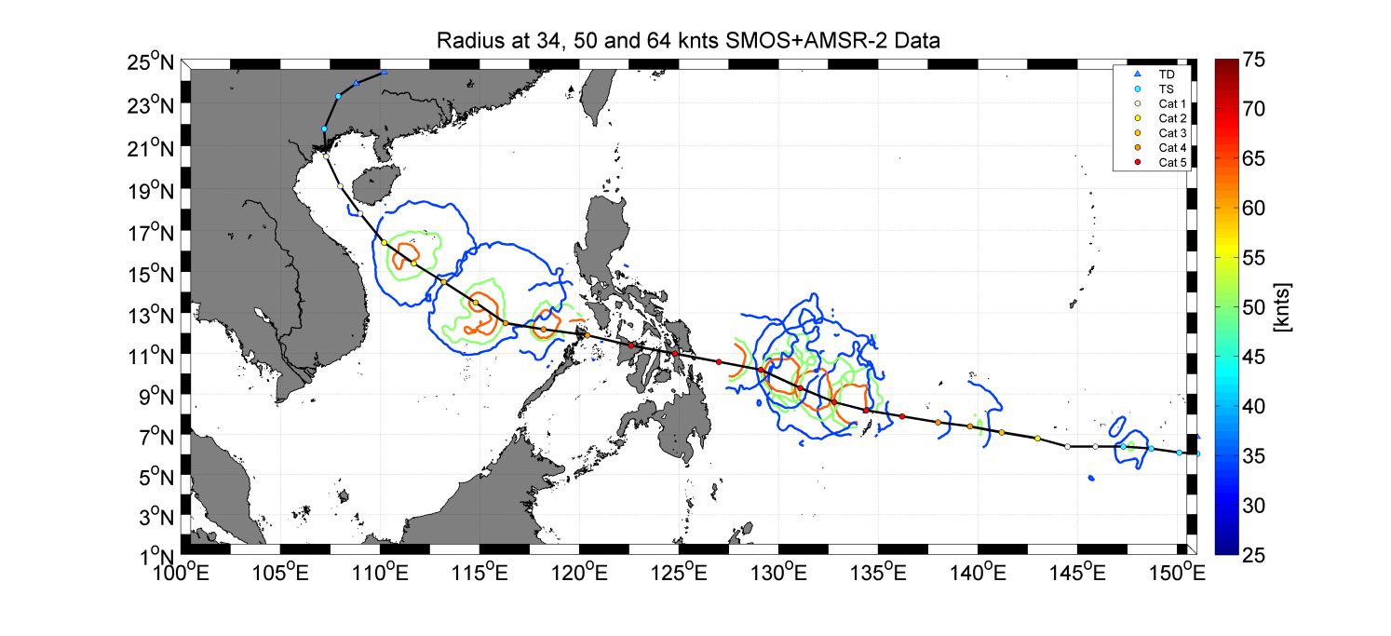

**Figure 22:** *Contours of the merged SMOS+AMSR2 retrieved winds over Haiyan at the threshold levels of 34 (blue), 50 (green) and 64 (orange) knots.*

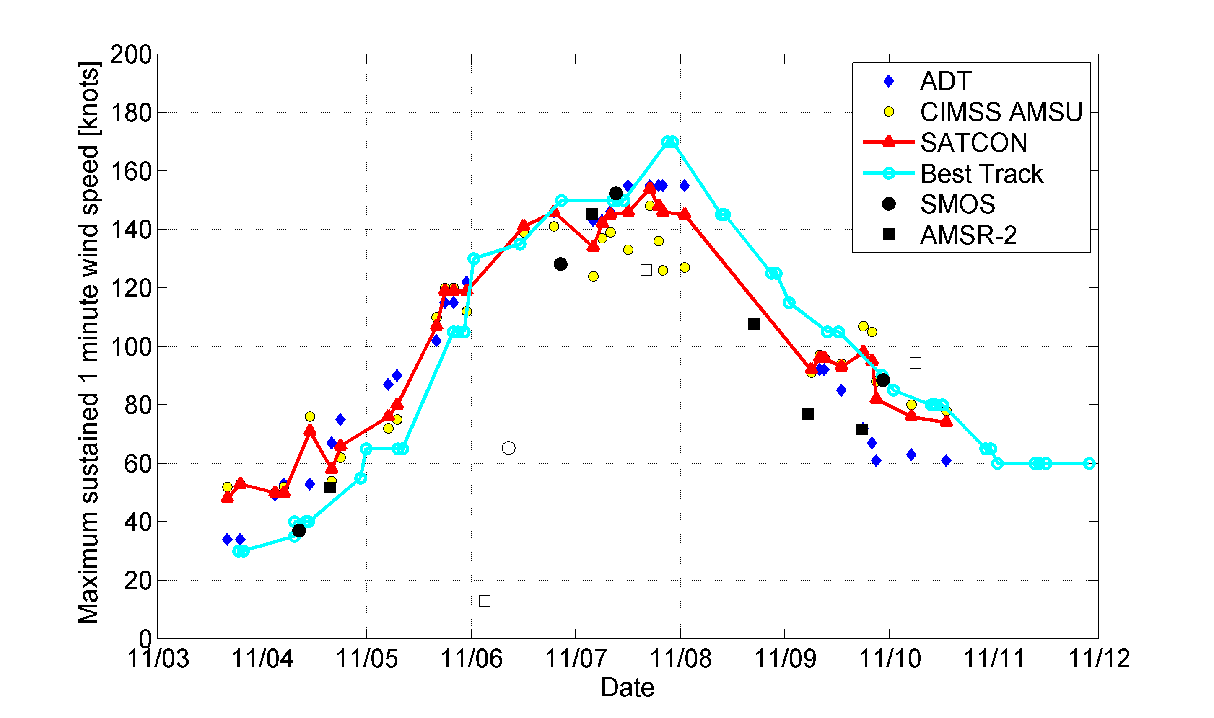

**Figure 23:** *Maximum sustained 1 minute wind speed estimated during Haiyan Typhoon. From SMOS data (black filled dots) and AMSR2 (black filled squares) compared to other top-of the atmosphere measurements. Note the empty circlesand squares correspond to the SMOS or AMSR2 measurements for which only a small portion of the cyclone signal was intercepted.*

As shown in Figures 21,22 and 23, by combining both sensors, consistent and more continuous estimations of key parameters for describing the storms in the context of improving NWP forecasts, such as radii at 34, 50 and 64 knots, and maximum sustained winds can now be provided and augmented.

**Another illustrative example of SMOS/AMSR2 synergy: the case of an ETC in the North Pacific in 2013**

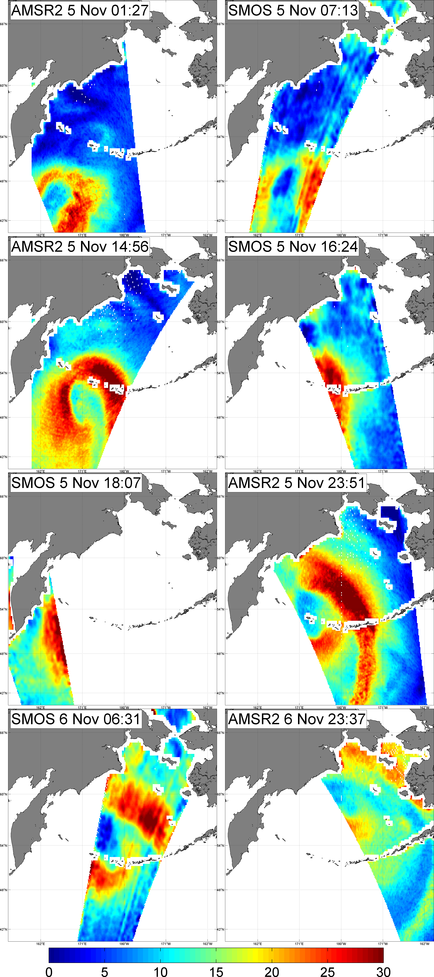

**Figure 23**: An Example of Extra-Tropical Storm sampling by SMOS and AMSR2 for 5 and 6 Nov 2013 (colorbar in units of m/s).

In Figure 23, we illustrate another potential benefit of the SMOS/AMSR2 merging capability to monitor surface winds in ETCs. Only 2 days of SMOS and AMSR-2 High Wind speed retrievals are shown in Fig 23 as the sensors intercepted a severe ETC propagating northward in the northern Pacific across the Aleutian Islands. Retrieved surface wind speeds are in general below the hurrciane wind strength (<33 m/s) but both sensor often consistently detected wind speeds exceeding 30 m/s. As shown, in Figure 24, Metop/Ascat retrievals rarely exceeded 25 m/s for that storm during these two days.

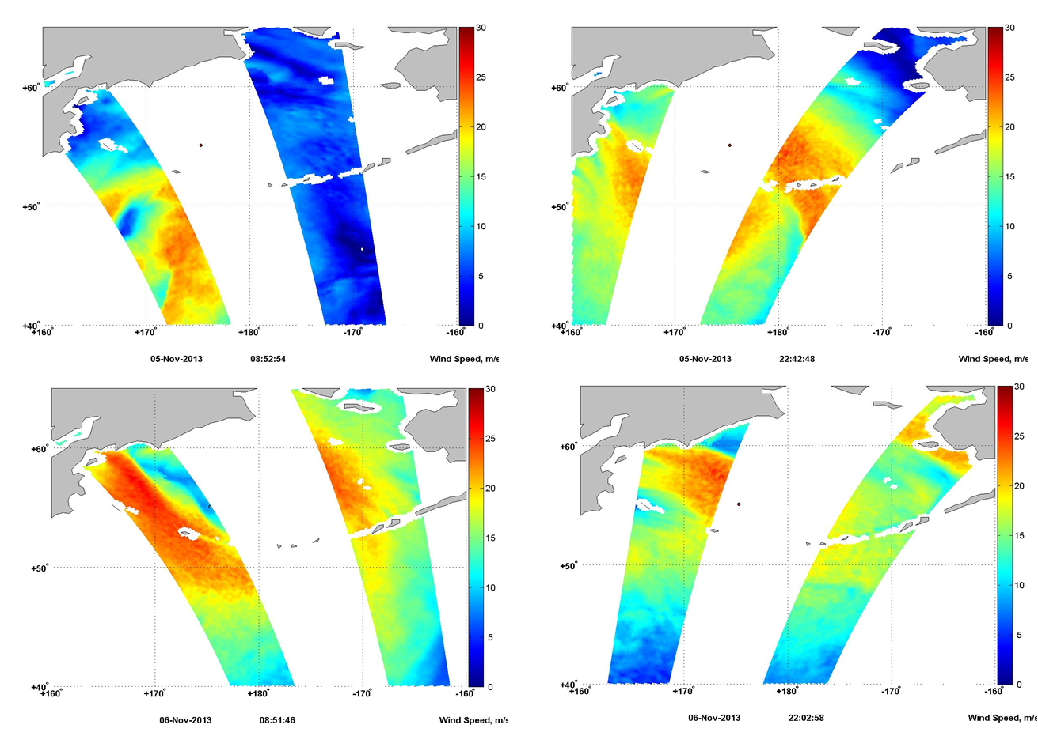

**Figure 24**: Sampling of the previously analysed Extra-Tropical Storm by METOP/Ascat from 5 to 6 Nov 2013 (m/s).

While a careful and extended validation of the SMOS and AMSR2 radiometer wind speed retrievals for ETC is still required, these first preliminary analyses indicate the strtong potential of merging SMOS and AMSR2 data to increase the coverage of storm events and to probably better characterize the high wind speed regimes and structures of TC and ETC as compared to scatterometer data alone.

The blended SMOS/AMSR2 HWS products and database will be generated in WP2000. Combination with Metop/Ascat and Oceansat II scatterometer observations as well as the futur SMAP observations can be envisaged in this frame.

**Output**

|  |  |  |  |  |  |  |  |  |  |
| --- | --- | --- | --- | --- | --- | --- | --- | --- | --- |
| **Short Name** | **Deliverable title and description** | | | **Date due** | | **Number of hard copies** | **Electronic delivery** | | |
| BLEND-ATBD | | BLEND-SHWS combined ATBD/IODD/DPM | KO+12 | | 0 | | | Web |

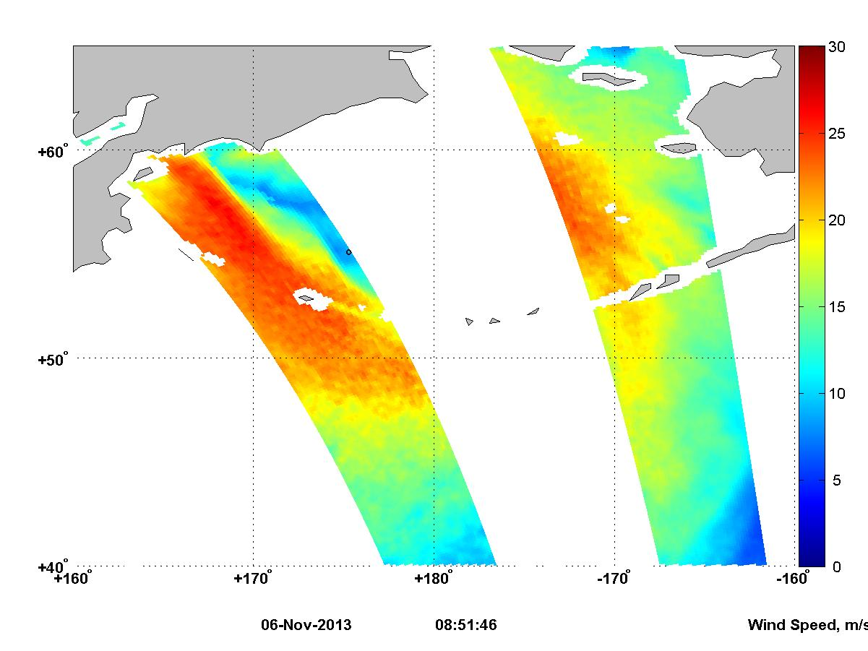

## 2.5 WP2000: Generate & Validate SMOS High Wind Speed Product Databases

Using the previously derived algorithms, the entire SMOS Mission archive will be processed to systematically produce and validate L-band SMOS high wind speed products globally with uncertainty estimates and flags. This will include High wind speed retrievals from SMOS data alone, herefater refered to as the SMOS-HWS products and the whitecap and foam related-products (SMOS-WF), as well as the blended SMOS/AMSR2 winds (BLEND-HWS) under both ETCs and TCs. The tasks that will be perform to reach this objective will include Task 4 and 5 as described in the SoW.

### 2.5.1 WP2100: Data Set collection and Preprocessing

The auxilliary data set that we will collect for the entire SMOS archive will include the following data :

* Microwave Brightness temperatures data:
* SMOS L1B, L1C data,
* AMSR-2 ,WindSat and SFMR C and X-band brightness temperatures,
* SSM/I, AMSR-2 85 GHz Tbs.
* Aquarius L1 L-band Tbs and associated scatterometer data
* Storm track data:
* NHC BEST Tracks data, and,
* IBtracks data,
* Best track for the Pacific from the Joint Typhoon Warning Center (JTWC)
* JRA 25 reanalyses of the 850 Mb vorticity
* Surface wind products including:
* HRD SFMR data sets, GPS dropwindsondes data and H*WInd analysis,
* GFDL hurricane wind model outputs,
* ECMWF wind products,
* WindSat and AMSR-2 wind products,
* ASCAT and OceanSAT-II scatterometer produtcs,
* JASON 1,2 and Envisat/RA and Cryosat altimeter wind products.
* Envisat/ASAR and Radarsat-1 products,
* NOOA/NDBC buoy data
* Sea Surface State parameters from
* numerical wave models (NAH, IFREMER wavewatch III, ECMWF),
* Envisat/ASAR and Radarsat-1 products, and,
* JASON 1,2 and Envisat/RA altimeter wave products.
* NOA/NDBC buoy data sets
* Rain Rates estimates from
  + - TRMM/TMI
    - HRD SFMR data sets,
    - WRF model outputs,
    - JASON 1,2 and Envisat/RA rain rate estimates.
    - WindSat
* SSS estimates from:
* SMOS
* Aquarius
* In situ (Coriolis, ISAS OI analysis)
* SST estimates from:
* GHRSST OSTIA and ODYSSEA

The first task before collecting all the necessary data will consist in detecting usefull events for the developement and refinement of the SMOS-HWS GMF. In addition to Hurricane Centers Best track data and some of the listed auxilliary data (e.g. ECMWF winds in SMOS products), the characterization of storms for SMOS data analysis will profit from several dedicated tools already developed by the teams within our consortium for storm tracking, involving detecting of severe events in several satellite wind products. These tools are described in detail in Appendix A. Events detected by SMOS will be further classified as function of their potential for scientific developement: e.g., a storm may be only intercepted by SMOS swath once along its track, or only visible on the swath borders, or detected at location too close to the coasts or in a strongly RFI contaminated zone.

For those storms that will be classifiied as 'usefull' for future algorithm development, validation activites and/or for the demonstration, the second step will consist in collecting all available information from the non-exhaustive list provided above.

All these data sets within this list are obtained at different spatial and temporal resolution, varying swath size and temporal repititivity: therefore, in this task, we shall

(i) detect the usefull events,

(ii) collect the necessary datsets to be used for products developements (WP1200-WP1300) and validation (WP2300) and

(iii) pre-process these data sets so that they can be compared with SMOS observables.

This imply that EO data and numerical model outputs will have to be either :

- spatially and temporally co-located with SMOS data if possible, or

- interpolated in Space and Time at SMOS/TCs & ETC intercepts.

As part of the interpolation process, we will acount for any time shifts between different data sources to re-center the data around a storm center coordinate system.

In addition if the considered data sets are obtained at a higher spatial resolution than the SMOS data (e.g. wind model outputs at 25 km resolution, scatterometer winds at 12.5 km, H*Wind products at 10 km, Altimeter data, SFMR data, etc..) the latter will have to be first spatially averaged at the SMOS actual resolution, using a SMOS synthetic beam spatial filter in order to produce comparable datasets.

### 2.5.2 WP2200: Building and publishing of a SMOS HWS/BLEND HWS Storm catalog

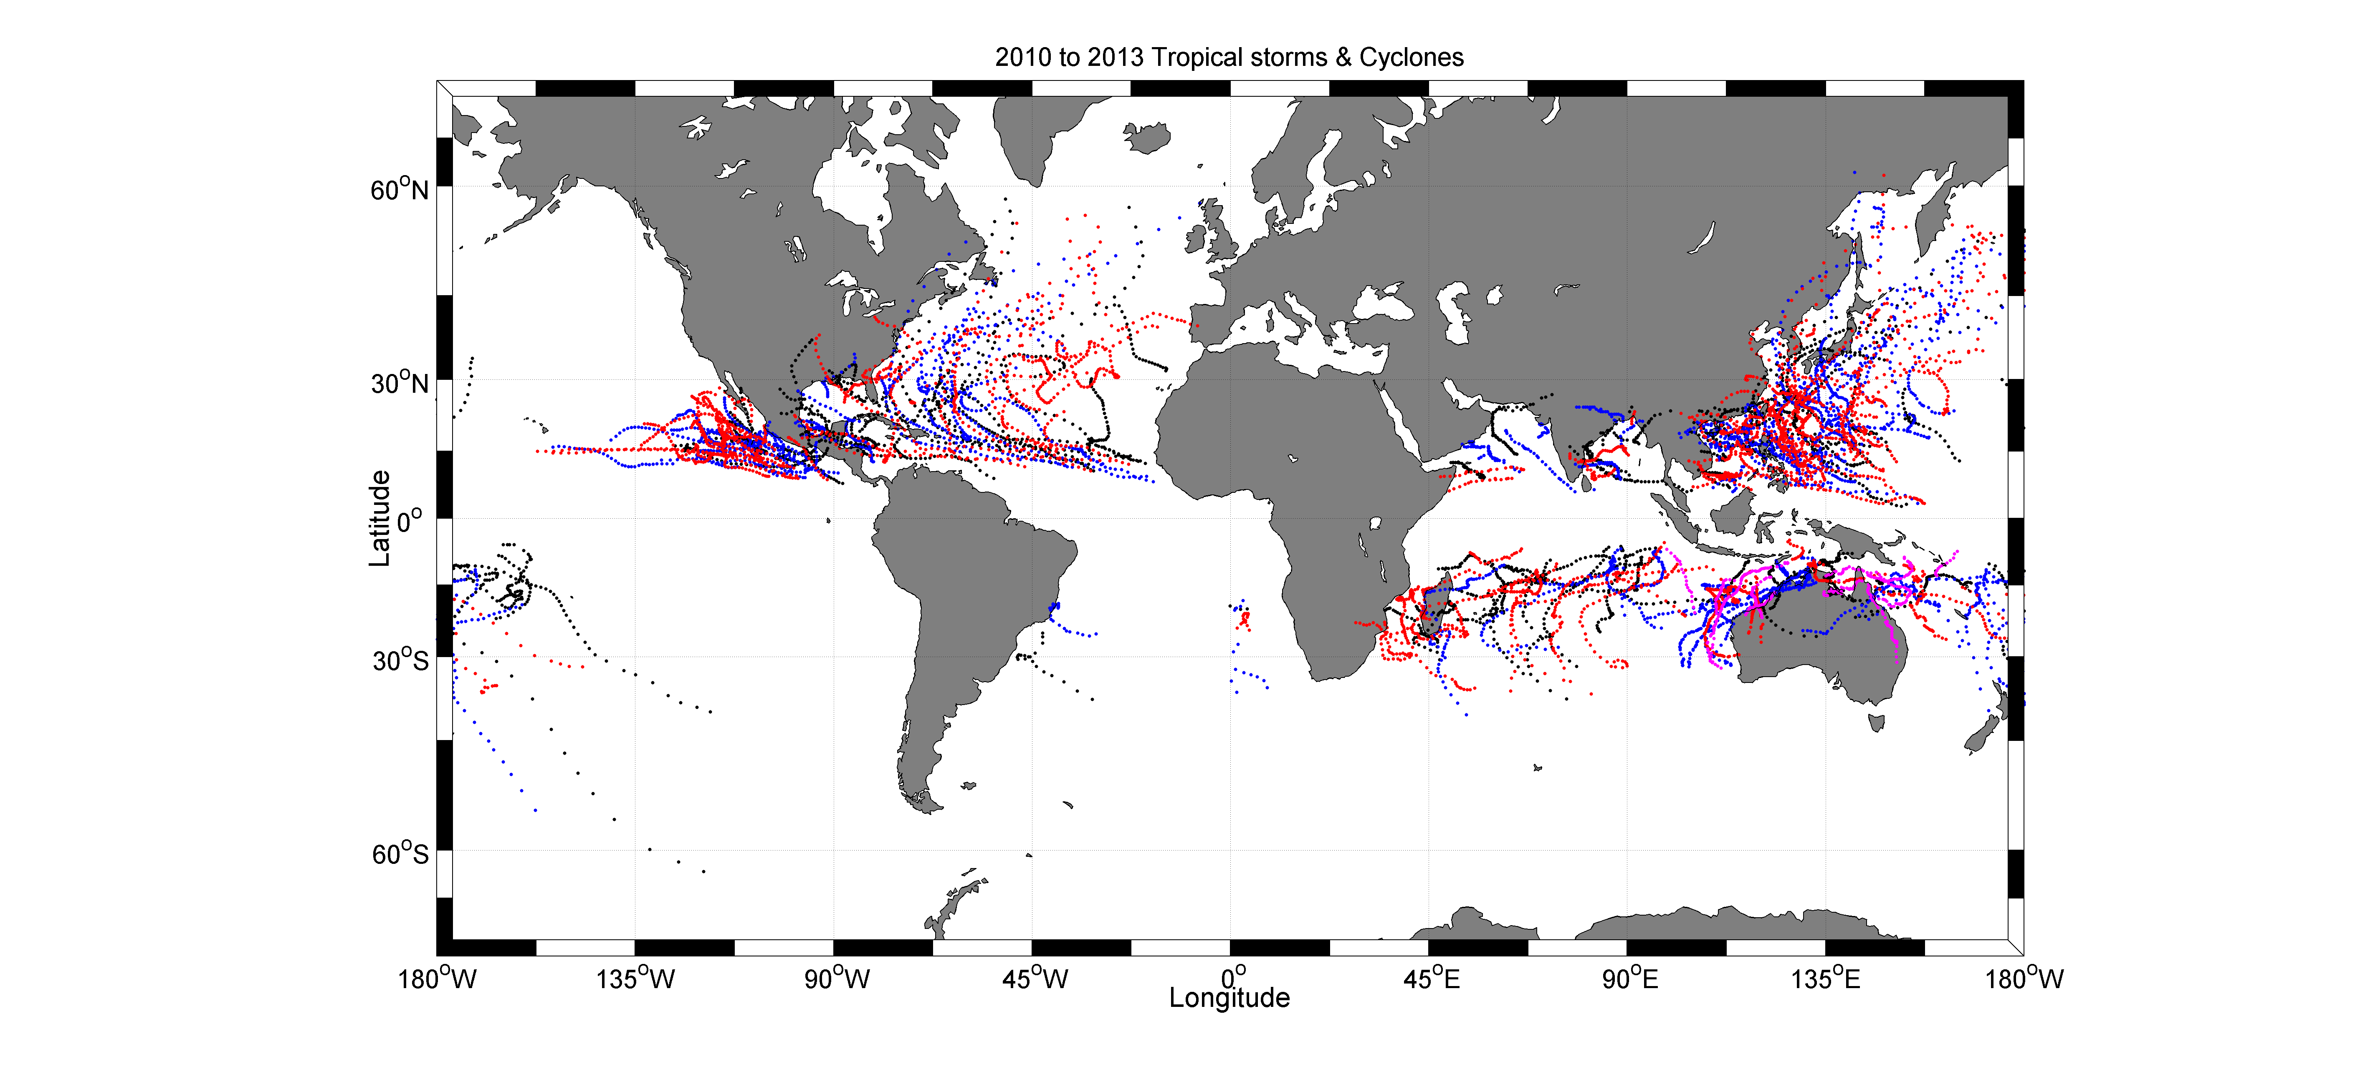

**Figure 25**:Ensemble tracks of tropical storms and Cyclones from 2010 to 2013 available in the IBtracks database. Black: 2010, Blue: 2011, Red:2012 and Magenta: 2013.

Once the usefull SMOS HWS, SMOS-WF and BLEND-HWS detected events will have been classified and once the available auxilliary data will have been collected and pre-processed for these cases, once the GMF and product retrieval algorithms will have been properly tuned, we plan to build-up a dedicated SMOS-Storm catalog (STORM-DB) with a storm user interface provided with the dataset publication on a dedicated web site. Moreover, some data subsets might be available for a given SMOS intercept with a TC while other might be not (e.g. SFMR flight data, H*WIND analysis, SAR products,..). In this context, we plan to classify the collected datasets by Tropical Cyclone events name according to the WMO TC naming protocol (<http://www.wmo.int/pages/prog/www/tcp/Storm-naming.html>) and per identified ETC (detection based on the surface pressure).

For each storm, the data will thus be published on the project webpage following a classification by TC event name, and the usefull data will be made accessible only at the SMOS/TCs intercepts (following the examples for haiyan and ETC shown in §2.4) . Secondary classifications might be used as well as function of the major characteristics of the event detected (e.g. Hurricane intensity, landfalling Hurricane, TC versus ETC, density of the storm track coverage by SMOS data,..). A large number of data within these sets are operationnally produced and distributed by dedicated National center (e.g. H*WIND analysis distributed by HRD, North Atlantic Hurricane Wind Wave forecasting system (NAH) available at http://polar.ncep.noaa.gov/waves/, NHC best track data,...). Restriction in the use of these data for science application is to our knowledge very limited, but as most of them are produced by dedicated operational centers, their might be limitations concerning the rights for web distribution, which will be investigated. The collected datasets per test zone will be made available on a dedicated 'SMOS Storm' web site through an ftp server, accompagnied with a detail user manuel (STORM-UM) for each data set.

In Figure 25, we show the tracks of tropical storms and TC available in the most recent IBtrack database covering 2010-2013, which cover most of the SMOS mission operation period.

|  |  |  |  |  |  |
| --- | --- | --- | --- | --- | --- |
|  | **2010** | **2011** | **2012** | **2013** | All years |
| All Storms  All basins | 89 | 97 | 91 | 68* | 345 |
| Tropical Depression  (0-62km/h 0-34 knts) | 89 | 97 | 91 | 68 | 345 |
| Tropical Storms  (63-117 km/h 35-63 knts) | 73 | 76 | 84 | 34 | 267 |
| Category 1  (118-153 km/h 64-82 knts) | 36 | 36 | 42 | 11 | 125 |
| Category 2  (157-177 km/h 83-95 knts) | 26 | 24 | 28 | 4 | 82 |
| Category 3  (178-209 km/h 96-113 knts) | 20 | 20 | 16 | 3 | 59 |
| Category 4  (210-240 km/h 114-135 knts) | 11 | 11 | 5 | 4 | 31 |
| Category 5  (>250 km/h >136 kts) | 2 | 0 | 0 | 3 | 5 |

**Table 2**: Number of tropical storm and cyclone events as function of wind intensity encountered along track and as function of the years during the first 4 years of SMOS mission . Note that a single storm can be classified in several catgeories (e.g., as a Tropical Storm when it developed and then as an higher category storm on the Saffir-Simpson scale if it intensified along track). The first row is giving the total number of storms.

As shown in Table 2, their was 345 named tropical storms during the 2010-2013 period with ~36 intense events above Category 4, the spatial distribution of which is shown in Figure 26.

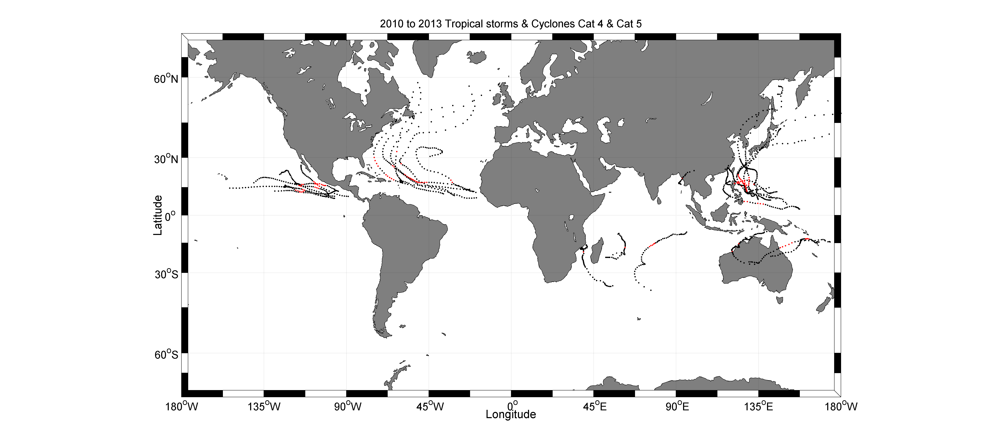

**Figure 26**:Ensemble tracks of Tropical Cyclones from 2010 to 2013 available in the IBtracks database that exceeded Cat 4. Red segment indicate where this happened along each track

Extension to Extra-tropical Storms and severe event warnings:

The present proposal will be mostly focussed on the production of SMOS products for the Tropical cyclones monitoring, which are beyond the most complex phenomenon signing at the ocean surface. Nevertheless, the knowledge gained in analyzing the L-band ocean surface emissivity in such complex geophysical conditions will be very helpfull to extend the proposed study for the cases of extra-tropical storm analysis, for which the highest sea states have been in general observed. In particular, a whitecap maping capability from SMOS in the Southern Oceans, North Atlantic and Pacific can be envisaged in combination with higher frequency radiometer estimates (WindSat, AMSR-2), following the approach proposed by Anguelova and Webster (2006). In the context of air-sea gas transfer studies, it is mandatory to produce regular and global gridded whitecap statistics. In this context, polar orbiting satellites such as SMOS can only provide a sub-sampling of the storm events and of the associated breaking wave statitics. An idea could then be to tune the breaking wave statistics functional estimates from wave model using the SMOS or combined SMOS/AMSR-2 & WIndSat products.

As well, as recently discussed by Sienkiewicz (2010) our ability to detect and emit Hurricane Force warning is increased with :

-Forecaster familiarity

-Data availability

-Improved resolution

-Improved algorithm

As shown, much more severe events where detected during the QuickSCAT era. Even ASCAT “hits” often fail to sample the entire Storm circulation. The loss of useful data for the analyzing the location, intensity, and structure of TCs, particularly those that are not sampled by aircraft reconnaissance is non negligible. Therefore, the wide swath measurements of SMOS and combined SMOS+AMSR2 products will be as well a new source of available data to help detecting and emitting Extra-Tropical storm warnings.

There is no available database of ETC tracks, equivalent to the Ibtracks for TCs. In this task, we shall detect ETCs events based on the extraction of the lowest surface pressure data from NWP, such as ECMWF. Thresholds on both the surface pressure and surface wind speeds shall be use to detect and track such events.

### 2.5.3 WP2300: SMOS-HWS & BLEND-HWS product validation

**2.5.3.1 Validation**

One of the major difficulty with TC wind product development and validation for SMOS will be the low amount of reliable co-localized auxilliary data available (e.g. H*WIND products not available for a given SMOS/hurricane intercept, other missing co-localized datasets such as rain rates, etc..). Therefore, an accumulation of events merging the 2010-2015 hurricane and typhoon seasons will be required both for validation but also to potentially improve some geophysical dependencies.

An overall summary of the validation exercise results will be provided as well in the form of the Impact Assessment Report. For each of the SMOS detected Storms, the SMOS HWS & BLEND-HWS products will be compared in this report with available data from either :

* HRD SFMR data sets, GPS dropwindsondes data and H*WInd analysis,
* GFDL hurricane wind model outputs,
* ECMWF wind products,
* WindSat and AMSR-2 wind products,
* ASCAT and OceanSAT-II scatterometer produtcs,
* JASON 1,2, Cryosat and Envisat/RA altimeter wind products.
* Envisat/ASAR and Radarsat-1 and sentinel-1 products,
* NDBC/buoy and dedicated campaign data

The results will be summarized in graphic forms such as the plots given in Reul et al., 2012 for the IGOR case, showing comparative estimates for the maximum winds, radii of maximum winds and radii at 34, 50 and 64 knots for all available products along each storm track.

Plots showing the cross-section of the different products across the SMOS/TC and ETC's intercepts in the different storm quadrants and along the storm tracks shall be as well provided in this report impact assessment report.

Numerically, an assessment of the ensemble of SMOS high wind products quality with respect the above listed available data will be estimated, using the ensemble data compaisons and local illustrative cases.

Based on the quality indicators derived for the main sources of errors and limitations, products in the SMOS-DB shall be characterized by QI providing the users with a quality index for

-rain impacts,

-sea state biases,

-land & rfi contamination,

-noise level and spatial resolution issues.

For each SMOS/storm incercept a detail analysis of these specific source of errors will be as well provided in the SMOS-DB.

**2.6.2.3 Validation of the whitecap by-products**

To the authors knowledge, measurements of the whitecap coverage and bubble layer properties in Hurricanes are not yet available for the 2010-2013 seasons.



**Figure 27**: Whiteap coverage statitsics derived from WindSat (Anguelova and Webster, 2006)

Bubble properties measurements are conducted at the Station Papa Mooring in the NE Pacific as part of the Canadian SOLAS effort. While severe storms can be encountered there, it is not a path for Hurricane tracks but it is for ETC. If severe storms are detected there with SMOS, it might be however a zone to perform bubble-layer retrieval validation.

In the frame of the international ITOP project (http://www.eol.ucar.edu/projects/itop/), two dozen oceanographic floats were air deployed during the 2010 typhoon season in the western Pacific. Three tropical cyclones were targeted during the period — Typhoons Fanapi and Malakas, and Super Typhoon Megi. The EM-APEX floats measure temperature, salinity, and velocity – the three crucial variables to understand the response of the ocean to typhoons or hurricanes on the scale of the storm. The Lagrangian floats – APL-UW designed Mixed Layer Floats, Second Generation – measure turbulence, waves, and wave breaking, which are key to understanding the rates of mixing in the upper layers of the ocean. The Lagrangian floats also measure oxygen and nitrogen to enable studies of the exchange of these gasses with the atmosphere under the severe wave breaking and bubble conditions in a strong storm. While this database is available on the web and could be used for SMOS whitecap products validation, this area is clearly in a strongly RFI contaminated zone and a dedicated analysis will have to be conducted to investigate if validation can be tempted here.

As a first step, the validation of the SMOS derived SMOS-WF products will therefore have to rely on statistical characterisations. SMOS retrieved Whitecap coverage statistics over the mission lifetime will be provided and compared to available databasesfrom WindSat (see Figure 27).

The validation activities and results elaborated following the tasks in WP2000 will be detailed in a deliverable document (product validation report).

### 2.5.4 Output of WP2000

Summary of the ensemble of output and deliverables of WP2000

|  |  |  |  |  |  |  |  |  |  |  |
| --- | --- | --- | --- | --- | --- | --- | --- | --- | --- | --- |
| **Short Name** | | **Deliverable title and description** | | **Date due** | | **Number of hard copies** | **Electronic delivery** | | | |
| SHWS-DATA | | SMOS High Wind Speed Data set for 2010-215 | | KO+15 | | 0 | | Web | | |
| SHWS-DATA-UM | | User manual for SHWS-DATA | | KO+15 | | 0 | | Web | | |
| BHWS-DATA | | Blended High Wind Speed Data set for 2010-215 | | KO+15 | | 0 | | | | Web |
| BHWS-DATA-UM | | User manual version for BHWS-DATA | | KO+15 | | 0 | | | | Web |
| STORM-DB | SMOS+STORM Evolution Database of TC and ETC events 2010-2015 | | KO+15 | | 0 | | | | Web | | |
| STORM-DB-UM | User Manual for STORM-DB | | KO+15 | | 0 | | | | Web | | |

## 2.6 WP3000: Applications in the domain of Ocean-Atmosphere Interactions

From the historical SMOS archive database of storm products (SMOS-HWS, SMOS-WF and BLEND-HWS), additional geophysical parameters that are key for ocean-atmosphere coupling, such as surface wind stress estimates, radii and areas of wind in excess of 34, 50 and 64 knots, will be derived. Statistical analyses (geographical and seasonal distributions, extreme event distributions,..) for the latter products but also for the SMOS retrieved whitecap and foam properties will then be conducted. The contributions of these new L-band-based products for better estimations of the sea surface drag, air-sea gas-transfer coefficients, swell generation and tracking as well as upper ocean mixed-layer dynamics for ETC and TC cases will be assessed. This objective is a subpart of Task 6 as stated in the SoW.

### 2.6.1 WP3100 Statistical Analysis

In this task, the SMOS-DB will be statistically analysed and compared to other sources of marine surface wind data.

In particular,

-climatologies of global ocean area with wind speed in excess of 34, 50 and 64 knots will be derived for SMOS-HWS, BLEND-HWS and compared to ASCAT and OSCAT equivalent analyses.

- geographical, seasonal and interannual variability of the extreme event distributions will be provided

-correlations with extreme wave event statitics and seasonal surface cooling can be as well envisaged

### 2.6.2 WP3200 Impact on Sea Surface Drag parametrization

Authoritative studies of the drag coefficient as function of wind speeds are given in the below Table and Figures extracted from Holthuijsen et al., 2012.





**Figure 28**: Wind Drag coefficient studies (top) and evolution as function of wind speed (A) and azimuthal hurricane sectors (B) from Holthuijsen et al., 2012.

The CD values from these studies and from Holthuijsen et al., 2012's wind profiles are given in Figure 28 as a function of surface wind speed U10. For high wind speeds (40 < U10 < 50 m/s) data are consistent with previous GPS sonde data [Powell et al., 2003] and balance estimates [Jarosz et al., 2007]. The very low value CD = 0.7 x 10-3 at very high wind speeds (U10 ≈ 60 m/s in Figure 28a) seems inconsistent with white out conditions in which the layer of foam needs to be sustained. However, white out need not be associated with a high drag coefficient. It is sufficient to have a high wind speed. As discussed in Holthuijsen et al., 2012, once the foam is there, it is plausible that the drag goes down, and the momentum transfer needed to maintain the foam depends on the half-life of the foam. If that is large, not much momentum and energy transfer is needed to maintain it. For wind speeds U10 < 40 m/s, Holthuijsen et al., 2012's values are considerably lower than those in the previous studies. At lower wind speeds and therefore in the far field of the hurricanes, the presence of cross swell may have reduced the wind drag. This seems consistent with swell induced reduction of white capping at low wind speeds U10 < 13 m/s [Sugihara et al., 2007; Callaghan et al., 2008b].

CD values sorted over the storm azimuthal sectors, or equivalently, the type of swell, are shown in Figure 28b. For wind speeds U10 < 25 m/s approximately, the values found by Holthuijsen et al., 2012's are considerably lower in the left-front sector (cross swell) than in the right front and rear sectors (following swell or opposing swell) with diminishing differences toward U10 = 30 m/s as in the observations of Black et al. [2007] in Figure 7. Swell therefore seems to reduce the wind drag at these wind speeds and more so under cross swell conditions than under following or opposing swell conditions. The effects of following swell and opposing swell are otherwise uncertain.

To gain insight into the parametrization of the drag coefficient and its azimuthal variability within storm sectors, the BLEND-HWS products combined with wave fields characterization will be used to derive:

- new global climatological maps of surface wind stresses using authoritative studies parametrization of the drag coefficient as function of wind speeds (e.g. fits through Fig 28a plots) and the latter will be compared to lower-wind speed contents data from e.g., scatterometer data. Wind stress, wind divergence and stress curl are indeed key products for the understanding and forecasting of oceanic circulation and earth climate changes. Evaluating the added-value of SMOS-HWS and Blend-HWS in terms of coverage and wind speed range capability sampling compared to more traditional scatterometer based observations will be performed in this task.

-averaged azimuthal variability of the BLEND-HWS and SMOS-WF products will be tentatively derived as function of the storm sectors and as function of the storm wind speed strength and sea state developements. The availability of new high wind speed data in storms from SMOS shall help refining the strong azimuthal anisotropy observations from Holthuijsen et al., 2012. In particular, the physical sources for the very low CD values found at very high wind will be re-analyzed in terms of whitecap and foam properties derived from SMOS observations.

### 2.6.4 WP3300 Impact on Ocean Responses to storms

Besides the potential to help infer improved products, it can also be repeated that a proper characterization of the hurricane-induced mixing to control the evolutions of the temperature and salinity horizontal and vertical fluxes under the maximum wind field and its wake, is still lacking

Intense hurricane-induced mixing and upwelling act to entrain cool thermocline water into the mixed layer, leaving behind a cool wake of SST depressed by a few degrees, which reduces hurricane growth potential (e.g. Price, 1981; Bender and Ginis, 2000; Zhu and Zhang, 2006). Understanding the oceanic and atmospheric processes involved in modulating the SST changes under TC is therefore key for better Hurricane Forecasting. Several studies aimed at characterizing the lagrangian hurricane induced cooling amplitude for an ensemble of storms and analyzed its dependencies with respect the storm strength and translation speeds. . As discussed in Price (1983), an important scaling to characterize the oceanic response to TC is indeed the non-dimensional storm speed V/(2Rf), for V the storm translation speed, R the radius to maximum stress and f, the Coriolis parameter. considering the approach of Llyod and Vecchi (2010), TC are classified as function of V/f only. Llyod and Vecchi (2010) found that for V/f<1, TC induced mixing tend on average to produce greater SST cooling. For tropical cyclones with V/f >1, which have a reduced mean SST response, oceanic feedback is weaker, and atmospheric forcing tends to dominate the SST response.

Based on microwave satellite SST data, sea surface cooling amplitude ΔSSTCW in the wake of storm was determined recently by several authors (Vincent et al. 2012) within a radius of 200 km from the storm tracks, and classified as function of the maximum wind speed along track derived from the best-track data and of the hurricane translation speed, both factors strongly impacting the cooling amplitude in TC wakes. Azimuthal variability of the wind speed field might be a strong source of moidulation of the SST response to TC passages. The lack of reliable high wind speed data in TC hampered the analysis of SST response dependencies on the local wind speed strength. Combining the ensemble of TC SMOS-HWS and BLEND-HWS data, a refined re-analysis of SST anomalies as function of surface winds speed and storm translation speed can be envisaged in the frame of that study. We will restrict our analysis to the SMOS-DB period and perform a statistical evaluation of the sea surface cooling amplitude ΔSSTCW in the wake of storm now based on the nwe wind speed products.

### 2.6.5 Output of WP3000

See §2.7.4. The output of WP3000 will be joined with the output of WP4000 in the form of the Scientific and Impact Assessment Report (SIAR).

|  |  |  |  |  |
| --- | --- | --- | --- | --- |
| **Short Name** | **Deliverable title and description** | **Date due** | **Number of hard copies** | **Electronic delivery** |
| SIAR | SMOS+ STORM EvolutionScientific and Impact Assessment Report(SIAR) in the form of a **collection** of draft peer reviewed journal papers | KO+23 | 0 | Web |

## 2.7 WP4000: Applications in the domain of NWP

Given the historical SMOS archive of storm products (SMOS-HWS and BLEND-HWS), we shall finally demonstrate the utility, performance and impact of SMOS+ STORM Evolution products on TC and ETC prediction systems in the context of maritime applications. To reach this objective we shall first conduct statistical analysis comparing SMOS wind speed data with short range forecasts of 10m winds from the Met Office global model. Assimilation experiments will be further performed to demonstrate the impact of SMOS wind speed observations on Met Office forecasts and analyses. For the tropical storm season, the time period will be chosen to encompass enough storms in order to verify the mean impact on tropical cyclone forecast skill across the whole season. This objective will form the second subpart of Task 6 as stated in the SoW.

The Met Office contribution to this task will cover the following areas

### 2.7.1 WP4100 Statistical analysis

This will primarily be done through comparison of the SMOS wind speed data with short range forecasts of 10m winds from the Met Office global model background to generate observed minus background values (O-B). The SMOS wind speeds and O-B values will also be compared with collocated scatterometer surface wind measurements from the ASCAT, OSCAT and WindSat instruments. This error characterisation will help assess the global performance of SMOS data across a range of meteorological conditions, examine how it compliments existing scatterometer data and to gauge where the data might be useful to numerical weather prediction (NWP). The statistical analysis should ideally cover a period of several months and could span the tropical and extra-tropical seasons mentioned in section 2.

A key part of the analysis will be to refine a suitable quality control (QC) methodology using the supplied QC flags to screen for potentially contaminated observations. Some form of bias correction may also be required prior to use of the data and this will also need to be investigated.

SMOS wind speed data will be processed in the Met Office Observation Processing System (OPS) by employing code originally developed for the quality control of wind speed observations from the Special Sensor Microwave Imager (SSMI). However, some code development will be necessary to adapt the existing system for use with SMOS wind speed data.

### 2.7.2 WP4200 Assimilation

Assimilation experiments will be performed to demonstrate the impact of SMOS wind speed observations on Met Office forecasts and analyses. These should cover two seasons of at least 6 weeks in length, e.g. a North Atlantic / Pacific tropical cyclone season and a winter extra-tropical season. Season-long experiments will help replicate the new observing system's impact were it to be used operationally.

NWP forecast skill is partly controlled by the quality of the analysis (initial state). The Met Office’s data assimilation scheme uses a four-dimensional variational (4D-Var) method. In variational data assimilation schemes the analysis is derived by minimizing a cost function made up of a departure from the background and a departure from the observations. How close the analysis pulls towards the observations is determined by the balance of observation errors and model background errors. If the observation errors are set too low the observations are given too much weight which can have a detrimental impact on the quality of the analysis, too high and the observations are less able to correct errors in the background. An accurate specification of the SMOS observation error will be important to assimilate the data in a near-optimal way.

The impact of assimilating SMOS wind speeds will be demonstrated by diagnosing changes to the mean global atmospheric analyses e.g. low-level wind field, pressure at mean sea level (PMSL), etc. Forecast verification will show how changes in the analysis as a result of assimilating SMOS wind speed observations affect global model forecasts out to lead times of T+144 hours. This will done by comparing various forecast variables (e.g. wind, surface pressure, geopotential height) with quality-controlled observations valid at the same time/location and calculating the difference in root mean square (RMS) error between the trial and control values. An important metric for accessing forecast impact at the Met Office is the so-called global NWP index which is a weighted skill score combining improvements in forecast skill for a subset of atmospheric parameters.

### 2.7.3 WP4300 Tropical cyclone verification

For the tropical storm season, the time period will be chosen to encompass enough storms in order to verify the mean impact on tropical cyclone forecast skill across the whole season. The following measures can be used:

1. Track forecast error
2. Track forecast skill against CLIPER (climatology & persistence)
3. Frequency of superior performance (for track) i.e. summing up the number of forecasts when the trial error was lower
4. Mean change in intensity as measured by 850mb relative vorticity, 10m wind and central pressure.
5. Mean absolute error of 10m wind and central pressure
6. Intensity tendency skill score (ability to correctly predict strengthening or weakening). Separate strengthening and weakening scores can also be calculated.

For track verification the warning centre advisory positions are used. For intensity, the warning centre estimates of central pressure and maximum sustained wind are used. For the latter, the 1-minute average winds are primarily used. The models 10m wind is not exactly equivalent to the estimated 1-minute average wind, but in the context of global models where the predicted wind is nearly always too weak, it is satisfactory to equate the two in order to assess a control against a trial.

Case studies of individual storms can also be performed to compare wind speeds from SMOS, scatterometers and NWP forecasts, and to assess the affect of SMOS wind speed assimilation on the latter.

### 2.7.4 Output of WP3000 & WP4000

The ouptput of WP3000 and WP4000 will be **writen in a a comprehensive Scientific and Impact Assessment Report (SIAR)**, in the form of a collection of peer reviewed journal paper(s) that present all scientific findings and impact assessment results of the project. The major outcomes of the project and their significance and relevance to the SMOS and other relevant communities will be clearly highlighted in the report.

|  |  |  |  |  |
| --- | --- | --- | --- | --- |
| **Short Name** | **Deliverable title and description** | **Date due** | **Number of hard copies** | **Electronic delivery** |
| SIAR | SMOS+ STORM Evolution Scientific and Impact Assessment Report (SIAR) in the form of a **collection** of draft peer reviewed journal papers | KO+23 | 0 | Web |

## 2.8 Study Plan and Logic

According to the first iteration of the activity as described previously, the study will be composed of four top level workpackages:

•WP 1000 : Improve physical understanding, retrieval algorithms and product quality for SMOS High Wind Speed products

•WP 2000 : Generate & Validate SMOS High Wind Speed Product Databases

•WP 3000 : Applications in the Domain of Ocean Atmosphere Interactions

•WP 4000 : Application in the Domain of NWP

Among those top level workpackages, WP 1000, WP 2000, WP3000 and WP 4000 have lower level workpackages. These are:

* WP1100: L-band signal response over the ocean in very high wind speed conditions.
* WP1200 : SMOS GMF development & surface wind speed retrieval algorithm.
* WP1300: Foam properties retrieval from SMOS data
* WP1400: An algorithm/Method for Blended Wind Speed products
* WP2100: Data Set collection and Preprocessing
* WP2200: Building and publishing of a SMOS HWS/BLEND HWS Storm catalog
* WP2300: SMOS-HWS & BLEND-HWS product validation
* WP3100 Statistical Analysis
* WP3200 Impact on Sea Surface Drag parametrization
* WP3300 Impact on Ocean Responses to storms
* WP4100 Statistical Analysis
* WP4200 Assimilation
* WP4300 Tropical Cyclone Verification

Thus, there are 12 final workpackages that will be described in details (WP 1100, WP 1200, WP 1300, WP 1400, WP 2100, WP 2200, WP2300, WP 3100, WP3200, WP3300, WP 4100, WP4200 and WP4300). In addition, there will be a management dedicated workpackage named WPM and a Final task Workpackage WP5000, that will be described in the next section:

WPM: Cross cutting requirements managements and coordination, outreach, communication and promotion (see details in §3.4)

WP5000: Final Workshop and Final Reporting (see details in §3.5)

The study logic flow shart in Figure 29 is based on the identification of tasks workpackage definition given in Appendix A and the chaining between tasks as is described in section 3.7

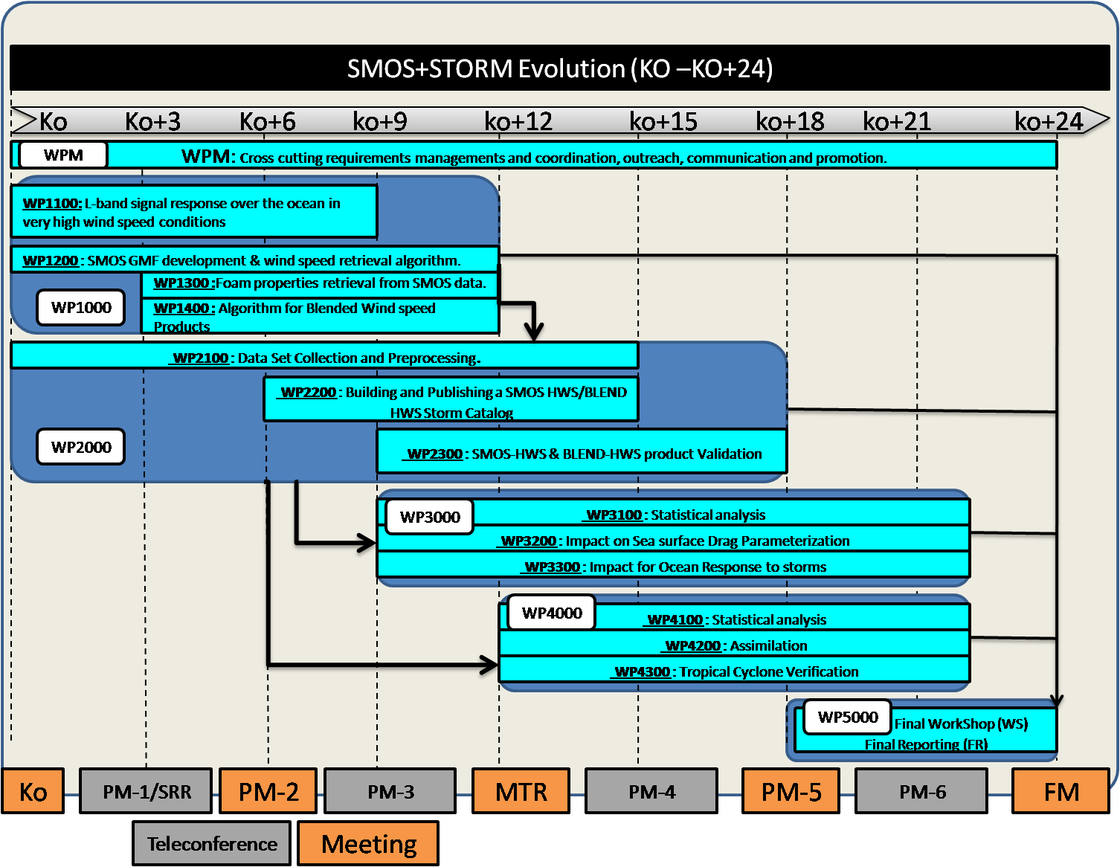

**Figure 29:** study logic plan

## 2.12 References

**Allen, W. T. R. (1983),** Wind and sea: State of sea photographs for the Beaufort Wind Scale 57 pp., Atmos. Environ. Serv., Environ. Can., Ottawa, Ontario.

**Anguelova, M. D., and F. Webster** (2006), Whitecap coverage from satellite measurements: A first step toward modeling the variability of oceanic whitecaps, *J. Geophys. Res.*, 111, C03017, doi:10.1029/2005JC003158.

**Anguelova, M. D** (2008), Complex dielectric constant of sea foam at microwave frequencies *J. Geophys. Res.*, 113, C08001, doi:10.1029/2007JC004212.

**Anguelova, M.D., Bobak, J.P., Asher, W.E., Dowgiallo, D.J., Moat, B.I., Pascal, R.W. and Yelland**, M.J. (2009) Validation of satellite-based estimates of whitecap coverage: Approaches and initial results. In, 16th Conference on air-sea interaction, *Phoenix, USA* *11 - 15 Jan 2009.* Boston MA, USA, American Meteorological Society, 14pp.

**Ardhuin, F., B. Chapron, F. Collard (2009)** Observation of swell dissipation across oceans, Geophy. Res. Letter, 36, L06607, doi:10.1029/2008GL037030.

**Banner, M. L., and D. H. Peregrine** (1993), Wave breaking in deep water, *Annu. Rev. Fluid Mech*., 25, 373–397.

**Bettenhausen M. H., C. K. Smith, R. M. Bevilacqua, N.-Y. Wang, P. W. Gaiser, and S. K.Cox** (2006), "A nonlinear optimization algorithm for WindSat wind vector retrievals," *IEEE* *Transactions on Geoscience and Remote Sensing*, vol. 44, no. 3, pp. 597-608, 2006.

**Black, P. G., R. W. Burpee, N. M. Dorst, and W. L. Adams (1986),** Appearance of the sea surface in tropical cyclones, Weather Forecasting, 1, 102–107.

**Black, P. G., E. A. D'Asaro, W. M. Drennan, J. R. French, P. P. Niiler, T. B. Sanford, E. J. Terrill, E. J. Walsh, and J. A. Zhang (2007),** Air-sea exchange in hurricanes, *Bull. Am. Meteorol. Soc.*, 88, 357–374.

**Boyer, T.P., Antonov, J.I. , Garcia, H.E., Johnson, D.R., Locarnini, R.A., Mishonov, A.V., Pitcher, M.T., Baranova, O.K. and Smolyar, I.V**., (2006), *World Ocean Database 2005*. U.S. Government Printing Office, Washington, D.C., DVD.

**Bender, M. A. and I. Ginis**. 2000. Real-case simulations of hurricane–ocean interaction using a high-resolution coupled model: Effects on hurricane intensity. Mon. Wea. Rev. 128:917–946

**Camps, A., Vall-llossera, M.,  Villarino, R.,   Reul, N.,   Chapron, B.,   Corbella, I.,   Duffo, N.,   Torres, F.,   Miranda, J.J.,   Sabia, R.,   Monerris, A., and R.  Rodriguez, R** (2005),The emissivity of foam-covered water surface at L-band: Theoretical modeling and experimental results from the FROG 2003 field experiment, *IEEE Trans. Geosci. Remote Sens.*, 43, 925–937.

**Carrère, L., Y. Quilfen, F. Mertz, J. Dorandeu, J. Patoux (2008)** Observing and studying extreme low pressure events with altimetry. Sensors 9, 1306-1329, doi:10.3390/s90301306.

**Chao, Y., L. Burroughs and H. Tolman**, (2003) Wave Forecasting for the western North Atlantic and Adjacent Waters. *Technical Procedures Bulletin* No. 495, National weather Service, NOAA, U.S. Department of Commerce.

**Chao, Y. Y. and H. L. Tolman** (2001), Specification of Hurricane Wind Fields for Ocean Wave Prediction. Ocean Wave Measurement and Analysis, San Francisco, CA, B.L. Edge and J. M. Hemsley, Eds., ASCE, 671-679.

**Collard, F., F. Ardhuin, and B. Chapron (2009),** Monitoring and analysis of ocean swell fields from space: New methods for routine observations , J. Geophys. Res. , 114 , C07023, doi:10.1029/2008JC005215.

**Delpey, M. T., F. Ardhuin, F. Collard, and B. Chapron (2010),** Space-time structure of long ocean swell fields, J. Geophys. Res., 115, C12037, doi:10.1029/2009JC005885.

**Donlon, C. J., M. Martin, J. D. Stark, Jonah Roberts-Jones and Emma Fiedler,** (2011), The Operational Sea Surface Temperature and Sea Ice analysis (OSTIA), *in press, Remote Sensing of the Environment.*

**Donelan, M. A., B. K. Haus, N. Reul, W. J. Plant, M. Stiassnie, and H. C. Graber**, 2004: On the limiting aerodynamic roughness of the ocean in very strong winds. Geophys. Res. Lett., 31.L18306, doi:10.1029/2004GL019460.

**Dombrovskiy, L. A., and V. Y. Raizer** (1992), Microwave model of a two-phase medium at the ocean surface, Izvestiya, Atmospheric and Oceanic Physics, 28, 650-656.

**D'Asaro E., and C. McNeil** (2007), Air-sea gas exchange at extreme wind speeds measured by autonomous oceanographic floats, *Journal of Marine Systems*, Volume 66, Issues 1-4, 5th International Symposium on Gas Transfer at Water Surfaces - Pages 92-109, ISSN 0924-7963, DOI: 10.1016/j.jmarsys.2006.06.007.

**Dvorak, V. F., 1984: Tropical cyclone intensity analysis using satellite data. NOAA Tech. Memo. NESDIS-11, 47 pp.**

**Elachi, C., T. W. Thompson, and D. King** (1977), Ocean wave patterns under Hurricane Gloria: Observations with an airborne synthetic aperture radar, Science, 98, 609-610.

**J. Font, A. Camps, A. Borges, M. Martín-Neira, J. Boutin, N. Reul, Y. H. Kerr, A. Hahne, and S. Mecklenburg** (2010), SMOS: The Challenging Sea Surface Salinity Measurement from Space, *Proceedings of the IEEE* , vol 98, 5,649-665.

**Gloersen, P. and F. T. Barath** (1977), Scanning multichannel microwave radiometer for Nimbus-G and Seasat-A. *IEEE Journal of Ocean Engineering* OE-2: 172-178.

**Goldenberg, S.B., Landsea, C.W., Mestas-nunez, A.M., and W.M. Gray** (2001), The recent increase in Atlantic hurricane activity: causes and implications: Science, v. 293, p. 474–479.

**Guo, J., L. Tsang, W. Asher, K.-H. Ding, and C.-T. Chen** (2001), Applications of dense media radiative transfer theory for passive microwave remote sensing of foam covered ocean, IEEE Trans.Geosci. and Remote Sens., 39, 1019-1027.

**Hanson, Jeffrey L., Owen M. Phillips**, 1999: Wind Sea Growth and Dissipation in the Open Ocean. J. Phys. Oceanogr., 29, 1633–1648

**Harris, D. L**., 1986: Models for the hurricane wave field. Wave Dynamics and Radio Probing of the Ocean Surface, O. M. Phillips and K. Hasselmann, Eds., Plenum Press, 677–681.

**Hasselmann K., T.P. Barnett, E. Bouws, H. Carlson, D.E. Cartwright, K. Enke, J.A. Ewing, H. Gienapp, D.E. Hasselmann, P. Kruseman, A. Meerburg, P. Mller, D.J. Olbers, K. Richter, W. Sell, and H. Walden** (1973),Measurements of wind-wave growth and swell decay during the Joint North Sea Wave Project (JONSWAP)' Ergnzungsheft zur Deutschen Hydrographischen Zeitschrift Reihe, A(8) (Nr. 12), p.95.

**Hilburn K. A. and F. J. Wentz** (2008), "Intercalibrated passive microwave rain products from the unified microwave ocean retrieval algorithm (UMORA)," *Journal of Applied* *Meteorology and Climatology*, vol. 47, pp. 778-794

**Holt, B., and F. I. Gonzalez** (1986), SIR-B Observations of Dominant Ocean Waves Near Hurricane Josephine, J. Geophys. Res., 91(C7), 8595–8598, doi:10.1029/JC091iC07p08595.

**Hock, T. F., and J. L. Franklin**, 1999: The NCAR GPS dropwindsonde. Bull. Amer. Meteor. Soc., 80, 407–420.

**Katsaros, K. et al**., 2000: Wind fields from SAR: Could they improve our understanding

of storm dynamics? *Johns Hopkins APL Technical Digest*, **21,** No. 1., 86-93.

**Kerr Y. H., P. Waldteufel, J-P. Wigneron, F. Cabot, J. Boutin, M-J. Escorihuela, N. Reul, C. Gruhier, S. Juglea, J. Font, S. Delwart, M. Drinkwater, A. Hahne, M. Martín-Neira, and S. Mecklenburg** (2010) The SMOS mission: new tool for monitoring key elements of the global water cycle, *Proceedings of the IEEE*, vol 98, 5, 666-687.

**Kunkee, D. B., and A. J. Gasiewski** (1997), Simulation of passive microwave wind direction signatures over the ocean using an asymmetric-wave geometrical optics model, Radio Sci., 32, 59-78.

**Kleiss, J. M., W. K. Melville, J. R. Lasswell, P. Matusov, and E. Terrill,** (2004)Breaking waves in hurricanesIsabel and Fabian. Preprints, *26th Conf. on Hurricanes**and Tropical Meteorology,* Miami Beach, FL,Amer. Meteor. Soc., CD-ROM, 3A.1.

**Mecklenburg S., N. Wright, C. Bouzinac and S. Delwart** (2009), Getting down to business - SMOS operations and products, *ESA Bulletin*, **137**, 25-30.

**Meissner, T, FJ Wentz**, (2009), Wind vector retrievals under rain with passive satellite microwave radiometers, *IEEE Transactions on Geoscience and Remote Sensing*, 47, 3065-3083, doi:10.1109/TGRS.2009.2027012.

**Melville, W. K**. (1996), The role of surface-wave breaking in air-sea interaction. *Annu. Rev. Fluid Mech.*, 28**,** 279–321

**Miller, B. I**., 1958: The three-dimensional wind structure around a tropical cyclone. National Hurricane Research Project Rep. 15, U. S. Weather Bureau, 41 pp.

**Monahan, E.** (1971).,Oceanic whitecaps, J. Phys. Oceanogr., 1, 139.

**Monahan, E., and I. G. O’Muircheartaigh** (1980),Optimal power-law description of oceanic whitecap coverage dependence onwind speed, J. Phys. Oceanogr., 10, 2094–2099.

**Norberg, W., J. Conaway, D. B. Ross, and T. Wilheit** (1971), Measurements of microwave emission from a foam-covered, wind-driven sea, *J. Atmos. Sci*., 429– 435.

**Padmanabhan, S.,   Reising, S.C.,   Asher, W.E.,   Rose, L.A. and   P.W. Gaiser** (2006),  Effects of foam on ocean surface microwave emission inferred from radiometric observations of reproducible breaking waves, *IEEE Trans. Geosci. Remote Sen*., vol. 44, no. 3, pp. 569-583.

**Pielke R. A., Jr. and C. W. Landsea** (1999), La Niña, El Niño, and Atlantic Hurricane Damages in the United States, Bull. Amer. Meteor. Soc., 80, 2027-2033.

**Pore, A.,** 1957: Ocean surface waves produced by some recent hurricanes. Mon. Wea. Rev., 85, 385–392.

**Powell, M. D., S. H. Houston, L. R. Amat, and N Morisseau-Leroy**, (1998), The HRD real-time hurricane wind analysis system. *J. Wind Engineer. and Indust. Aerodyn.* 77-78, 53-64.

**Powell, M. D., S. H. Houston, and T. A. Reinhold, 1996:** Hurricane Andrew’s landfall in South Florida. Part I: Standardizing measurements for documentation of surface wind fields. Wea. Forecasting, 11, 304–328.

**Powell, M. D., Eric W. Uhlhorn, Jeffrey D. Kepert.** (2009) Estimating Maximum Surface Winds from Hurricane Reconnaissance Measurements. *Weather and Forecasting* **24**:3, 868-883.

**Quilfen, Y., J. Tournadre, and B. Chapron** (2006) Altimeter dual-frequency observations of surface winds, waves, and rain rate in tropical cyclone Isabel, J. Geophys. Res., 111, C01004, doi:10.1029/2005JC003068.

**Quilfen, Y., C. Prigent, B. Chapron, A. A. Mouche, and N. Houti** (2007) The potential of

QuikSCAT and WindSat observations for the estimation of sea surface wind vector under severe weather conditions, J. Geophys. Res., 112, C09023, doi:10.1029/2007JC004163.

**Quilfen, Y., B. Chapron and J. Tournadre,** (2010), Satellite Microwave Surface Observations in Tropical Cyclones. Mon. Wea. Rev., 138, 421–437. doi: 10.1175/2009MWR3040.1.

**Quilfen, Y., D. Vandemark, B. Chapron, H. Feng, and J. Sienkiewicz** (2011), Estimating gale to hurricane force winds using the satellite altimeter. *J. Atmos. Oceanic Technol., in press.*

**Raizer, V.** (2007), Macroscopic foam-spray models for ocean microwave radiometry, *IEEE Trans. Geosci. Remote Sens*., 45(10), 3138–3144.

**Reul N. (2001) ,"Foam emissivity modeling at L-band',** in “Scientific requirements and impact of space observations of ocean salinity for modelling and climate studies ». ESA contract 14273/00/NL/DC.

**Reul, N., and B. Chapron** (2003), A model of sea-foam thickness distribution for passive microwave remote sensing applications, *J. Geophys. Res*., 108(C10), 3321, doi:10.1029/2003JC001887.

**Reul, N., J. Tenerelli, B. Chapron, D. Vandemark, and Y. Quilfen (2011),** Remote sensing of ocean surface properties beneath hurricanes with the new SMOS L-band radiometer, in preparation.

**Ross, D. B., and V. Cardone** (1974), Observations of oceanic whitecaps and their relation to remote measurements of surface wind speed*, J. Geophys. Res*.,79, 444– 452.

**Rose L.A, W.E. Asher, S.C. Reising, P.W. Gaiser, K.M.,St. Germain, D.J. Dowgiallo, K.A. Horgan, G. Farquharson, and E. J. Knapp,** (2002)., “Radiometric Measurements of the Microwave Emissivity of Foam,” IEEE Trans. Geosci. Remote Sens. 40(12), 2619-2625

**Rosenkranz, P., and D. Staelin** (1972),Microwave emissivity of ocean foam and its effect on nadiral radiometric measurements, J. Geophys. Res., 77, 6528–6538

**Ruf, C.S., Swift, C.T., Tanner, A.B. and Le Vine D.M.**, (1988), Interferometric synthetic aperture microwave radiometry for the remote sensing of the Earth*.* *IEEE Transactions on Geoscience and Remote Sensing,* 26, pp. 597-611.

**Sampson, R. C., and A. J. Schraeder**, (2000) The Automated Tropical Cyclone Forecasting System, version 3.2, *Bull. Amer. Meteor. Soc.,* 81, 1231-1240.

**Sienkiewicz J.**, 2010: Extra-tropical Cyclone Climatology. International Ocean Vector Winds Meeting, Barcelona, 18-20 Mai 2010

**Smith, P. M**. (1988), The emissivity of sea foam at 19 and 37 gHz, IEEE Trans. Geosci. Remote Sens., 26, 541– 547.

**Skou N.** (2003),Faraday rotation and L-band oceanographic measurements, Radio Sci., vol. 38, p. 8059.

**Sharkov A.** (2006), Breaking Ocean Waves, Springer-Praxis books in geophysical science, 278pp.

**Skou N. and D. Hoffman-Bang** (2005)**,** L-band radiometers measuring salinity from space: Atmospheric propagation effects," *IEEE T. Geosci. Remote,* vol. 43, pp. 2210-2217, 2005.

**Soden, Brian J., C S Velden, and Robert E Tuleya, (2001):** The impact of satellite winds on experimental GFDL hurricane model forecasts. Monthly Weather Review, 129(4), 835-852.

**Stogryn, A**. (1972), The emissivity of sea foam at microwave frequencies, *J. Geophys. Res.,* 77, 1658–1666.

**Schulz J. (2001),** "Rain Impact at L-band", “Scientific requirements and impact of space observations of ocean salinity for modelling and climate studies ». ESA contract 14273/00/NL/DC, (2002).

**Schlüssel, P., and H. Luthardt** (1991), Surface wind speeds over the North Sea from Special Sensor Microwave/Imager observations. *J. Geophys. Res.,***96,** 4845–4853

**Shibata A**. (2006) A wind speed retrieval algorithm by combining 6 and 10 GHz data from Advanced Microwave Scanning Radiometer: Wind speed inside hurricanes. *Journal of Oceanography* **62**:3, 351-359

**Uhlhorn, E. W. and P. G. Black (2003)** Verification of Remotely Sensed Sea Surface Winds in Hurricanes*, J. Atm. Ocean. Tech*.,    20,   1,   99-116.

**Uhlhorn, Eric W., Peter G. Black, James L. Franklin, Mark Goodberlet, James Carswell, Alan S. Goldstein (**2007), Hurricane Surface Wind Measurements from an Operational Stepped Frequency Microwave Radiometer. *Mon. Wea. Rev.*, 135, 3070–3085.

**Walsh, E. J. and Coauthors**. 2002. Hurricane directional wave spectrum spatial variation at landfall. J. Phys. Oceanogr. 32:1667–1684

**Webster, W. J., T. T. Wilheit, D. B. Ross, and P. Gloersen** (1976) Spectral characteristics

of the microwave emission from a wind-driven foam covered sea*, J. Geophys. Res*., 81, 3095–3099, 1976.

**Wentz F. J. and R. W. Spencer** (1998), "SSM/I rain retrievals within a unified all-weather ocean algorithm," *Journal of the Atmospheric Sciences*, vol. 55, no. 9, pp. 1613-1627, 1998.

**Wright, C. W. and Coauthors**. 2001. Hurricane directional wave spectrum spatial variation in the open ocean. J. Phys. Oceanogr. 31:2472–2488

**Young, I. R.**, (1988), Parametric hurricane wave prediction model, J. Waterway, Port, Coastal and Ocean Eng., 114, 5,639-652.

**Young, I. R**. (2006), Directional spectra of hurricane wind waves, J Geophys Res, 111, C08020.

**Yueh, S.H., West, R., Wislon W.J., Li, F.K., Njoku, E.G. and Rahmatsamii,Y**., (2001), Error sources and feasibility for microwave remote sensing of ocean surface salinity*. IEEE Transactions on Geoscience and Remote Sensing,* 39, pp. 1049-1060.

**Yueh S.H., S.J. Dinardo, A.G. Fore, F.K. Li** (2010), “Passive and Active L-band Microwave Observations and Modeling of Ocean Surface Winds”, IEEE Trans. Geosci. Remote Sens., vol. 48, no. 8, pp. 3087-3100, Aug. 2010.

**Zine S., J. Boutin 1, J.Font, N. Reul, P.Waldteufel, C.Gabarró, J. Tenerelli, F. Petitcolin, J.-L. Vergely, M. Talone**, (2008) Overview of the SMOS sea surface salinity prototype processor, IEEE Transactions on Geoscience and Remote Sensing, vol 46, 3, doi:10.1109/TGRS.2007.915543.

**Zhang, Weiqing, William Perrie**, (2008) The Influence of Air–Sea Roughness, Sea Spray, and Storm Translation Speed on Waves in North Atlantic Storms. *J. Phys. Oceanogr.*, **38**, 817–839.

## 2.13 Technical Proposal Checklist

Introduction §2.1

Overview of the proposed approach §2.2

Detailed Proposed approach from §2.3 to §2.7

Study Logic §2.8

# Management section

## Introduction

This section constitutes the management proposal from IFREMER to the ESA SoW entitled "SMOS + STORM Evolution" concerning the exploitation of SMOS data for ocean surface remote sensing at high winds with SMOS.

This section includes:

- the presentation of the institute, the industry and the scientific teams (including the identification of the key personnel) that are involved in the project (§.3.2)

- the presentation of the relevant knowledge and experience of the teams in the field of the study

(§.3.3)

- the presentation of the project management and control (§.3.4)

- the presentation of the Work Breakdown Structure (§.3.5)

- the presentation of the deliverables (§.3.6)

- the presentation of the schedule (§.3.7).

## Project organisation

### Objective of the project and knowledge required

The present project has one overall aim which is to ***Demonstrate the performance, utility and impact of SMOS L-band measurements at high wind speeds over the ocean during Tropical and Extra-Tropical storm conditions.***

The seven specific **objectives** to be addressed within the SMOS+ STORM Evolution project are:

1. Improve and consolidate our theoretical understanding of the L-band signal response and physical properties that can be inferred over the ocean during the passage of Tropical Cyclone (TC) and Extra-Tropical Cyclone (ETC) systems.
2. Consolidate, evolve, implement and validate the STSE SMOS+ STORM feasibility project Geophysical Model Function (GMF) and retrieval algorithm for high wind speed conditions.
3. Systematically produce and validate L-band SMOS high wind speed products with uncertainty estimates/flags for ETC and TC conditions over the entire SMOS Mission archive.
4. Develop, implement and validate new blended multi-mission oceanic wind speed products with uncertainty estimates incorporating SMOS+STORM Evolution L-Band measurements at high-wind speeds for TC and ETC events.
5. Generate a global database of TC and ETC events over the ocean surface and characterize each event using diverse Earth Observation and other observations in synergy.
6. Improve our understanding and parameterization ofocean-atmosphere coupling and mixed-layer dynamics for ETC and TC cases.
7. Demonstrate the utility, performance and impact of SMOS+ STORM Evolution products on TC and ETC prediction systems in the context of maritime applications.

It requires know-how and experience in the following areas:

o ocean surface passive/active microwave remote sensing,

o SMOS missions technical and scientific specificities,

o Hurricane and sea surface physics at High Wind

o satellite data processing and algorithm developments,

o ocean wind and wave modelling.

o Numerical Weather Forecasting

### Consortium organisation

In order to fulfil the requirements mentioned in the SoW, the proposed consortium is led by IFREMER and supported by OceanDatalab and the UK MetOffice to ensure the compliance with the study objective. IFREMER will act as the Coordinator and will keep the responsibility for technical, managerial and contractual matters. IFREMER's designated Project Coordinator will be the formal interface to/from ESA with respect to this project, providing a single point of contact between the consortium and ESA. For technical matters, IFREMER and OceanDatalab have a strong history of cooperation since several years on the SMOS and Envisat/ASAR projects (belonging to same ESL teams) and will work conjointly on almost all subtasks. Also the project coordinator will have the support of B. Chapron for the technical matters as well as an IFREMER contract officer for administrative and contractual matters.

The consortium is deeply involved in the fields of remote sensing over ocean surfaces, wave modelisation, scientific algorithms and processing line developments for SMOS mission (Level 1 to Level 3 products), as well as ocean surface remote sensing in the particular context of High wind speeds. In particular IFREMER led the SMOS+STORM feasability study and host the CATDS center, the french CNES/IFREMER/CESBIO ground segment for level 3 products. UK Metoffice is obviously a leading european institute in the matter of weather forecast.

The core team is structured with the following organisation:

**-IFREMER (France)** is responsible for the management of the project and will be involved in all technical tasks of the project

**-OceanDataLab (France)** will participate in WP100, WP1400, WP2100, WP2200, WP2300, WP3100, WP3200, WP3300 and WP5000 of the project.

-**UK/Metoffice (UK)** will participate to WP4000 and WP5000.

IFREMER

Prime contractor

SOLAB

External Expertise

ESA/ESTEC

Customer

OCEANDATALAB

Second contractor

METOFFICE

Third contractor

OCEANDATALAB

**WPM**

**WP1200,WP1400**

**WP2100,WP2200, WP2300**

**WP3100,WP3200, WP3300**

**WP5000**

Figure 1: Global project organisation

**IFREMER**

**WPM**

**WP1100,WP1200,WP1300,WP1400,**

**WP2100,WP2200,WP2300**

**WP3100,WP3200,WP3300**

**WP4000**

**WP5000**

Reporting

**ESA/ESTEC**

Deliveries

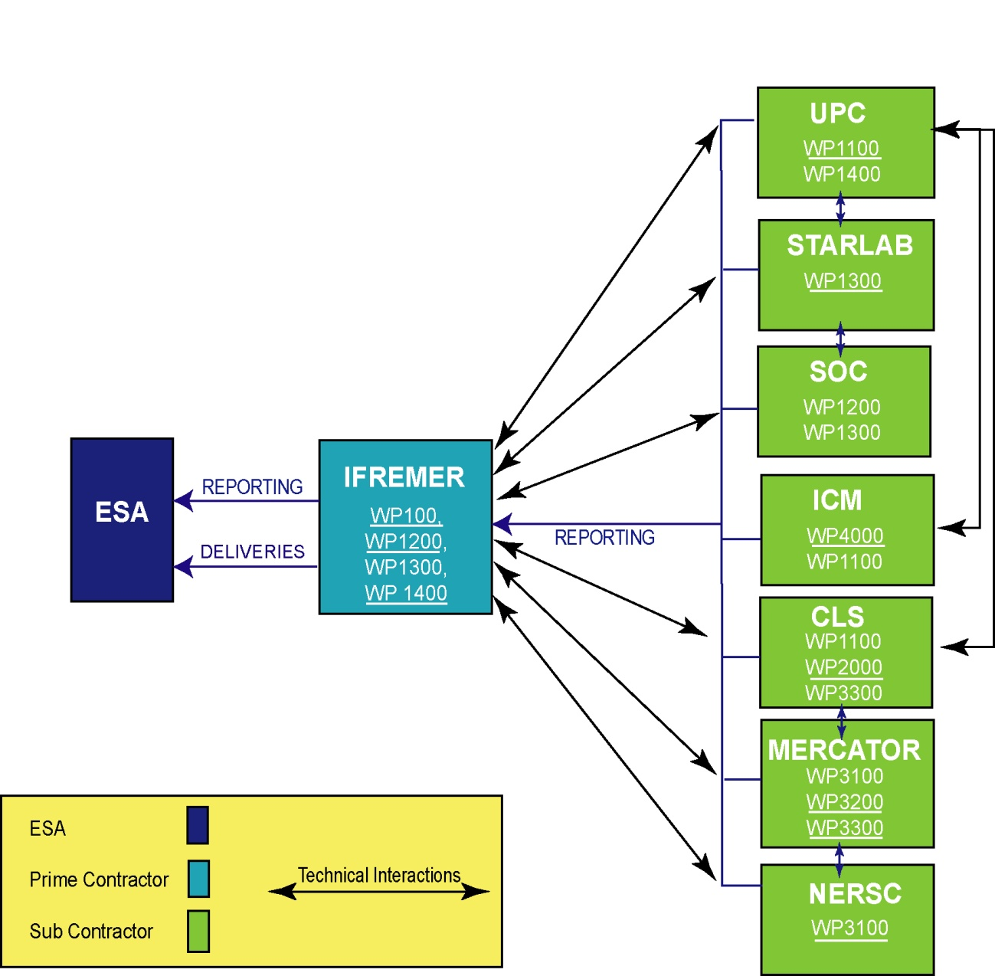

Reporting

UK METOFFICE

**WPM**

**WP4100,WP4200**

**WP4300**

**WP5000**

Figure 2: Task repartition of the project. Underlines indicates the WP manager

### Project team

It includes the following positions:

-Project Manager:

o **Dr Nicolas Reul** will be the project manager. He is responsible for the management and execution of the work to be performed and for the coordination and control of the work within the consortium. He will report directly to ESA to ensure that all contractual obligations are complied with, within the budget and according to the time schedule.

-Quality assurance team:

o **Dr Bertrand Chapron** is head of the department of Spatial Oceanography at IFREMER and is therefore manager of the quality for his department.

- Study team:

**o** **IFREMER**

**• Dr Nicolas REUL**

**• Dr Bertrand CHAPRON**

**• Dr Yves QUILFEN**

**• Jean François PIOLLE**

**o OCEANDATALAB**

**• Dr Fabrice COLLARD**

* **Gilles Guitton**

**o UK METOFFICE**

* **Dr Peter Francis**
* **Dr James Cotton**

In addition, both Ifremer and Oceandatalab will conduct non-contractual collaborations for this project with external experts and collegues from Satellite Oceanography LABoratory SOLAB (http://solab.rshu.ru/en/) in the field of AMSR2 algorithm (Elizaveta Zabolotskikh), drag coefficients and air-sea interaction processes at high winds (Vladimir Kudryavtsev).

### Key People

|  |  |  |
| --- | --- | --- |
| **Name** | **Company/Scientific entity** | **Position in the project** |
| **Nicolas REUL**  **Bertrand CHAPRON**  **Yves QUILFEN**  **Jean François Piolle**  **Fabrice Collard**  **Gilles Guitton**  **Peter Francis**  **James Cotton**  **Elizaveta Zabolotskikh**  **Vladimir Kudryavtsev** | **IFREMER**  **IFREMER**  **IFREMER**  **IFREMER**  **OceanDataLab**  **OceanDataLab**  **UK/MetOffice**  **UK/MetOffice**  **Solab**  **Solab** | **Project Manager & scientist**  **Scientist expert**  **Scientist expert**  **Scientific engineer**  **Scientific expert**  **Scientific expert**  **Scientific expert**  **Scientific expert**  **External Scientific expert**  **External Scientific expert** |

## Background and experience of the companies/laboratories

As explained in the previous paragraphs, the project team is composed of personnel from IFREMER, and CLS. Together, these companies and laboratories have all relevant know-how and experience necessary to successfully carry out the project. The relevant background and experience of the companies/laboratories are detailed in the following paragraphs. A general presentation of theses companies can be found in Appendix B.

### IFREMER

Address: IFREMER

Laboratoire d’Océanographie Spatiale (LOS)

Centre de Brest

Technopole de Brest-Iroise

B.P. 70

29280 Plouzané, France

Phone: +(33) 2 9822 4410; Fax: +(33) 2 9822 4533 ;

e-mail : [nreul@ifremer.fr](mailto:nreul@ifremer.fr)

Created in 1991, the Département d'Océanographie Physique et Spatiale (DOPS) located at IFREMER (Institut Francais de Recherche et d'Exploitation de la MER) in Brest, integrates a scientific team and the CERSAT (Centre for Archiving and Processing of ERS data).

CERSAT is a node of the ESA ground segment for the ERS-1 and ERS-2 Earth observation satellites, performing off-line processing of the ERS-1 and ERS-2 "low-bit rate" Sensors: : the Radar Altimeter, Scatterometer, Microwave sounder and SAR in wave mode. These data, available either on CDROM or exabyte, are distributed to the scientific community worldwide. CERSAT has then evolved towards a multi-mission data centre for archiving, processing and validating data from spaceborne sensors (such as altimeters, scatterometers, radiometers, SAR,...). It is intended for the oceanographic community, making available homogeneous time series of value-added data relevant to the sea surface state (wind fields, fluxes, waves or sea-ice). IFREMER/DOPS is thus the European distributor of the scatterometer data of the NSCAT and QuikSCAT. IFREMER/DOPS also uses data from the Special Microwave Imager SSM/I, and has access to these data via the NASA WETNET program. Based on our experience on model tuning and validation studies for the ERS-1 and 2 scatterometers, NSCAT and SeaWinds validation activities and geophysical application, the tools available in our lab will be adapted rapidly to work with WindSAT data as soon as calibrated brightness temperatures are available. Among these tools, we have a co-location capability of satellite to satellite and satellite to buoys data ( US, TOGA, PIRATA and Europeans buoy arrays ). We plan using SeaWinds on QuikSCAT and/or ADEOS II and buoy data for wind speed and direction but also existing altimeters as TOPEX, ERS or readily available ones as JASON and that of Envisat for wind speed, but also for rain flagging and possible second order effects as sea state. We thus foreseen to extend these services in the future to SEAWINDS and WINDSAT on ADEOSII and ASCAT on METOP (2003). We aim to provide the scientific community with long homogeneous series processed from the different sensors. We have already generated a Wind Atlas from all ERS1-ERS2-NSCAT data as well as a Sea Ice characterization Atlas for the same period. These datasets are regularly updated with the new ERS2 data and will be extended using future sensors. We also provide the scientific community with collocated datasets (data from different sensors for the same period and area) which facilitate the cross-calibration of these sensors.

The scientific team of the department is also strongly involved in algorithm development, calibration and validation work and data processing for SAR in WAve Mode, Radar Altimeter, microwave radiometer such as the SMOS (Soil Moisture and Ocean Salinity) satellite and Wind Scatterometer. IFREMER has established a reputation of one of the leading European centre in the field of air-sea interaction and ocean remote sensing. IFREMER has an outstanding competence in scatterometer, altimeter, radiometer and SAR analysis of surface wind and waves. In particular the LOS host the CATDS, the french Level 3 ground segment for SMOS data.

The Laboratory research program for the next years will be mainly centered on the 3 following axes:

1) Ocean-Atmosphere flux

2) Sea Ices

3) Sea salinity measurement from space

Others researches are conducted on:

· Synthetic Aperture Radar

· Global Positioning System

· Effect of rain on active microwave sensors

· Calibration/validation of satellite sensors

· Ocean circulation and meso-scale processes

· Scatterometry

· Extreme phenomena

· Projects related to Cersat activities: Atlas of satellite derived wind fields, Wind speed measured from SAR ERS-1

The DOPS also participated to several field experiment for air-sea study (FETCH, FASTEX, MAP,..). For some of these experiments, scatterometer (ERS, NSCAT, QuikScat) as well as altimeter (ERS, TOPEX) data have been processed and analysed over the experiment zone.

### OceanDatalab Facilities and Resource

OceanDataLab is a business unit within the IFREMER Space Oceanography Laboratory (LOS) that is working in close collaboration with the scientific teams of LOS. As a spinoff, ODL benefits from the from the LOS facilities for oceanographic research and the key staff have a long history of Earth Observation applications and software development and data processing for national, European Commission and ESA projects.

*EO Data processing facilities*

* ODL benefits from extensive hardware, including a Linux-based cluster Nephele at CERSAT, consisting of over 600 computing nodes connected via Gigabit Ethernet to one another and to 1 Petabyte of network attached storage.
* ODL is connected to the RENATER fibre link, the French Research and University network.
* ODL also has established links with other computing centers, including the SOLAB in St Petersburg or ESA GPOD facilities.
* ODL disseminates data via FTP, and via a variety of web-based services such as oceandatalab.syntool.org hosted in a private external data center with massive data storage. ODL has significant software development capabilities, with experience ranging from algorithm development, creation and integration of processing systems, data archival / metadata creation, data distribution to web development (including interactive web portals).
* For applications development and testing, ODL use IDL, Matlab and Python. For version control ODL uses Mercurial.
* The processing algorithms have been created (some externally) in many languages, meaning ODL has undertaken a significant amount of integration work and consequently has a lot of expertise in this area.
* ODL uses JIRA for information and issue management. Software change control uses Mercurial (ODL has also used CVS, SVN, and git).

### Metoffice Facilities and Resource

The Met Office runs global and regional operational NWP weather forecasts and climate model simulations from its headquarters in Exeter, U.K. To facilitate this, an IBM Power-7 supercomputer currently provides the compute power for running the models until 2015, and a new high performance computer system is expected to replace the current IBM and become operational during 2015. In addition to the supercomputers, there is a network of Linux compute servers, and all staff additionally have a Linux or Windows PC on their desktop.

   The majority of Met Office technical systems are run under the Linux operating system, with Fortran-90 as the main programming language which will be used for the majority of the code development in this project. Graphics packages, such as IDL and Python, are used for research and development within the Met Office, and this project will use these packages for most of the plotting tasks.  
  
To receive observations from around the globe in near real time, and to send out products to users, there is an advanced network system in place to provide the connectivity to the outside world. Satellite data from platforms such as MSG and Metop are received at the local antenna farm on the same site as the headquarters building, and then processed on PCs and powerful Linux compute servers. Other observations come via dedicated links to space agencies, National Meteorological Services, etc. Large numbers of observational datasets used for weather and climate research are archived at the Met Office.

## WPM: Project Requirements, Management, Promotion & Reporting

The **aim** of this Workpackage will be to manage requirements and coordinate the SMOS+ STORM Evolution project for the duration of the contract.

The standard requirements for Management, Reporting, Meetings and Deliverables (Appendix 2 to the Contract applicable to this project) **will** apply, taking account of the following specific requirements for the present activity, which **will** prevail in case of conflict.

### Management

Ifremer wi**ll** be responsible for identifying the project requirements and constraints derived from this SoW and defining formal milestones that enable the project progress to be controlled with respect to cost, schedule and technical objectives.

A ***project management plan (PMP)* will be provided at KO** based on our proposal and include:

1. A **project directory and mailing list (DIR) by KO+1** including full contact list for each member of the project Consortium identifying clearly the role of all people in the project, their address, telephone, Fax and email address. The DIR will be maintained and updated throughout the project.
2. The **project management approach and methodology** to be used throughout the life cycle of the project,
3. A description of **management disciplines** and approach.
4. A description of the **project organization** (including the work breakdown structure, work package descriptions including task leaders and level of effort per work package),
5. A **Gantt chart with a critical path** identified,
6. A matrix of **staff time versus projected actual hours** to be worked,
7. An overview of **resource allocations and projections**,
8. A travel and meeting plan **including actual proposed dates, actual meeting locations** and a travel budget,
9. A list of deliverables and their **actual date of delivery and the method of delivery**,
10. A **project communications plan** identifying the audience for communication and the approach to communication,
11. A **collaboration plan** that identifies all necessary and desired external collaborations that may benefit the implementation and outcomes of the project. The collaboration plan **shall** include reasonable actions that may be taken to improve external collaboration.
12. A **table of contents for each document deliverable**,
13. A proposed **document review cycle**,
14. An analysis of **risk factors and mitigation strategies**,
15. Any other information relevant to the overall management of the project.

**A full and revised version of PMP plan will be prepared and presented at the KO and MTR meetings.** The PMP **shall** be updated continuously during the project; a revised version **shall** be presented at each progress meeting, where the respective upcoming phase **shall** be considered in more detail.

### Requirements

In addition, within this task we will manage requirements of the SMOS+ STORM Evolution project for the duration of the contract.

* In consultation with Met-Office and other key users (WP4000), we will develop and maintain a SMOS+ STORM **Requirements Baseline (RB)** document. The **aim** of this sub-task is to ensure that the project specification (work and products) is matched to WP3000 & WP4000 user requirements and expectations.
* The RB **will** provide a set of **Numbered Requirements for all activities that are to be addressed by the project** in the following example format:

|  |  |
| --- | --- |
| **STORM-RB-REQ-010: SHWS-DATA uncertainty estimates** | |
| SHWS-DATAshall include an estimate of uncertainty for each measurement. | |
| **Verification Method** | Inspection |

* A summary description of **all data products required by the project**.
* **Requirements for NRT data products shall be fully described and justified in the RB.** A chapter shall be provided describing in detail the specification of data and timeliness requirements required by the project for a NRT demonstration. **Exact data provision requirements for the SMOS ground Segment shall be clearly articulated.**
* Organise a **Systems Requirement Review (SRR) meeting** at PM-1 to verify a common understanding of *SMOS+ STORM Evolution* functional and system requirements between the Contractors and the Agency.
* Write a **SRR Report (SRRR)** that documents the SRR that **shall** be available within 2 weeks of the SRR.

### Communication and outreach

* Starting from the SMOS+ STORM Feasibility project web site (<http://smosstorm.ifremer.fr>) we will revise, evolve, develop and operate the web site as public ***SMOS+ STORM Evolution* project web portal (referred to as WWW)** that will provide a ‘communications and project management’ portal for the project. The web portal **shall** include at least the following pages and management services:
  1. Homepage with a description of the *SMOS+ STORM Evolution project* based on the SoW and our proposal,
  2. A Gantt chart for all project activities,
  3. A list of planned project deliverables,
  4. A calendar of all meetings and events
  5. Contact details of key project staff,
  6. Interfaces to the STORM-DB with appropriate visualisation tools
  7. A project document library that allows on-line access to all project documents in Adobe pdf and/or Microsoft Word format that is cross referenced to the SoW and contract deliverables,
  8. Pages where documents and presentations required and used during project meetings can be downloaded **at least 1 week before the meeting**,
  9. Pages **indicating the project progress against each task and deliverable** listed in this SoW given in percentage complete units,
  10. A means for **public users to provide feedback and comments** to the project team. All user feedback **shall** be communicated immediately to the Agency Technical Officer.
  11. Pages where products and data sets developed during the **project data can be accessed and downloaded** by public users if required,
  12. A secured password protected area where **sensitive project management documents** can be accessed if required,
  13. A set of **relevant links** for the project and other useful resources.
  14. The portal **shall** not duplicate STSE web pages.
  15. Contents of the web site **shall** be submitted to the Agency for approval before being published.
* **Maintain the web portal** for the duration of the project, adding project deliverables as they become available and functionality as required by this SoW and/or user requests.
* **Update the web portal** with short news stories about the activities of the project, progress on each task and deliverable in percentage unitsand any other relevant aspect of the project at least once per month.
* Actively develop and submit (to appropriate international science journals) **scientific peer reviewed papers** based on the results of the *SMOS+ STORM Evolution* project. The Contractor shall pay all costs for publication.
* **Actively promote**(e.g. web stories, animations, etc.) the *SMOS+ STORM Evolution* project results and distribute freely all data, reports and experimental output data to scientific user communities.
* **Present the *SMOS+ STORM Evolution* project and results at relevant international events**, including future ESA meetings and other international symposia during the lifetime of the project.
* **Prepare a glossy (4-8 pages) promotional brochure(BRO)**describing the *SMOS+ STORM Evolution* project and print 100 copies for distribution. The brochure **shall** also be available on the projectweb site in Adobe PDF format and circulated to all email addresses on theprojectDIR.

### Reporting

All document deliverables **shall** be concisely written, containing either original material or references to publicly available resources. Any material reproduced from other sources **will** be clearly marked and properly referenced.

* Any material reproduced from other sources **will** be clearly marked and properly referenced.
* Documents to be reviewed at progress meetings **will** be delivered to ESA in Microsoft Word format **at least one week in advance** of the meeting.
* Only final document versions **will** be delivered to ESA for review (i.e. no intermediate draft documents) unless requested by the Technical Officer.
* Ifremer will revise any documents rejected by ESA and address all problems raised as Review Item Discrepancies (RIDs), and an updated version **will** be delivered to ESA within one month.
* All changes to documents **will** be tracked with the Microsoft Word Track-Changes tool, and written answers to each problem raised **will** be provided.
* Original and updated delivered versions **will** be appropriately numbered with an issue and a version number (*e.g.,* v1.0, v1.1, v1.2, etc.) and clearly marked with distribution privilege and status (*i.e.* DRAFT in review, Authorised and Issued).
* **Two signed copies** of each final accepted document **will** be delivered to ESA in electronic format (ideally electronically signed as locked Adobe PDF files), and also made available on the *SOS* Web portal in Adobe PDF format.

A ***monthly executive progress report (MR )* will** be delivered to ESA and **will** include the following section:

* Executive Summary of progress (200-300 words)
* General project description (200-300 words and should be the only section of the monthly report that does not change)
* The progress on each of the major work-packages including: brief description of progress, description of any difficulties, major events and planned activities for the next reporting period.
* Management activities
* Extract of ADB listing the actions raised, closed and outstanding from the last month
* Status of each deliverable
* Status of each milestone
* Status of travel expenditure vs. planned expenditure
* Risk analysis including planned actions to mitigate each identified risk
* Problem reports
* Reasons for slippage in the schedule, and corrective action taken
* Statistics on accesses and downloads from the SMOS+ STORM Evolutionweb site
* Activities to be carried out in the following month.
* An Actions Database (ADB) to manage actions raised by the project. The ADB **will** contain the following fields: action reference number, meeting reference number (if raised during a meeting), actionee, action description, due date and status.

The monthly executive report **will** be delivered to ESA and to any partners within the project in electronic format via the project web page by the end of each calendar month for the full duration of the contract.

A QuarterlyStatus Report (QSR) of major achievements, activities, problems and planned activities for the following quarter **will** be delivered to ESA on a quarterly basis. The QSR **will** be no more than 1 page of A4.

|  |  |  |  |  |
| --- | --- | --- | --- | --- |
| **Short Name** | **Deliverable title and description** | **Date due** | **Number of hard copies** | **Electronic delivery** |
| DIR | Project Directory | KO+1 and updated continuously throughout the project. | 0 | Web |
| RB | SMON+ STORM Evolution Requirements Baseline | KO+ 2 | 0 | Web |
| SRRR | System Requirements Review Report | KO+ 3 | 0 | Web |
| WWW | Project web portal (Full revised version) | KO+ 6 | 0 | Web |
| BRO | Project Brochure | KO+15 | 200 | Web |
| PMP | Project Management Plan | KO, MTR and updated before every progress meeting | 0 | Web |
| MR | Executive monthly progress reportand Actions database(may be part of the MR) | Monthly, for the full duration of the project | 0 | Web page |
| QSR | Quarterly Status Report | Quarterly, for the full duration of the project | 0 | Web page |

## WP5000: Project Final Workshop, Scientific Roadmap and Project Closeout

The **aim** of this task will be to consolidate and promote the project outcomes at an open scientific workshop and close the project.

**Ifremer**  **will**:

* ***Organise an open invitation SMOS+ STORM Evolution Workshop*** to present and discuss the findings of the project with the scientific community. The meeting shall be widely promoted, advertised and arranged at least 12 months in advance.
* ***Write a Workshop Proceedings(WKP)*** document that provides a reference document for the workshop (this could be in the form of a monograph or an article)
* ***Consolidate all deliverables into a Technical Data Package (TDP)*** that shall be provided to ESA on the project web page. The Contractor shall also provide the TDP to ESA on CD or DVD media.
* **Write a Final Report (FR)** including:
* Introduction
* A complete overview of the project (aims, design, development, implementation, data processing, analysis, and conclusions). This section may be reported in the form of a Scientific Journal Article.
* A description of the SMOS+ STORM Evolution Workshop proceedings and final conclusions. This section may be reported in the form of a Scientific Journal Article.
* A Scientific Roadmap (SR) for future activities that **shall**:

1. Provide a critical analysis of all the feedbacks from scientists and institutions that have accessed SMOS+ STORM Evolution products,
2. Identify potential strategies for integrating the development methods and models into existing large scientific initiatives and operational institutions,
3. Define a scientific development strategy improving the development methods and products,
4. Identify scientific and technical priority areas to be addressed in potential future projects in support of ocean surface salinity.

* Summary and conclusions
* References
* Any other sections required reporting on the work performed and outcomes of the SMOS+ STORM Evolution project.

OutPut

|  |  |  |  |  |
| --- | --- | --- | --- | --- |
| **Short Name** | **Deliverable title and description** | **Date due** | **Number of hard copies** | **Electronic delivery** |
| WKP | SMOS+ STORM Evolution workshopand proceedings | KO+23 | 0 | Web |
| FR | Final Report | KO+24 | 0 | Web |
| TDP | Technical Data Package | KO+24 | 0 | 5 x USB |

## List of Inputs and Deliverables

There will be three types of deliverables :

1. the documentation
2. the
3. the data

### 3.6.1 Inputs

#### 3.6.1 Documentation

* No input documentation is required from the Agency.

#### 3.6.2 Software

- No software is required from the Agency.

#### 3.6.3 Data

* No data is required from the Agency

### 3.6.2 Deliverables

All document deliverables **will** be concisely written, containing either original material or references to publicly available resources. Any material reproduced from other sources **will** be clearly marked and properly referenced.

All deliverables **will** be subject to approval by ESA.

Note that in addition to the deliverables required in the Sow we added a new deliverable which is the ATBD for whitecap properties (WF-ATBD output of task WP1300).

|  |  |  |  |  |  |
| --- | --- | --- | --- | --- | --- |
| **Short Name** | **Deliverable title and description** | **Date due** | | **Number of hard copies** | **Electronic delivery** |
| DIR | Project Directory | KO+1 and updated continuously throughout the project. | 0 | | Web |
| RB | SMOS+ STORM Evolution Requirements Baseline | KO+ 2 | 0 | | Web |
| SRRR | System Requirements Review Report | KO+ 3 | 0 | | Web |
| WWW | Project web portal (Full revised version) | KO+ 6 | 0 | | Web |
| BRO | Project Brochure | KO+15 | 200 | | Web |
| TR-1 | Technical Note-1 (> 50 pages that may take the form of a Peer Reviewed Journal Article(s)) | KO+9 | 0 | | Web |
| SHWS-ATBD | SMOS-HWS combined ATBD/IODD/DPM | KO+12 | 0 | | Web |
| WF-ATBD | SMOS-WF combined ATBD/IODD/DPM | KO+12 | 0 | | Web |
| BHWS-ATBD | BLEND-HWS combined ATBD/IODD/DPM | KO+12 | 0 | | Web |
| SHWS-DATA | SMOS High Wind Speed Data set for 2010-2015 | KO+15 | 0 | | Web |
| SHWS-DATA-UM | User manual for SHWS-DATA | KO+18 | 0 | | Web |
| BHWS-DATA | Blended High Wind Speed Data set for 2010-215 | KO+15 | 0 | | Web |
| BHWS-DATA-UM | User manual version for BHWS-DATA | KO+18 | 0 | | Web |
| STORM-DB | SMOS+STORM Evolution Database of TC and ETC events 2010-2015 | KO+18 | 0 | | Web |
| STORM-DB-UM | User Manual for STORM-DB | KO+18 | 0 | | Web |
| SIAR | *SMOS+ STORM Evolution* Scientific and Impact Assessment Report (SIAR) in the form of a **collection** of draft peer reviewed journal papers. | KO+23 | 0 | | Web |
| WKP | SMOS+ STORM Evolution workshop and proceedings | KO+23 | 0 | | Web |
| FR | Final Report | KO+24 | 0 | | Web |
| TDP | Technical Data Package | KO+24 | 0 | | 5 x USB |
| PMP | Project Management Plan | KO, MTR and updated before every progress meeting | 0 | | Web |
| MR | Executive monthly progress report | Monthly, for the full duration of the project | 0 | | Web page |
| QSR | Quarterly Status Report | Quarterly, for the full duration of the project | 0 | | Web page |

## Schedule

**Duration**

The duration of the project will not exceed 24 months from Kick-Off to the Final Review

**Milestones**

The following milestones will apply to this project:

* KO: Kick-Off
* KO+3: PM-1/SRR
* KO+6: PM-2
* KO+9: PM-3
* KO+12:Mid Term Review
* KO+15: PM-4

* KO+18: PM-5
* KO+21: PM-6
* KO+24 Final Review

## Meetings

Regular progress meetings will be held alternately at ESA and at the premises of Ifremer or UKmetoffice organisation, and will normally last two full days. The KO meeting and the Final Presentation (KO+24) will take place at ESA. Choice of date, venue and agenda will be subject to approval by ESA. Some progress meetings may be held in conjunction with the annual User Consultation Meetings as appropriate. The use of video- and tele-conferencing will be regular (*e.g.,* via WebEx) for interim progress meetings.

Ifremer will circulate a draft agenda and meeting logistical information at least two weeks in advance of the meeting.

* Ifremer will be responsible for all meeting organization activities including:
* Video/tele conferences,
* Drafting and circulating the agenda,
* Publication of the announcement,
* Registration of participants,
* Administrative and logistical support during the meeting and
* Any other activity necessary to hold and conduct the meeting unless agreed otherwise with the Technical Officer.

Announcements and agendas will be subject to approval by the Agency Technical Officer prior to issue.

Ifremer will provide electronic versions of all handouts, brochures and deliverable reports relevant to the meeting for each progress meeting at least one week in advance of the meeting on theproject web portal.

All material required to conduct the meeting will be accessible by all participants of the meeting (Agency and non Agency staff).

Ifremer will ensure all actions raised during the meetings are promptly recorded in the Actions Database.

Ifremer will provide electronic versions of all presentations given at meetings on a dedicated meetings section of theprojectWeb Portal no later than **one week after** each meeting.

Ifremer will draft the minutes of meeting. Ideally minutes will be finalized and signed during the meeting. However, if this is not possible, then draft minutes willbe circulated electronically no later than 3 daysafter the meeting for comment and modification. All parties shall then sign the final issue of the minutes. The final version of the minutes will contain meeting participant signatures and be issued in PDF format.

The meeting foressen in the frame of the project are given in the following table:

|  |  |  |  |  |
| --- | --- | --- | --- | --- |
| **ID** | **Date** | **Venue** | **Purpose** | **Deliverables under review** |
| KO | KO | Ifremer Brest | Kick off meeting | PMP |
| PM-1/SRR | KO+3 | Teleconference | Progress meeting-1 and System Requirements Review | PMP, RB, DIR |
| PM-2 | KO+6 | Ifremer Toulon | Progress meeting 2 | PMP, WWW |
| PM-3 | KO+9 | Teleconference | Progress meeting 3 | PMP, TN-1, SHWS-ATBD, BHWS-ATBD |
| MTR | KO+12 | ESTEC | Mid Term Review | All deliverables to date |
| PM-4 | KO+15 | Teleconference | Progress meeting 4 | PMP, BRO |
| PM-5 | KO+18 | UK/Metoffice | Progress meeting 5 | PMP, SHWS-DATA, SHWS-DATA-UM, BHWS-DATA, BHWS-DATA-UM, STORM-DB, STORM-DB-UM |
| PM-6 | KO+21 | Teleconference | Progress meeting 6 | PMP, Draft SIAR |
| FM | KO+24 | ESTEC | Workshop and Final meeting | SIAR, TDP, FR |
| CONF | Various | Teleconference | Tele/video conferences as required. | As required |

Travel and subsistence plan for these meetings can be found in Appendix E.

# Administrative and Contractual section

## Introduction

IFREMER is prime contractor of this study.performed with UK METOFFICE and OceanDatalab as partners.

## Prime contractor

**Company Name:** IFREMER(French Research Institute for Exploitation of the Sea**)**

**Adress**: 155, rue Jean-Jacques Rousseau  
92138 Issy-les-Moulineaux Cedex  
Tel. (33) 01 46 48 21 00  
Fax (33) 01 46 48 21 21  
Web site: <http://www.ifremer.fr>

**Represented by:** F. Jack–President and Chief Executive Officer

## Correspondence

### Correspondence toward the Prime Contractor

All correspondence to the Prime Contractor shall be addressed to:

Nicolas Reul

IFREMER, Toulon Center

Laboratoire d’Océanographie Spatiale (LOS)

Centre Méditerranée - Zone Portuaire

de Brégaillon -CS20 330 -

83507 La Seyne-sur-Mer Cedex

Tel:(33)-04-94-30-44-86

Fax:(33)-04-94-30-49-40

email:nreul@ifremer.fr

For technical, contractual, administrative or financial matters to:

Mr Nicolas REUL (e-mail : [nreul@ifremer.fr](mailto:nreul@ifremer.fr)) with copies to

* Bertrand CHAPRON (e-mail: [bchapron@ifremer.fr](mailto:bchapron@ifremer.fr))
* Janick VOURC'H (e-mail: <Janick.Vourch@ifremer.fr>)

Gestionnaire Financière

IFREMER  
ZI Pointe du Diable

CS 10070

29280 PLOUZANE

Tel : 02 98 22 43 16 Fax : 02.98.22.45.33

* And Ronan CAOUDAL (e-mail : [Ronan.Caoudal@ifremer.fr](mailto:Ronan.Caoudal@ifremer.fr))

For management and technical matters to:

Mr Nicolas REUL (e-mail : [nreul@ifremer.fr](mailto:nreul@ifremer.fr))

with copies to Bertrand CHAPRON (e-mail: [bchapron@ifremer.fr](mailto:bchapron@ifremer.fr))

### Correspondence toward the Agency

IFREMER has noted that all correspondence for the Agency will be addressed to :

**EUROPEAN SPACE AGENCY**

**ESTEC**

For technical matters, contractual and administrative matters (with exceptions of invoices)**.**

# Financial section

## Price

To carry out the work as described in the technical proposal (chapter 3), we quote a price which accounts to **249938** Euros. The distribution between the partners is shown below.

The prices are Firm Fixed Price (FFP). Prices are binding in Euro and are based on 2014 economic

conditions. No escalation will be considered for the period in which the work is scheduled to be performed.

The following PSS forms are supplied in Appendix E:

•  Travel plan

•  PSS-A1 (for each company) gives the general pricing elements of the company;

•  PSS-A2 (for each company) gives he breakdown of the price with all rates applied;

•  PSS-A8 (for each company) shows the summary per work packages;

## Price summary and geographic distribution

The overall work to be carried out under this activity will be performed by personnel from IFREMER – France, and its partners OCEANDATALAB– France and UKMetOffice UK. The price per company and for the total is summarised by the following table :

|  |  |  |  |
| --- | --- | --- | --- |
| **Country** | **Company** | **Total (Euros)** | **Total (%)** |
| France | IFREMER | 99938 | 40 |
| France | OCEANDATALAB | 90 000 | 36 |
| UK | UKMETOFFICE | 60 000 | 24 |
|  | *Total Price* | 249938 | 100 % |

## Milestone Payment plan and conditions

IFREMER proposes the following milestone payment plan (as per the draft contract) for all the participants

### IFREMER

|  |  |  |  |
| --- | --- | --- | --- |
| **Milestone description** | **Perc** | **Scheduled date** | **Amount (euros)** |
| Kick off Meeting | 30% | T0 | 29981,4 |
| MTR | 30% | T0+12 | 29981,4 |
| Final Meeting | 40% | T0+24 | 39975,2 |

### OCEANDATALAB

|  |  |  |  |
| --- | --- | --- | --- |
| **Milestone description** | **Perc** | **Scheduled date** | **Amount** |
| Kick off Meeting | 30% | T0 | 27000 |
| MTR | 30% | T0+12 | 27000 |
| Final Meeting | 40% | T0+24 | 36000 |

### 5.3.3 UK- METOFFICE

|  |  |  |  |
| --- | --- | --- | --- |
| **Milestone description** | **Perc** | **Scheduled date** | **Amount** |
| Kick off Meeting | 30% | T0 | 18000 |
| MTR | 30% | T0+12 | 18000 |
| Final Meeting | 40% | T0+24 | 24000 |

## Travel and subsistence plan

The project’s travel and subsistence plan is provided in Appendix E (the number of participants is approximate)

# Appendix A: Storm Tracking Tools

#### A.1 Storm tracking at CERSAT

The CERSAT provides coherent and continuous time series of key ocean surface parameters such as multi-mission scatterometer (ERS-1, ERS-2, NSCAT, QuikSCAT, ADEOS-2, METOP/ASCAT) measurements (but also from other sensors such as altimeters or microwave radiometers), delivering over more than 17 years long estimation of wind vectors, wind stress, curl and divergence at global scale but also sea-ice edge and type discrimination over both northern and southern poles. Accordingly it has developped a fast and flexible reprocessing capability in order to continuously improve and exploit this massive archive, with minimum manpower cost. Data mining application have been or are currently being conducted over this archive focusing on extreme events.

In particular, all scatterometer orbit files have been scanned in order to extract storm features which are being cross correlated with storm tracks as derived from JRA 25 reanalyses of the 850 Mb vorticity. This results in a unique database of all storm observations since 1991, each individual feature being associated with a single and well identifed storm event when possible (i.e.when seen also by the model). These storm observations are now being associated with available roughness and wind field high resolution images by SAR onboard RADARSAT-1 and ENVISAT, as well as swell observation by SAR wave mode (onboard ERS-1,ERS-2 and ENVISAT) when it can be established they were generated by the same storm event constituting a new and promising source to estimate the intensity of these events and the total energy transmitted to the ocean or resulting exchange at air/sea interface. We plan to include in this scope new sources of data such as altimeter and SMOS in order to build the most exhaustive catalog of storm observations.

All the extracted features, together with their respective descriptive properties, are indexed and registered into an advanced and user-friendly data and knowledge storage and extraction system, NAIAD, developped by Ifremer. A dedicated user interface will be built to allow users to query quickly data with respect to content oriented search criteria (and not only space and time location like in most geospatial information systems), based on the registered knowledge (from the offline data mining mentioned above). In addition, it will make possible to easily cross-reference and intercompare observations with other available sources of data : starting for instance from a single observation of a feature or event, all connected data (at least through space and time proximity, but possibly also through causality, similarity or propagation relationships) can be collected.

#### A.2 Storm detection from scatterometer (StormWatch)

Since the launch of ERS-1 in 1991, sea surface winds have been continuously measured at global scale thanks to an uninterrupted series of missions such as ERS-2; ADEOS-1, QuikSCAT, ADEOS-2 and now METOP-A or OCEANSAT-2. We have scanned the complete archive of some of these missions (currently ERS-1, ERS-2, QuikSCAT and METOP-A) in order to identify and register a complete index of all storm observations. Users with a focus on extreme wind events can now access this extensive catalogue which spans over **more than 17 years**. This work was supported by ESA, as part of the enhancement of the legacy of ERS missions, and achieved in collaboration with CLS Radar division. The StormWatch index consists in an identification of all storm events (including hurricanes, typhoons but also high latitude storms) in the observations collected by the satellite embedded scatterometers since 1991. Here is the list of products and related time coverage parsed to build this index.

|  |  |
| --- | --- |
| **Scatterometer product** | **Time span** |
| ERS-1 25 km-resolution wind vectors (WNF) | 1996-03-19 / 2001-01-17 |
| ERS-2 25 km-resolution wind vectors (WNF) | 1991-08-04 / 1996-06-02 |
| QuikSCAT 25 km-resolution wind vectors (L2B) | 1999-07-19 / 2009- |
| ASCAT 25 km-resolution wind vectors | 2007 / ongoing |

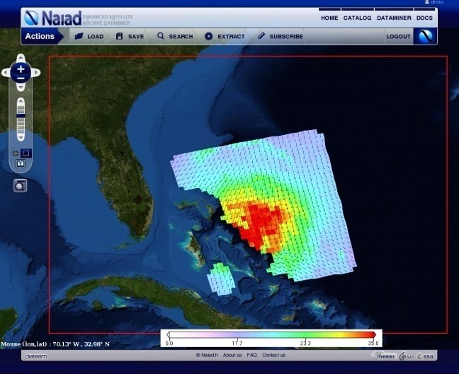

The identification of an extreme event on scatterometer data is primarily based on the high wind velocity detection. However care must be taken since high wind velocities retrieved from scatterometer measurement can come from contamination by rain or the presence of sea ice. Therefore, it is of primary importance to check the quality of the scatterometer measurement and apply the required corrections prior to any detection.

Once the scatterometer winds can be trusted, the first step of the identification of a storm event can be based on a threshold wind speed. However, since we know that scatterometer winds are significantly underestimated in the high wind range, the threshold wind speed cannot be based on the actual Hurricane force wind threshold, for instance, that would lead to missing most of the storm events on scatterometers datasets. Therefore, the wind threshold for the identification of storm events on scatterometer datasets can be adjusted to a smaller value determined for instance by the minimum wind speed of the 1% highest quality checked wind speed recorded by a given scatterometer over a period of 1 year. By doing such, the storm event criterium can be considered largely independent on the scatterometer model used in the wind vector retrieval.

Properties characterizing the observed storm feature are then extracted from the swath section, such as :

1. the storm position, set to be the position of the highest wind speed associated with the identified storm event.
2. the extension of the storm event, set as the location where the wind speed decreases continuously from the maximum recorded wind but still remains higher than a minimum threshold wind speed. This threshold is configurable and set by default to 15m/s based on experience.
3. the storm center, estimated as the location where the wind speed is maximum. This convention is in line with the possible use of StormWatch results to initiate tracking of storm generated waves whose main source is the higher wind area of the Storm.
4. the storm intensity, estimated by the total wind power over the detected storm area. The wind power is the square root of the wind speed times the individual wind cell size.
5. the maximum wind speed together with the area where the wind speed is detected above the scatterometer extreme wind threshold, considered as the dominant extreme parameters to be extracted together with the maximum wind vorticity

The storm observations are also colocated with numerical model outputs for which similar properties are extracted, and with hurricane tracks and properties delivered by various hurricane centers.

The methodology is now being extended in order to build similar storm catalogs from other sources of data such as various multi-sensor or blended weather/satellite wind fields, in order to assess and intercompare the sensibility and the response of different sources of data to this algorithm.

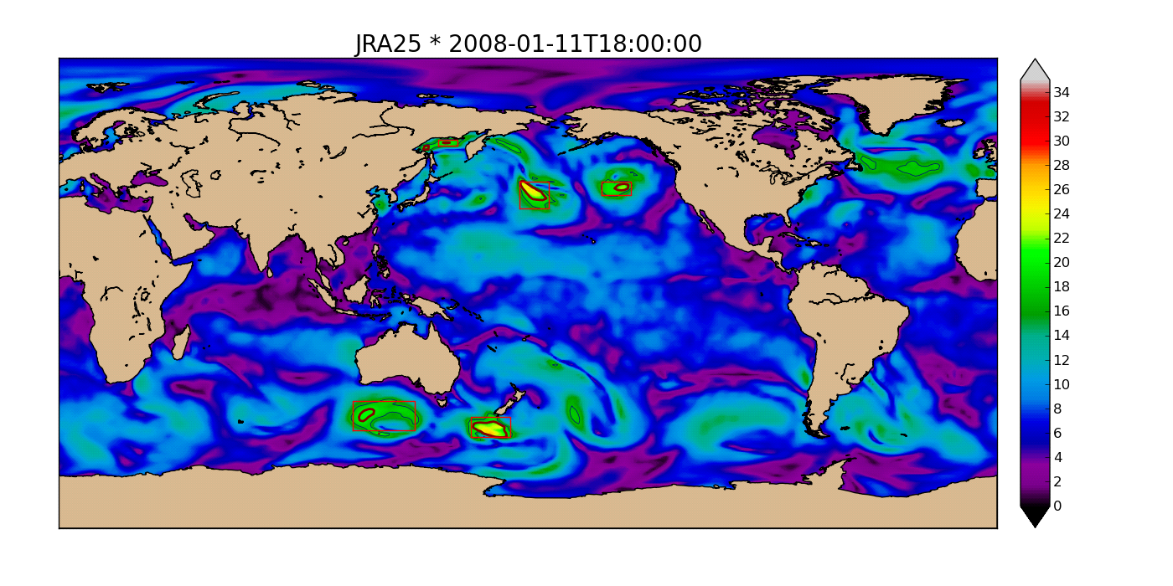**Figure13:**Detection of storm features on JRA25 reanalysis. Bold line (20 m/s) is the detection threshold beyond which a storm event is retrieved, thin line (17 m/s) is used to bound the storm extent.

#### A.3 Storm tracking

The method described above provides scattered observations from various events that need to be related to each other. For the same single event, there can be several days between two consecutive observations by the same sensor and therefore it is not possible from observation only to assess if two observations belongs to the same event or not, and subsequently relate each observation to unique and correctly identified events, which is required if one wants to establish some classification of these events based on observation.

One way to achieve this is to run a storm detection and tracking algorithm on weather model outputs, the high temporal resolution of these models allowing to efficiently track events along time. We choosed for that purpose the JRA25 reanalysis ([http://www.jreap.org](http://www.jreap.org/)) from the Japan Meteorological Agency which :

1. covers all the scatterometer era (1991-today) and beyond, and therefore can be used consistently over our complete period of focus
2. is continuously updated and therefore allows to update our catalog, including the SMOS era, using the same methodology and with the same source of data
3. assimilates all scatterometer data and therefore ensures that the retrieved storm tracks should be consistent with the scatterometer storm observations, easing the matching of the two sources
4. is arguably performing better wind retrieval in the tropical areas compared to other analyses such as ECMWF.

The applied methodology (Hodges, 94) relies on image segmentation and feature extraction over a sequences of 850 Mb vorticity fields from the JRA25 model, applied to the unit sphere. Further filtering and combination with other parameters (such as surface wind speed) is then applied to select only the most significant events in terms of intensity, duration and extent.

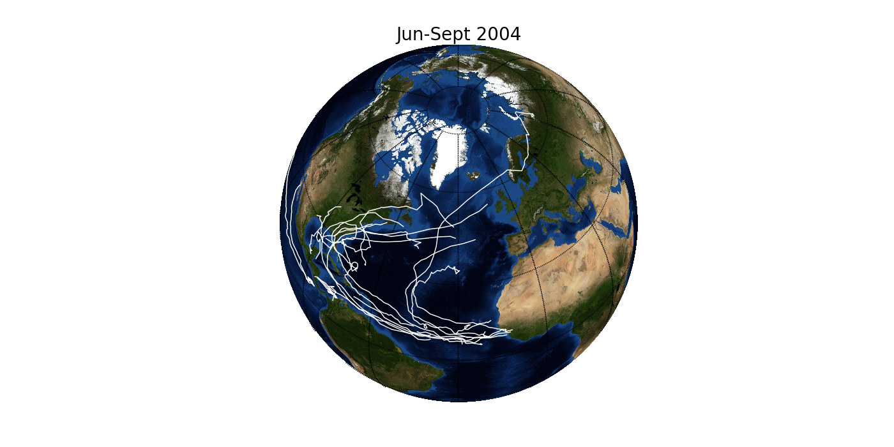**Figure 14:** Tracks of tropical storms in North-Atlantic, June to September 2004, from JRA25 reanalysis.

19 years (1991-2009) of JRA25 model were processed, at global scale, providing an equivalent time series of tropical and extra-tropical storm tracks over the whole globe to be matched with the available sources of observation.

#### A.4 Swell tracking

The identification and lifetime history restitution of storm events can also be retrieved from indirect and remote observation several thousands of km away of the swells generated by these storms. Directional spectra of the swell is available from SAR wave mode observations (ERS from 1991 to 2011, Envisat from 2002-ongoing) based on an inversion algorithm developed by Ifremer. Retro-propagation of the observed swells can then be applied using a simple backward propagation model and the storm generation area identified from the focus point (Ifremer and CLS) . Same type of methodology can be applied to remote in situ buoy measurements (e.g., NDBC/NODC, Meds, CDIP, EPPE,... ), to backpropagate waves and estimate wave parameters at the location of the storms.



**Figure 15**: Measurement derived great-circle trajectories for swell systems with periods between 16 s and 17 s. The selective space-time match-filter is built according to the selected group velocity and estimated swell propagation directions from ENVISAT SAR measurements at locations indicated by blues circles. Size of the circles is related to the computed significant wave height. Trajectories are color-coded as a funtion of the propagation time since the swell generation at the source locate with the red circle.

The swell properties provides a unique insight on the storm history and intensity, stressing out the need to uniquely identify each event and relate each observation from whatever source to these events to offer the most extensive view of each event and allow for proper characterization and classification.

Association between storm events and swells is an ongoing effort and a product spanning over the full Envisat era (from ASAR wave mode data) will be soon available. Meanwhile a reprocessing of the ERS-1 and ERS-2 is ongoing at Ifremer to provide a new time series of swell observations using the same inversion method than for Envisat. It will then be investigated if data quality and sampling is sufficient to apply a swell generation area detection algorithm as for Envisat.

#### A.5 Cross-source storm database

As mentioned in the above section, building a proper database for storm characterization and classification relies on interconnecting the observations from various sources (offering a different view of the same phenomenon) and relating them to unique events. The rationale applied to achieve this task is :

1. to first identify the most exhaustive catalog of events, which is done as shown before :
2. identifying and tracking features from high temporal frequency model outputs
3. identifying from observations events that may not have been captured by numerical models (StormWatch)
4. then building of the cross-source database is performed both ways :
5. from observation to event : detecting events from analysis of satellite imagery or in situ data (StormWatch, swell tracking from SAR or buoys, …) and finding the event in the catalog matching each observation
6. from event to observation : extracting in the satellite or in situ data all the observations intersecting the path of the storm events documented in the catalog, which is the fastest way to populate a cross-sensor database once we have enough confidence in the storm catalog
7. for each storm observation by any source, metadata are extracted to document it (time and geolocation, file and subset into file, properties on the seen event computed from the data) and stored into a database, allowing then fast identification and access to the relevant data

The current storm database includes :

1. tracks from JRA25 reanalysis
2. wind speed from ERS-1 & ERS-2 scatterometer
3. wind speed from QuikSCAT scatterometer
4. wind speed from ASCAT onboard METOP-A scatterometer
5. swell from Envisat/ASAR
6. SAR images from Envisat and Radarsat-1 (over tropical storms only)

It is planned to extend this database to available altimeters, scatterometers (SeaWinds, OceanSAT-2, NSCAT) and radiometers (WindSat, AMSRE, SMOS).

#### A.6 Storm user interface

A web user interface developed in Flex is currently being implemented, allowing for discovery, visualization and extraction of the available observations in the storm database. It will include :

1. multi-criteria search of specific events in the storm catalog
2. step-by-step visualization of the tracks
3. display of all connected observations (from satellite, model or buoys) and related metadata

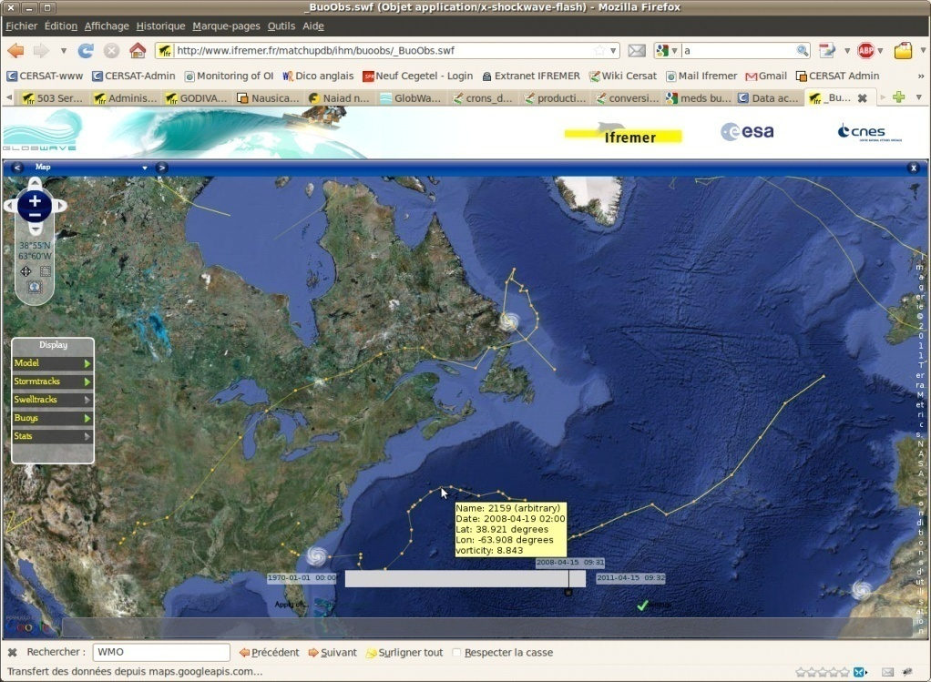

Figure 16: extraction of the data on the flex web CERSAT interface.

This tool will be included in the dedicated SMOS STORM web site.

# Appendix B: Work Package description

|  |  |
| --- | --- |
| Work Package Description | WPM |
| Title**: Requirements Management, Coordination, Outreach, Communication and Promotion.** | |
| Manager: IFREMER  Participants:OceanDataLab,UKMETOFFICE | |
| Start event: Kick-off meeting Start date: T0  End event: Final meeting Duration : T0+24 months  Workload: 220 hours | |
| **Ojectives** | |
| Ensure the fulfilmeent of all project objectives, the outreach, communication and promotion of the project results with the required performances and in time | |
| **Inputs** | |
| * SoW * Contractor Proposal * SMP | |
| **Activities** | |
|  | |
| **Outputs**   |  |  |  |  |  | | --- | --- | --- | --- | --- | | **Short Name** | **Deliverable title and description** | **Date due** | **Number of hard copies** | **Electronic delivery** | | DIR | Project Directory | KO+1 and updated continuously throughout the project. | 0 | Web | | RB | SMON+ STORM Evolution Requirements Baseline | KO+ 2 | 0 | Web | | SRRR | System Requirements Review Report | KO+ 3 | 0 | Web | | WWW | Project web portal (Full revised version) | KO+ 6 | 0 | Web | | BRO | Project Brochure | KO+15 | 200 | Web | | PMP | Project Management Plan | KO, MTR and updated before every progress meeting | 0 | Web | | MR | Executive monthly progress reportand Actions database(may be part of the MR) | Monthly, for the full duration of the project | 0 | Web page | | QSR | Quarterly Status Report | Quarterly, for the full duration of the project | 0 | Web page | | |
|  | |

|  |  |
| --- | --- |
| Work Package Description | WP 1100 |
| * Title: **L-band signal response over the ocean in very high wind speed conditions.** | |
| Manager: IFREMER  Participants: | |
| Start event: Kick-Off meeting Start date: T0  End event: PM3 Duration : 9 months  Workload estimation: 90 h | |
| **Ojectives** | |
| * Building directly from the outcomes and results of the SMOS+ STORM feasibility project, ***conduct fundamental research and development*** to further our knowledge of SMOS L-band signal response and physical properties that can be inferred over the ocean at high very wind speeds associated with TC and ETC events. * ***Improve the extraction of*** L-band emissivity properties at high winds by better exploiting SMOS data multi-angular (incidence, azimuth), multi-spatial resolution and polarization properties and recently improved level 1 characteristics (RFI filtering, stability, solar and galactic aspects etc.). * ***Analyse the impacts*** of rain, sea state, SSS and SST on the observed emissivity changes to better understand asymmetries in the observed SMOS Tb distributions within TC and ETC. In particular:   + Is the increase in the Tb sensitivity to wind speed at hurricane force (>64 knots) purely driven by surface processes or affected by intense rain events?   + Do wave parameters need to be accounted for in the wind speed retrieval?   + Any other aspect relevant to the project activities. * ***Analyze and define which*** physical properties (e.g., foam formation properties, breaking wave statistics) and how they characterize the sea surface at very high wind speeds. Determine how these properties can be inferred from SMOS measurements in very high wind speed conditions. | |
| **Inputs**  **•** All relevant publications and technical reports | |
| **Activities** | |
| • Literature and recent work review | |
| **Outputs** | |
| •   |  |  |  |  |  | | --- | --- | --- | --- | --- | | **Short Name** | **Deliverable title and description** | **Date due** | **Number of hard copies** | **Electronic delivery** | | TR-1 | Technical Report-1 (>50 pages that may take the form of a Peer Reviewed Journal Article(s)) | KO+9 | 0 | Web | | |

|  |  |
| --- | --- |
| Work Package Description | WP 1200 |
| Title: **SMOS GMF development & surface wind speed retrieval algorithm.** | |
| Manager: IFREMER  Participants: OCEANDATALAB | |
| Start event: KO Start date : KO  End event: MTR Duration : KO+12 months  Workload estimation: 630 h | |
| **Ojectives** | |
| Combining the results of the previous tasks, a detailed new "surface wind speed" SMOS-HWS algorithm will then be defined in the form of ATBD/IODD and DPM for L-band satellite High wind speed product. This documents will include:   * An overview description of the background to the algorithm, * A Mathematical description of the algorithm, * A description of all related data sources in an Input/Output Data Description (IODD) Chapter,following the template provided in Appendix-1 of the SoW. Any restrictions in the use of any type of data sets (e.g., proprietary campaign data) willbe communicated to the Agency immediately. * A Detailed Processing Model (DPM) Chapter that can be used to implement the Algorithm. * A separate chapter documenting the scientific justification for specific development choices and trade-offs (including technical considerations justifying the selected methodologies and approach), * The design and specification of output product contents and their format. The use of standards based formats will be considered (e.g., netCDF, CF compliant), * The design and specification of product metadata (based on existing standards) necessary to discover and manipulate data products, * Identification of risks and proposed solutions. | |
| **Inputs** | |
| **•** All relevant publications and technical reports  **• SMOS DB** | |
| **Activities** | |
| • Literature and recent work review  • Multi-sensor co-localisations  GMF derivation & analysis  ATBD writing  Product validation & report | |
| **Outputs**   |  |  |  |  |  |  |  |  |  |  | | --- | --- | --- | --- | --- | --- | --- | --- | --- | --- | | **Short Name** | **Deliverable title and description** | | | **Date due** | | **Number of hard copies** | **Electronic delivery** | | | | TR-1 | Technical Report-1 (>50 pages that may take the form of a Peer Reviewed Journal Article(s)) | | | KO+9 | | 0 | Web | | | | SHWS-ATBD | | SMOS-HWS combined ATBD/IODD/DPM | KO+12 | | 0 | | | Web | | |

|  |  |
| --- | --- |
| Work Package Description | WP 1300 |
| Title: **Foam property retrieval capability from SMOS data** | |
| Manager: IFREMER  Participants: | |
| Start event: PM1 Start date: T0+3 months  End event: Mid Term Meeting Duration : 9 months  Workload: 30 hours | |
| **Ojectives** | |
| * Based on the output of WP1100, an algorithm will be proposed here to retrieve directly foam formation properties : whitecap coverage and foam-layer thickness as a geophysical product instead of wind speed at the surface of TC and ETC from SMOS radio-brightness contrasts in storms. We anticipate the potential retrieval of both whitecap & streak coverage but also of foam-formation layer thicknesses. * Write an ATBD for these products, | |
| **Inputs** | |
| • TR1 | |
| **Activities** | |
| • algo development | |
| **Outputs** | |
| •   |  |  |  |  |  |  |  |  |  |  | | --- | --- | --- | --- | --- | --- | --- | --- | --- | --- | | **Short Name** | **Deliverable title and description** | | | **Date due** | | **Number of hard copies** | **Electronic delivery** | | | | WF-ATBD | | SMOS-WF combined ATBD/IODD/DPM | KO+12 | | 0 | | | Web | | |
| **Excluded tasks** | |
|  | |

|  |  |
| --- | --- |
| Work Package Description | WP 1400 |
| Title: : Merged Multi-mission Wind Speed product Algorithm | |
| Manager: OCEANDATALAB  Participants: IFREMER | |
| Start event: PM1 Start date: T0+3  End event: MTR Duration : 9 months  Workload:520 hours | |
| **Ojectives**  The complementarity of SMOS-HWS products and added-value with scatterometer ones (ASCAT & Oscat) and NWP products (ECMWF & NCEP) will be studied with the aim to produce new blended surface wind speed products including the SMOS high wind speed data. Such capability will be analyzed in detail in this task, blending methodology will be studied with the aim of defining an algorithm to generate such blended wind products.  As a first objective we plan to merge SMOS data and AMSR2 wind speed retrievals and probably further add the WindSat data and the future SMAP sensor ones. For AMSR2 high wind speed retrieval under rain, we will rely on a new methodology currently being developed by *Zabolotskikh et al.*, 2013 | |
|  | |
| **Inputs** | |
| • Summary from the WP1100 & WP1200  SMOS-HWS DB | |
| **Activities** | |
| Analysis of optimal multi-sensor blending methodologies  Writing of an combined ATBD/IODD/DPM | |
| **Outputs** | |
| |  |  |  |  |  |  |  |  |  |  | | --- | --- | --- | --- | --- | --- | --- | --- | --- | --- | | **Short Name** | **Deliverable title and description** | | | **Date due** | | **Number of hard copies** | **Electronic delivery** | | | | BLEND-ATBD | | BLEND-SHWS combined ATBD/IODD/DPM | KO+12 | | 0 | | | Web | | |
| **Excluded tasks** | |
|  | |

|  |  |
| --- | --- |
| Work Package Description | WP 2100 |
| Title: Data Set collection and Preprocessing | |
| Manager:IFREMER  Participants:Ocenadatalab | |
| Start event: KO Start date:T0 months  End event: PM4 Duration :15 months  Workload: 100 hours | |
| **Ojectives**  • , in this task, we shall  (i) detect the usefull events,  (ii) collect the necessary datsets to be used for products developements (WP1200-WP1300) and validation (WP2300) and  (iii) pre-process these data sets so that they can be compared with SMOS observables. | |
|  | |
| **Inputs** | |
| •Ensemble of EO data | |
| **Activities** | |
| • ) detect the usefull events,  (ii) collect the necessary datsets to be used for products developements (WP1200-WP1300) and validation (WP2300) and  (iii) pre-process these data sets so that they can be compared with SMOS observables. | |
| **Outputs** | |
| •   |  |  |  |  |  |  |  | | --- | --- | --- | --- | --- | --- | --- | | **Short Name** | **Deliverable title and description** | **Date due** | **Number of hard copies** | **Electronic delivery** | | | | SHWS-DATA | SMOS High Wind Speed Data set for 2010-215 | KO+15 | 0 | | Web | | | SHWS-DATA-UM | User manual for SHWS-DATA | KO+15 | 0 | | Web | | | BHWS-DATA | Blended High Wind Speed Data set for 2010-215 | KO+15 | 0 | | | Web | | BHWS-DATA-UM | User manual version for BHWS-DATA | KO+15 | 0 | | | Web | | STORM-DB | SMOS+STORM Evolution Database of TC and ETC events 2010-2015 | KO+15 | 0 | | | Web | | | STORM-DB-UM | User Manual for STORM-DB | KO+15 | 0 | | | Web | | | |
| **Excluded tasks** | |
|  | |

|  |  |
| --- | --- |
| Work Package Description | WP 2200 |
| Title: **Building and publishing of a SMOS HWS/BLEND HWS Storm catalog** | |
| Manager: IFREMER  Participants: Ocendatalab | |
| Start event: PM2 Start date: T0+6  End event: PM4 Duration :9 months  Workload: 570 hours | |
| **Ojectives**  • Once the usefull SMOS HWS, SMOS-WF and BLEND-HWS detected events will have been classified and once the available auxilliary data will have been collected and pre-processed for these cases, once the GMF and product retrieval algorithms will have been properly tuned, we plan to build-up a dedicated SMOS-Storm catalog (STORM-DB) with a storm user interface provided with the dataset publication on a dedicated web site. | |
| **Inputs**  All relevant data | |
| **Activities**   * Data Classification * • publication on the project webpage   • redaction of the dataset user manuel | |
| **Outputs** | |
| •   |  |  |  |  |  |  |  | | --- | --- | --- | --- | --- | --- | --- | | **Short Name** | **Deliverable title and description** | **Date due** | **Number of hard copies** | **Electronic delivery** | | | | SHWS-DATA | SMOS High Wind Speed Data set for 2010-215 | KO+15 | 0 | | Web | | | SHWS-DATA-UM | User manual for SHWS-DATA | KO+15 | 0 | | Web | | | BHWS-DATA | Blended High Wind Speed Data set for 2010-215 | KO+15 | 0 | | | Web | | BHWS-DATA-UM | User manual version for BHWS-DATA | KO+15 | 0 | | | Web | | STORM-DB | SMOS+STORM Evolution Database of TC and ETC events 2010-2015 | KO+15 | 0 | | | Web | | | STORM-DB-UM | User Manual for STORM-DB | KO+15 | 0 | | | Web | | | |
| **Excluded tasks** | |

|  |  |
| --- | --- |
| Work Package Description | WP 2300 |
| Title**: SMOS STORM Product validation** | |
| Manager: IFREMER  Participants:Oceandatalab | |
| Start event: PM3 Start date: T0+9 months  End event: PM5 Duration : 9 months  Workload: 246 hours | |
| **Ojectives**  **Validation of SMOS STORM products** | |
| **Inputs**  • All relevant data | |
| **Activities**  • Data Classification & validation  • publication on the project webpage  • redaction of the dataset user manuel | |
| **Outputs** | |
| • The validation activities and results elaborated following the tasks in WP2000 will be detailed in a deliverable document 'product validation report' included into the User manuals.   |  |  |  |  |  |  |  | | --- | --- | --- | --- | --- | --- | --- | | **Short Name** | **Deliverable title and description** | **Date due** | **Number of hard copies** | **Electronic delivery** | | | | SHWS-DATA-UM | User manual for SHWS-DATA | KO+15 | 0 | | Web | | | BHWS-DATA-UM | User manual version for BHWS-DATA | KO+15 | 0 | | | Web | | STORM-DB-UM | User Manual for STORM-DB | KO+15 | 0 | | | Web | | | |
| **Excluded tasks** | |
|  | |

|  |  |
| --- | --- |
| Work Package Description | WP 3100 |
| Title: WP3100 Statistical Analysis | |
| Manager: IFREMER  Participants: OceanDatalab | |
| Start event: PM3 Start date:T0+9 months  End event: KO+23 Duration : 14 months  Workload: 150 hours | |
| **Ojectives**   * In this task, the SMOS-DB will be statistically analysed and compared to other sources of marine surface wind data. * In particular, * -climatologies of global ocean area with wind speed in excess of 34, 50 and 64 knots will be derived for SMOS-HWS, BLEND-HWS and compared to ASCAT and OSCAT equivalent analyses. * - geographical, seasonal and interannual variability of the extreme event distributions will be provided * -correlations with extreme wave event statitics and seasonal surface cooling can be as well envisaged | |
| **Inputs**  • SMOS-DB  • Collected Datasets | |
| **Activities**  Perform statistical and scientific analysis and exploitaton of the SMOS-DB | |
|  | |
| **Outputs** | |
| • Technical note and or paper describing the resukts of the analysis   |  |  |  |  |  | | --- | --- | --- | --- | --- | | **Short Name** | **Deliverable title and description** | **Date due** | **Number of hard copies** | **Electronic delivery** | | SIAR | SMOS+ STORM EvolutionScientific and Impact Assessment Report(SIAR) in the form of a **collection** of draft peer reviewed journal papers | KO+23 | 0 | Web | | |
| **Excluded tasks** | |
|  | |

|  |  |
| --- | --- |
| Work Package Description | WP 3200 |
| Title**: Impact on Drag Parameterization** | |
| Manager: IFREMER  Participants:oceanDataLab | |
| Start event: PM3 Start date:T0+9 months  End event: T0+23 months Duration :14 months  Workload: 147 hours | |
| **Ojectives** | |
| • To gain insight into the parametrization of the drag coefficient and its azimuthal variability within storm sectors | |
| **Inputs** | |
| All relevant data | |
| **Activities** | |
| To gain insight into the parametrization of the drag coefficient and its azimuthal variability within storm sectors, the BLEND-HWS products combined with wave fields characterization will be used to derive:  - new global climatological maps of surface wind stresses using authoritative studies parametrization of the drag coefficient as function of wind speeds (e.g. fits through Fig 28a plots) and the latter will be compared to lower-wind speed contents data from e.g., scatterometer data. Wind stress, wind divergence and stress curl are indeed key products for the understanding and forecasting of oceanic circulation and earth climate changes. Evaluating the added-value of SMOS-HWS and Blend-HWS in terms of coverage and wind speed range capability sampling compared to more traditional scatterometer based observations will be performed in this task.  -averaged azimuthal variability of the BLEND-HWS and SMOS-WF products will be tentatively derived as function of the storm sectors and as function of the storm wind speed strength and sea state developements. The availability of new high wind speed data in storms from SMOS shall help refining the strong azimuthal anisotropy observations from Holthuijsen et al., 2012. In particular, the physical sources for the very low CD values found at very high wind will be re-analyzed in terms of whitecap and foam properties derived from SMOS observations. | |
| **Outputs** | |
| |  |  |  |  |  | | --- | --- | --- | --- | --- | | **Short Name** | **Deliverable title and description** | **Date due** | **Number of hard copies** | **Electronic delivery** | | SIAR | SMOS+ STORM EvolutionScientific and Impact Assessment Report(SIAR) in the form of a **collection** of draft peer reviewed journal papers | KO+23 | 0 | Web | | |
| **Excluded tasks** | |
|  | |

|  |  |
| --- | --- |
| Work Package Description | WP 3300 |
| Title**: Impact on Ocean Responses to storms** | |
| Manager: IFREMER  Participants:oceanDataLab | |
| Start event: PM3 Start date:T0+9 months  End event: T0+23 months Duration :14 months  Workload: 155 hours | |
| **Ojectives** | |
| • Improve statistical evaluation of the sea surface cooling amplitude ΔSSTCW in the wake of storms now based on the new SMOS wind speed products. | |
| **Inputs** | |
| All relevant data | |
| **Activities** | |
| • . Combining the ensemble of TC SMOS-HWS and BLEND-HWS data, a refined re-analysis of SST anomalies as function of surface winds speed and storm translation speed can be envisaged in the frame of that study. We will restrict our analysis to the SMOS-DB period and perform a statistical evaluation of the sea surface cooling amplitude ΔSSTCW in the wake of storm now based on the nwe wind speed products. | |
| **Outputs** | |
| |  |  |  |  |  | | --- | --- | --- | --- | --- | | **Short Name** | **Deliverable title and description** | **Date due** | **Number of hard copies** | **Electronic delivery** | | SIAR | SMOS+ STORM EvolutionScientific and Impact Assessment Report(SIAR) in the form of a **collection** of draft peer reviewed journal papers | KO+23 | 0 | Web | | |
| **Excluded tasks** | |
|  | |

|  |  |
| --- | --- |
| Work Package Description | WP 4100 |
| Title**: Statistical Analysis** | |
| Manager: Metoffice  Participants:Ifremer | |
| Start event: MTR Start date:T0+12 months  End event: T0+23 Duration :11 months  Workload: 100 hours | |
| **Ojectives** | |
| perform comparison of the SMOS wind speed data with short range forecasts of 10m winds from the Met Office global model background to generate observed minus background values (O-B).  A key part of the analysis will be to refine a suitable quality control (QC) methodology using the supplied QC flags to screen for potentially contaminated observations. Some form of bias correction may also be required prior to use of the data and this will also need to be investigated | |
| **Inputs** | |
| SMOS-DB | |
| **Activities** | |
| The SMOS wind speeds and O-B values will also be compared with collocated scatterometer surface wind measurements from the ASCAT, OSCAT and WindSat instruments. This error characterisation will help assess the global performance of SMOS data across a range of meteorological conditions, examine how it compliments existing scatterometer data and to gauge where the data might be useful to numerical weather prediction (NWP). The statistical analysis should ideally cover a period of several months and could span the tropical and extra-tropical seasons mentioned in section 2. | |
| **Outputs** | |
| |  |  |  |  |  | | --- | --- | --- | --- | --- | | **Short Name** | **Deliverable title and description** | **Date due** | **Number of hard copies** | **Electronic delivery** | | SIAR | SMOS+ STORM EvolutionScientific and Impact Assessment Report(SIAR) in the form of a **collection** of draft peer reviewed journal papers | KO+23 | 0 | Web | | |
| **Excluded tasks** | |
|  | |

|  |  |
| --- | --- |
| Work Package Description | WP 4200 |
| Title**: Assimilation** | |
| Manager: Metoffice  Participants:Ifremer | |
| Start event: MTR Start date:T0+12 months  End event: T0+23 Duration :11 months  Workload: 200 hours | |
| **Ojectives** | |
| Assimilation experiments will be performed to demonstrate the impact of SMOS wind speed observations on Met Office forecasts and analyses | |
| **Inputs** | |
| SMOS-DB & WP4100 | |
| **Activities** | |
| The impact of assimilating SMOS wind speeds will be demonstrated by diagnosing changes to the mean global atmospheric analyses e.g. low-level wind field, pressure at mean sea level (PMSL), etc. Forecast verification will show how changes in the analysis as a result of assimilating SMOS wind speed observations affect global model forecasts out to lead times of T+144 hours. This will done by comparing various forecast variables (e.g. wind, surface pressure, geopotential height) with quality-controlled observations valid at the same time/location and calculating the difference in root mean square (RMS) error between the trial and control values. An important metric for accessing forecast impact at the Met Office is the so-called global NWP index which is a weighted skill score combining improvements in forecast skill for a subset of atmospheric parameters | |
| **Outputs** | |
| |  |  |  |  |  | | --- | --- | --- | --- | --- | | **Short Name** | **Deliverable title and description** | **Date due** | **Number of hard copies** | **Electronic delivery** | | SIAR | SMOS+ STORM EvolutionScientific and Impact Assessment Report(SIAR) in the form of a **collection** of draft peer reviewed journal papers | KO+23 | 0 | Web | | |
| **Excluded tasks** | |
|  | |

|  |  |
| --- | --- |
| Work Package Description | WP 4300 |
| Title**: TC verification** | |
| Manager: Metoffice  Participants:Ifremer | |
| Start event: MTR Start date:T0+12 months  End event: T0+23 Duration :11 months  Workload: 120 hours | |
| **Ojectives** | |
| verify the mean impact on tropical cyclone forecast skill across the whole season | |
| **Inputs** | |
| SMOS-DB & WP4100 & WP4200 | |
| **Activities** | |
| The following measures can be used:   1. Track forecast error 2. Track forecast skill against CLIPER (climatology & persistence) 3. Frequency of superior performance (for track) i.e. summing up the number of forecasts when the trial error was lower 4. Mean change in intensity as measured by 850mb relative vorticity, 10m wind and central pressure. 5. Mean absolute error of 10m wind and central pressure 6. Intensity tendency skill score (ability to correctly predict strengthening or weakening). Separate strengthening and weakening scores can also be calculated.   For track verification the warning centre advisory positions are used. For intensity, the warning centre estimates of central pressure and maximum sustained wind are used. For the latter, the 1-minute average winds are primarily used. The models 10m wind is not exactly equivalent to the estimated 1-minute average wind, but in the context of global models where the predicted wind is nearly always too weak, it is satisfactory to equate the two in order to assess a control against a trial.  Case studies of individual storms can also be performed to compare wind speeds from SMOS, scatterometers and NWP forecasts, and to assess the affect of SMOS wind speed assimilation on the latter. | |
| **Outputs** | |
| |  |  |  |  |  | | --- | --- | --- | --- | --- | | **Short Name** | **Deliverable title and description** | **Date due** | **Number of hard copies** | **Electronic delivery** | | SIAR | SMOS+ STORM EvolutionScientific and Impact Assessment Report(SIAR) in the form of a **collection** of draft peer reviewed journal papers | KO+23 | 0 | Web | | |
| **Excluded tasks** | |
|  | |

|  |  |
| --- | --- |
| Work Package Description | WP 5000 |
| Title**: Project Final Workshop, Scientific Roadmap and Project Closeout** | |
| Manager: IFREMER  Participants:OceanDatalab, Metoffice | |
| Start event: PM5 Start date:T0+18 months  End event: Final Meeting Duration :6 months  Workload: 310 hours | |
| **Ojectives** | |
| to consolidate and promote the project outcomes at an open scientific workshop and close the project. | |
| **Inputs** | |
| All relevant documentation | |
| **Activities**   * *Organise an open invitation SMOS+ STORM Evolution Workshop* to present and discuss the findings of the project with the scientific community. The meeting shall be widely promoted, advertised and arranged at least 12 months in advance. * *Write a Workshop Proceedings(WKP)* document that provides a reference document for the workshop (this could be in the form of a monograph or an article) * *Consolidate all deliverables into a Technical Data Package (TDP)* that shall be provided to ESA on the project web page. The Contractor shall also provide the TDP to ESA on CD or DVD media. * Write a Final Report (FR) including: * Introduction * A complete overview of the project (aims, design, development, implementation, data processing, analysis, and conclusions). This section may be reported in the form of a Scientific Journal Article. * A description of the SMOS+ STORM Evolution Workshop proceedings and final conclusions. This section may be reported in the form of a Scientific Journal Article. * A Scientific Roadmap (SR) for future activities that shall:  1. Provide a critical analysis of all the feedbacks from scientists and institutions that have accessed SMOS+ STORM Evolution products, 2. Identify potential strategies for integrating the development methods and models into existing large scientific initiatives and operational institutions, 3. Define a scientific development strategy improving the development methods and products, 4. Identify scientific and technical priority areas to be addressed in potential future projects in support of ocean surface salinity.  * Summary and conclusions * References * Any other sections required reporting on the work performed and outcomes of the SMOS+ STORM Evolution project. | |
|  | |
| **Outputs** | |
| |  |  |  |  |  | | --- | --- | --- | --- | --- | | **Short Name** | **Deliverable title and description** | **Date due** | **Number of hard copies** | **Electronic delivery** | | WKP | SMOS+ STORM Evolution workshopand proceedings | KO+23 | 0 | Web | | FR | Final Report | KO+24 | 0 | Web | | TDP | Technical Data Package | KO+24 | 0 | 5 x USB | | |
| **Excluded tasks** | |
|  | |

# Appendix C: Companies presentations

## IFREMER

IFREMER was created by decree of 5 June 1984, it is the only French organisation with an entirely maritime purpose. It operates under the joint auspices of the Ministries of Education, Research and Technology, Fisheries and Amenities, Transport and Housing.

Being involved in all the marine science and technology fields, IFREMER has the capability of solving different problems with an integrated approach. IFREMER scope of actions can be divided into four main areas, each of them including different topics as described hereunder:

Understanding, assessing, developing and managing the ocean resources :

* Knowledge and exploration of the deep sea
* Contribution to the exploitation of offshore oil
* Understanding ocean circulation (in relation with the global change)
* Sustainable management of fishery resources
* Optimisation and development of aquacultural production

Improving knowledge, protection and restoration methods for marine environment :

* Modelling of coastal zones and ecosystems
* Behaviour of pollutants
* Observation and monitoring of the sea

Production and management of equipment of national interest :

* Heavy equipment for oceanography (oceanographic vessels, underwater vehicles and equipment, testing facilities, telecommunication networks and information systems)
* Helping the socio-economic development of the maritime world :
* Integrated studies on the management of coastal zones
* Assessment and economics of marine resources
* Sea product processing

Moreover, IFREMER undertakes to:

* provide assistance to the government, public authorities and organisations concerned with the scientific, technical or economic research,
* gather, disseminate and enhance national and international oceanographic information,
* contribute to the implementation of international cooperation agreements in the marine field.

## UK-METOFFICE

The Met Office is the UK's National Weather Service. Since its foundation in 1854, it has a long history of weather forecasting, and has also been working in the area of climate change for more than two decades. It employs more than 1,800 staff at 60 locations throughout the world, and delivers weather and climate services to a range of customers: to UK Government; to businesses; to the general public; to armed forces; and to many other organisations.

The Met Office runs global and regional operational NWP weather forecasts and climate model simulations from its Headquarters in Exeter, UK. The global forecast model uses an advanced four-dimensional variational data assimilation system, and already assimilates many sources of satellite data operationally, including microwave and infrared radiances, Atmospheric Motion Vectors, GNSS Radio Occultation and Zenith Total Delay data and scatterometer ocean wind vectors. A team of around 30 scientists work in the Met Office's Satellite Applications group, continually improving the use of existing satellite data and enabling the use of new sources of data.

## Ocean Data Lab

 OceanDataLab (ODL) is a R&D PME working in close collaboration with IFREMER Space Oceanography Laboratory with the principal objective to develop and push forward the synergetic use of multisensory, model and in-situ data to provide a full picture of any given oceanic or atmospheric phenomena or variables of interest. The Developments at OceanDataLab are articulated around a multisensor plateform tool including both web and stand alone clients with multiple plugins for analysis, merging, linking and extraction of synthetic information. Some case studies are highlighted on the web site www.oceandatalab.com

ODL staff has extensive knowledge about data and products from all major satellite sensors useful for oceanic studies but also about instrument simulation, signal processing and the dynamic of oceanic and atmospheric fluids.

ODL is involved as Expect Support Laboratory for Sentinel1 Level2 wind wave and Doppler products to fine tune and validate geophysical parameters retrieval.

ODL is also involved in national and international projects aiming at enlarging the use of ocean remote sensing data by combining them with complementary in-situ data or models to emulate higher time sampling rate.

* + **Facilities and resources**
    - OceanDataLab

OceanDataLab is a business unit within the IFREMER Space Oceanography Laboratory (LOS) that is working in close collaboration with the scientific teams of LOS. As a spinoff, ODL benefits from the from the LOS facilities for oceanographic research and the key staff have a long history of Earth Observation applications and software development and data processing for national, European Commission and ESA projects.

*EO Data processing facilities*

* ODL benefits from extensive hardware, including a Linux-based cluster Nephele at CERSAT, consisting of over 600 computing nodes connected via Gigabit Ethernet to one another and to 1 Petabyte of network attached storage.
* ODL is connected to the RENATER fibre link, the French Research and University network.
* ODL also has established links with other computing centers, including the SOLAB in St Petersburg or ESA GPOD facilities.
* ODL disseminates data via FTP, and via a variety of web-based services such as oceandatalab.syntool.org hosted in a private external data center with massive data storage. ODL has significant software development capabilities, with experience ranging from algorithm development, creation and integration of processing systems, data archival / metadata creation, data distribution to web development (including interactive web portals).
* For applications development and testing, ODL use IDL, Matlab and Python. For version control ODL uses Mercurial.
* The processing algorithms have been created (some externally) in many languages, meaning ODL has undertaken a significant amount of integration work and consequently has a lot of expertise in this area.
* ODL uses JIRA for information and issue management. Software change control uses Mercurial (ODL has also used CVS, SVN, and git).

# Appendix D: Key people CV

This annex contains the CV of the Key personnel.

## Nicolas REUL

**Company: IFREMER**

**Position:** Permanent researcher

**Adress:** Département d’Océanographie Physique et Spatiale (DOPS)

Laboratoire d’Océanographie Spatiale (LOS)

Centre Méditerranée -

Zone Portuaire de Brégaillon -

CS20 330 - 83507 La Seyne-sur-Mer Cedex, France

**Phone:** +(33) 04 94 30 44 86

**Fax:**  +(33) 04 94 30 49 40

**E-mail:** [nreul@ifremer.fr](mailto:nreul@ifremer.fr)

**Date of Birth:** 1970

**Education:** **Ph.D., Physics** (Fluid Mechanics), IRPHE, University Aix-Marseille II (1998)

**B. Eng, (Marine Sciences**), ISITV, Toulon University (1993)

**Languages:** French, English

**Experience:**

**Permanent Researcher at Département Océanographie Spatiale**, IFREMER (2003) **-**Responsible for SMOS activity-

**Post-Doctoral Researcher at Département Océanographie Spatiale**, IFREMER (2001-2002)

**Post-Doctoral Researcher at the Applied Marine Physics department**, team of Prof. M.Donelan, Rosenstiel School of Marine and Atmospheric Science, University of Miami (1999-2001)

**Relevant publications**

Nicolas Reul, Bertrand Chapron, Tong Lee, Craig Donlon, Jacqueline Boutin, and Gael Alory, (2014), **Sea Surface Salinity structure of the meandering Gulf Stream revealed by SMOS sensor**, GRL, in press.

Garcon Veronique, Bell Thomas G, Wallace Douglas, Arnold Steve R., Baker Alex R., Bakker Dorothee C. E., Bange Hermann W., Bates Nicholas R., Bopp Laurent, Boutin Jacqueline, Boyd Phili^w., Bracher Astrid, Burrows John P., Carpenter Lucy J, De Leeuw Gerrit, Fennel Katja, Font Jordi, Friedrich Tobias, Garbe Christoph S., Gruber Nicolas, Jaegle Lyatt, Lana Arancha, Lee James D., Liss Peter S., Miller Lisa A., Olgun Nazli, Olsen Are, Pfeil Benjamin, Quack Birgit, Read Katie A., Reul Nicolas, Rodenbeck Christian, Rohekar Oliver, Saiz-Lopez Alfonso, Saltzman Eric S., Schneising Oliver, Schuster Ute, Seferian Roland, Seinhoff Tobias, [Le Traon Pierre-Yves](http://annuaire.ifremer.fr/cv/16918/), Ziska Franziska (2014). **Perspectives and Integration in SOLAS Science**. In Ocean-Atmosphere Interactions of Gases and Particles Springer Earth System Sciences 2014. Editors: Peter S. Liss, Martin T. Johnson ISBN: 978-3-642-25642-4, pp 247-306 (Springer Berlin Heidelberg). [http://archimer.ifremer.fr/doc/00171/28189/](javascript:%20void(0))

Durand F, Alory Gael, Dussin Raphael, Reul Nicolas (2013). **SMOS reveals the signature of Indian Ocean Dipole events**. *Ocean Dynamics*, 63(11-12), 1203-1212. [http://dx.doi.org/10.1007/s10236-013-0660-y](javascript:%20void(0))

Reul Nicolas, Fournier Severine, Boutin Jacqueline, Hernandez Olga, Maes Christophe, [Chapron Bertrand](http://annuaire.ifremer.fr/cv/15870/), Alory Gael, [Quilfen Yves](http://annuaire.ifremer.fr/cv/16533/), Tenerelli Joseph, Morisset Simmon, Kerr Yann, Mecklenburg Susanne, Delwart Steven **Sea Surface Salinity Observations from Space with the SMOS Satellite: A New Means to Monitor the Marine Branch of the Water Cycle**. *Surveys in Geophysics*. Publisher's official version : [http://dx.doi.org/10.1007/s10712-013-9244-0](javascript:%20void(0)) , Open Access version : [http://archimer.ifremer.fr/doc/00152/26334/](javascript:%20void(0))

Font Jordi, Boutin Jacqueline, Reul Nicolas, Spurgeon Paul, Ballabrera-Poy Joaquim, Chuprin Andrei, Gabarro Carolina, Gourrion Jerome, Guimbard Sebastien, Henocq Claire, Lavender Samantha, Martin Nicolas, Martinez Justino, Mcculloch Michael, Meirold-Mautner Ingo, Mugerin Cesar, Petitcolin Francois, Portabella Marcos, Sabia Roberto, Talone Marco, Tenerelli Joseph, Turiel Antonio, Vergely Jean-Luc, Waldteufel Philippe, Yin Xiaobin, Zine Sonia, Delwart Steven (2013). **SMOS first data analysis for sea surface salinity determination**. *International Journal of Remote Sensing*, 34(9-10), 3654-3670. [http://dx.doi.org/10.1080/01431161.2012.716541](javascript:%20void(0))

Hanafin Jennifer, [Quilfen Yves](http://annuaire.ifremer.fr/cv/16533/), [Ardhuin Fabrice](http://annuaire.ifremer.fr/cv/16811/), Sienkiewicz Joseph, Queffeulou Pierre, Obrebski Mathias, [Chapron Bertrand](http://annuaire.ifremer.fr/cv/15870/), Reul Nicolas, Collard Fabrice, Corman David, De Azevedo Eduardo B., Vandemark Doug, Stutzmann Eleonore (2012). **Phenomenal sea states and swell from a North Atlantic Storm in February 2011: a comprehensive analysis**. *Bulletin Of The American Meteorological Society*, 93(12), 1825-1832. Publisher's official version : [http://dx.doi.org/10.1175/BAMS-D-11-00128.1](javascript:%20void(0)) , Open Access version : [http://archimer.ifremer.fr/doc/00094/20538/](javascript:%20void(0))

Grodsky Semyon A., Reul Nicolas, Lagerloef Gary, Reverdin Gilles, Carton James A., [Chapron Bertrand](http://annuaire.ifremer.fr/cv/15870/), [Quilfen Yves](http://annuaire.ifremer.fr/cv/16533/), Kudryavtsev Vladimir N., Kao Hsun-Ying (2012). **Haline hurricane wake in the Amazon/Orinoco plume: AQUARIUS/SACD and SMOS observations**. *Geophysical Research Letters*, 39(L20603), 1-8. Publisher's official version : [http://dx.doi.org/10.1029/2012GL053335](javascript:%20void(0)) , Open Access version : [http://archimer.ifremer.fr/doc/00094/20540/](javascript:%20void(0))

Reul Nicolas, Tenerelli Joseph, Boutin Jaqueline, [Chapron Bertrand](http://annuaire.ifremer.fr/cv/15870/), [Paul Frederic](http://annuaire.ifremer.fr/cv/16952/), Brion Emilie, [Gaillard Fabienne](http://annuaire.ifremer.fr/cv/16058/), [Archer Olivier](http://annuaire.ifremer.fr/cv/15728/) (2012). **Overview of the First SMOS Sea Surface Salinity Products. Part I: Quality Assessment for the Second Half of 2010**. *Ieee Transactions On Geoscience And Remote Sensing*, 50(5), 1636-1647. Publisher's official version : [http://dx.doi.org/10.1109/TGRS.2012.2188408](javascript:%20void(0)) , Open Access version : [http://archimer.ifremer.fr/doc/00072/18313/](javascript:%20void(0))

Mecklenburg Susanne, Drusch Matthias, Kerr Yann, Font Jordi, Martin-Neira Manuel, Delwart Steven, Buenadicha Guillermo, Reul Nicolas, Daganzo-Eusebio Elena, Oliva Roger, Crapolicchio Raffaele (2012). **ESA’s Soil Moisture and Ocean Salinity Mission: Mission Performance and Operations**. *Ieee Transactions On Geoscience And Remote Sensing*, 50(5), 1354-1366. [http://dx.doi.org/10.1109/TGRS.2012.2187666](javascript:%20void(0))

Martin Adrien, Boutin Jacqueline, Hauser Daniele, Reverdin Gilles, Parde Mickael, Zribi Mehrez, Fanise Pascal, Chanut Jerome, [Lazure Pascal](http://annuaire.ifremer.fr/cv/16221/), Tenerelli Joseph, Reul Nicolas (2012). **Remote Sensing of Sea Surface Salinity From CAROLS L-Band Radiometer in the Gulf of Biscay**. *Ieee Transactions On Geoscience And Remote Sensing*, 50(5), 1703-1715. Publisher's official version : [http://dx.doi.org/10.1109/TGRS.2012.2184766](javascript:%20void(0)) , Open Access version : [http://archimer.ifremer.fr/doc/00079/18997/](javascript:%20void(0))

Boutin Jacqueline, Martin Nicolas, Yin Xiaobin, Font Jordi, Reul Nicolas, Spurgeon Paul (2012). **First Assessment of SMOS Data Over Open Ocean: Part II-Sea Surface Salinity**. *Ieee Transactions On Geoscience And Remote Sensing*, 50(5), 1662-1675. Publisher's official version : [http://dx.doi.org/10.1109/TGRS.2012.2184546](javascript:%20void(0)) , Open Access version : [http://archimer.ifremer.fr/doc/00074/18557/](javascript:%20void(0))

Alory Gael, Maes Christophe, Delcroix Thierry, Reul Nicolas, Illig Serena (2012). **Seasonal dynamics of sea surface salinity off Panama: The Far Eastern Pacific fresh pool**. *Journal Of Geophysical Research-oceans*, 117, -. Publisher's official version : [http://dx.doi.org/10.1029/2011JC007802](javascript:%20void(0)) , Open Access version : [http://archimer.ifremer.fr/doc/00072/18311/](javascript:%20void(0))

Reul Nicolas, Tenerelli Joseph, [Chapron Bertrand](http://annuaire.ifremer.fr/cv/15870/), Vandemark Doug, [Quilfen Yves](http://annuaire.ifremer.fr/cv/16533/), Kerr Yann (2012). **SMOS satellite L-band radiometer: A new capability for ocean surface remote sensing in hurricanes**. *Journal Of Geophysical Research-oceans*, 117, -. Publisher's official version : [http://dx.doi.org/10.1029/2011JC007474](javascript:%20void(0)) , Open Access version : [http://archimer.ifremer.fr/doc/00067/17805/](javascript:%20void(0))

J. Font, A. Camps, A. Borges, M. Martín-Neira, J. Boutin, N. Reul, Y. H. Kerr, A. Hahne, and S. Mecklenburg, SMOS: The Challenging Sea Surface Salinity Measurement from Space, *Proceedings of the IEEE* , vol 98, 5,649-665, 2010.

Y.H. Kerr, P. Waldteufel, J-P. Wigneron, F. Cabot, J. Boutin, M-J. Escorihuela, N. Reul, C. Gruhier, S. Juglea, J. Font, S. Delwart, M. Drinkwater, A. Hahne, M. Martín-Neira, and S. Mecklenburg,  The SMOS mission: new tool for monitoring key elements of the global water cycle, *Proceedings of the IEEE* , vol 98, 5, 666-687, 2010 .

Reul, N., S. Saux-Picart, B. Chapron, D. Vandemark, J. Tournadre, and J. Salisbury (2009), Demonstration of ocean surface salinity microwave measurements from space using AMSR-E data over the Amazon plume, *Geophys. Res. Lett*., 36, L13607, doi:10.1029/2009GL038860.

A. A. Mouche, B. Chapron, N. Reul, and F Collard, Predicted Doppler shifts induced by ocean surface wave displacements using asymptotic electromagnetic wave scattering theories *Waves in Random and Complex Media,* , Volume 18, Issue 1, pages 185 – 196,2008, **DOI:** 10.1080/17455030701564644 .

S. Zine, J. Boutin 1, J.Font, N. Reul, P.Waldteufel, C.Gabarró, J. Tenerelli, F. Petitcolin, J.-L. Vergely, M. Talone, Overview of the SMOS sea surface salinity prototype processor, *IEEE Transactions on Geoscience and Remote Sensing,* vol 46, 3, doi:10.1109/TGRS.2007.915543, 2008.

J. Tenerelli, N. Reul, A. A. Mouche and B. Chapron, “Earth Viewing L-Band Radiometer sensing of Sea Surface Scattered Celestial Sky Radiation. Part I: General characteristics”, *IEEE Transactions on Geoscience and Remote Sensing*, vol 46, 3, DOI:10.1109/TGRS.2007.914803, 2008.

N. Reul, J. Tenerelli, N. Floury and B. Chapron, “Earth Viewing L-Band Radiometer sensing of Sea Surface Scattered Celestial Sky Radiation. Part II: Application to SMOS”, *IEEE Transactions on Geoscience and Remote Sensing*, vol 46, 3, doi:10.1109/TGRS.2007.914804, 2008.

N. Reul, H. Branger, and J.P Giovannangeli, “Air flow structure over short breaking waves”*, Boundary Layer Meteorol.,* vol 126, No 3, p 477-505, doi: 10.1007/s10546-007-9240-3, 2008.

Mouche, A. A., B. Chapron, N. Reul, D. Hauser, and Y. Quilfen (2007), Importance of the sea surface curvature to interpret the normalized radar cross section*, J. Geophys. Res.,* 112, C10002, doi:10.1029/2006JC004010.

A. A. Mouche, B. Chapron and N. Reul , A Simplified Asymptotic Theory for Ocean Surface Electromagnetic Wave Scattering, *Waves in Random and Complex Media,* , Volume 17, Issue 3, pages 321 – 341,2007.

S. Michel, B. Chapron, J. Tournadre, N. Reul, “Sea surface salinity variability from a simplified mixed layer model of the global ocean”, *Ocean Sci. Discuss*., 4, 41–106, 2007.

N. Reul, J. Tenerelli, B. Chapron and P. Waldteufel, “Modelling Sun glitter at L-band for the Sea Surface Salinity remote sensing with SMOS”, *IEEE Transactions on Geoscience and Remote Sensing*, vol 45, No 7, pp 2073-2087, 2007.

Tournadre, J., B. Chapron, N. Reul, and D. C. Vandemark (2006), A satellite altimeter model for ocean slick detection, *J. Geophys. Res.*, 111, C04004, doi:10.1029/2005JC003109.

R. Sabia, A. Camps, M Vall-llossera and N Reul, “Impact on Sea Surface Salinity Retrieval of Different Auxiliary Data within the SMOS mission”, *IEEE Transactions on Geoscience and Remote Sensing*, , vol 44, No 10, pp 2769-2778, 2006.

A. Camps, M. Vall-llossera, R. Villarino, N. Reul, B. Chapron, I. Corbella, N. Duff, F. Torres,J. Miranda, R. Sabia, A. Monerris, R. Rodríguez, “The Emissivity Of Foam-Covered Water Surface at L-Band: Theoretical Modeling And Experimental Results From The Frog 2003 Field Experiment”, *IEEE Transactions on Geoscience and Remote Sensing*, vol 43, No 5, pp 925-937, 2005.

M. A. Donelan, B. Haus, N. Reul, M. Stiassne, H. Graber, O. Brown, E. Saltzman, “*On the limiting aerodynamic roughness of the ocean in very strong winds*”, *Geophys. Res. Lett.*, Vol. *31*, L18306, doi:10.1029, 2004.

N.Reul and B. Chapron, "A model of sea-foam thickness distribution for passive microwave remote sensing applications", *J. Geophys. Res.,* 108 (C10), Oct, 2003.

N. Reul, H. Branger, L.F. Bliven, and J. P. Giovanangeli, The influence of oblique wave on the azimuthal response of a Ku-band scatterometer : a laboratory study, *IEEE Trans. Geos. Remote Sensing*, vol.37, n°1, p.36-47, 1999.

N. Reul, H. Branger, and J.P Giovannageli, Air flow separation over unsteady breaking waves*, Phys. of Fluids*, 11, no.7, p.1-4, 1999.

Giovanangeli J.P., Reul N., Garat M.H., Branger H. Some aspects of wing-wave coupling at high winds. Wind over wave coupling, T. Sajjadi and M. Hunts (eds), Clarendon Press, Oxford University, p.81-90, 1999.

## Bertrand CHAPRON

**Company: IFREMER**

**Position:** head of the Spatial Oceanography group

**Adress:** Département d’Océanographie Physique et Spatiale (DOPS)

Laboratoire d’Océanographie Spatiale (LOS)

Centre de Brest

Technopole de Brest-Iroise, B.P. 70

29280 Plouzané, France

**Phone:** +(33) 2 98 22 44 12

**Fax:**  +(34) 2 98 22 45 33

**E-mail:** [bchapron@ifremer.fr](mailto:nreul@ifremer.fr)

**Date of Birth:** 1962

**Education:** **Ph.D., Physics** (Fluid Mechanics), IRPHE, University Aix-Marseille II (1988)

**B. Eng,** Institut National Polytechnique Grenoble(1984)

**Languages:** French, English

**Experience:**

He spent 3 years as a post-doctoral research associate at the NASA/GSFC/Wallops Flight Facility, USA. He has experience in applied mathematics, physical oceanography, electromagnetic wave theory and its application to ocean remote sensing. Bertrand Chapron, research scientist,  is presently head of the Spatial Oceanography group at IFREMER(<http://www.ifremer.fr/droos>), Institut Francais de Recherche et d'Exploitation de la MER, responsible of the CERSAT, Centre ERS Archivage et Traitement (<http://www.ifremer.fr/cersat>). CoI or Pi in several ESA (ENVISAT, Global Navigation Satellite System), NASA and CNES CNES (TOPEX/POSEIDON, JASON) projects. Co-responsible (with H. Johnsen, NORUT) of the ENVISAT ASAR-Wave Mode algorithms and scientific preparation for the ENVISAT wind and wave products.

**Relevant publications**

Nouguier Frederic, Guerin Charles-Antoine, **Chapron Bertrand** (2010). Scattering From Nonlinear Gravity Waves: The "Choppy Wave" Model. *Ieee Transactions On Geoscience And Remote Sensing*, 48(12), 4184-4192

Rouault M. J., Mouche Alexis, Collard Fabrice, Johannessen J. A., **Chapron Bertrand** (2010). Mapping the Agulhas Current from space: An assessment of ASAR surface current velocities. *Journal Of Geophysical Research-oceans*, 115,

Chen Ge, Shao Baomin, Han Yong, Ma Jun, **Chapron Bertrand** (2010). Modality of semiannual to multidecadal oscillations in global sea surface temperature variability. *Journal Of Geophysical Research-oceans*, 115, -. Publisher's official version : <http://dx.doi.org/10.1029/2009JC005574> ,   
  
Tran N., Vandemark D., Labroue S., Feng H**., Chapron Bertrand**, Tolman H. L., Lambin J., Picot N. (2010). Sea state bias in altimeter sea level estimates determined by combining wave model and satellite data. *Journal Of Geophysical Research-oceans*, 115(C03020), 1-7. Publisher's official version : http://dx.doi.org/10.1029/2009JC005534 ,

Guerin Charles-Antoine, Soriano Gabriel, **Chapron Bertrand** (2010). The weighted curvature approximation in scattering from sea surfaces. *Waves In Random And Complex Media*, 20(3), 364-384. Publisher's official version : http://dx.doi.org/10.1080/17455030903563824 ,

**Chapron Bertrand**, Bingham A, Collard Fabrice, Donlon Craig, Johannessen Johnny A., Piolle Jean-Francois, Reul Nicolas (2010). Ocean remote sensing data integration - examples and outlook. OceanObs'09: Sustained Ocean Observations and Information for Society (Vol. 1), Venice, Italy, 21-25 September 2009

Collard Fabrice, Ardhuin Fabrice, **Chapron Bertrand** (2009). Monitoring and analysis of ocean swell fields from space: New methods for routine observations. *Journal Of Geophysical Research Oceans*, 114, -. Publisher's official version : http://dx.doi.org/10.1029/2008JC005215 ,

Reul Nicolas, Saux Picart Stephane, **Chapron Bertrand**, Vandemark D., Tournadre Jean, Salisbury J. (2009). Demonstration of ocean surface salinity microwave measurements from space using AMSR-E data over the Amazon plume. *Geophysical Research Letters ( GRL )*, 36, 1-5. Publisher's official version : http://dx.doi.org/10.1029/2009GL038860 ,

Klein Patrice, Isern-Fontanet Jordi, Lapeyre Guillaume, Roullet G., Danioux Eric, **Chapron Bertrand**, Le Gentil Sylvie, Sasaki H. (2009). Diagnosis of vertical velocities in the upper ocean from high resolution sea surface height. *Geophysical Research Letters*, 36, -. Publisher's official version : http://dx.doi.org/10.1029/2009GL038359 ,

Ardhuin Fabrice, **Chapron Bertrand**, Collard Fabrice (2009). Observation of swell dissipation across oceans. *Geophysical Research Letters ( GRL )*, 36(L06607), 1-5. Publisher's official version : http://dx.doi.org/10.1029/2008GL037030

Johannessen J, **Chapron Bertrand,** Collard F, Kudryavtsev V, Mouche Alexis, Akimov D, Dagestad K (2008). Direct ocean surface velocity measurements from space: Improved quantitative interpretation of Envisat ASAR observations. *Geophysical Research Letters*, 35(22), 1-6. Publisher's official version : http://dx.doi.org/10.1029/2008GL035709 ,

Isern-Fontanet Jordi, Lapeyre Guillaume, Klein Patrice, **Chapron Bertrand**, Hecht M (2008). Three-dimensional reconstruction of oceanic mesoscale currents from surface information - art. no. C09005. *Journal of Geophysical Research - Oceans*, 113(C9), NIL_153-NIL_169. Publisher's official version : http://dx.doi.org/10.1029/2007JC004692 ,

Tenerelli Joseph, Reul Nicolas, Mouche Alexis, **Chapron Bertrand** (2008). Earth-viewing L-band radiometer sensing of sea surface scattered celestial sky radiation - Part I: General characteristics. *IEEE-Transactions on geoscience and remote sensing*, 46(3), 659-674. Publisher's official version : http://dx.doi.org/10.1109/TGRS.2007.914803 ,   
  
[Reul Nicolas](http://archimer.ifremer.fr/auteurs/nicolas-reul.htm), [Tenerelli Joseph](http://archimer.ifremer.fr/auteurs/joseph-tenerelli.htm), Floury N, Chapron Bertrand (2008). [Earth-Viewing L-Band Radiometer Sensing of Sea Surface Scattered Celestial Sky Radiation—Part II: Application to SMOS](http://archimer.ifremer.fr/doc/00000/3636/). *IEEE Transactions on Geoscience and Remote Sensing*, 46(3), 675-688. Publisher's official version : <http://dx.doi.org/10.1109/TGRS.2007.914804>   
  
Mouche Alexis, Chapron Bertrand, [Reul Nicolas](http://archimer.ifremer.fr/auteurs/nicolas-reul.htm), Collard F (2008). [Predicted Doppler shifts induced by ocean surface wave displacements using asymptotic electromagnetic wave scattering theories](http://archimer.ifremer.fr/doc/00000/3576/). *Waves in Random and Complex Media*, 18(1), 185-196. Publisher's official version : <http://dx.doi.org/10.1080/17455030701564644> ,   
  
Tran Ngan, Chapron Bertrand, Vandemark D (2007). [Effect of long waves on Ku-band ocean radar backscatter at low incidence angles using TRMM and altimeter data](http://archimer.ifremer.fr/doc/00000/3299/). *IEEE Geoscience and Remote Sensing Letters*, 4(4), 542-546. Publisher's official version : <http://dx.doi.org/10.1109/LGRS.2007.896329> ,

Mouche Alexis, Chapron Bertrand, [Reul Nicolas](http://archimer.ifremer.fr/auteurs/nicolas-reul.htm), Hauser D, [Quilfen Yves](http://archimer.ifremer.fr/auteurs/yves-quilfen.htm) (2007). [Importance of the sea surface curvature to interpret the normalized radar cross section - art. no. C10002](http://archimer.ifremer.fr/doc/00000/3577/). *Journal of Geophysical Research ( JGR ) - Oceans*, 112(C10002), 1-12. Publisher's official version : <http://dx.doi.org/10.1029/2006JC004010> , Open Access version : <http://archimer.ifremer.fr/doc/00000/3577/>  
  
  
[Quilfen Yves](http://archimer.ifremer.fr/auteurs/yves-quilfen.htm), Prigent C, Chapron Bertrand, Mouche Alexis, Houti N (2007). [The potential of QuikSCAT and WindSat observations for the estimation of sea surface wind vector under severe weather conditions - art. no. C09023](http://archimer.ifremer.fr/doc/00000/6393/). *Journal of Geophysical Research ( JGR ) - Oceans*, 112(C9), NIL_49-NIL_66. Publisher's official version : <http://dx.doi.org/10.1029/2007JC004163> ,

[Reul Nicolas](http://archimer.ifremer.fr/auteurs/nicolas-reul.htm), [Tenerelli Joseph](http://archimer.ifremer.fr/auteurs/joseph-tenerelli.htm), Chapron Bertrand, Waldteufel P (2007). [Modeling sun glitter at L-band for sea surface salinity remote sensing with SMOS](http://archimer.ifremer.fr/doc/00000/3565/). *IEEE - Transactions on geoscience and remote sensing*, 45(7), 2073-2087. Publisher's official version : <http://dx.doi.org/10.1109/TGRS.2006.890421> , Open Access version : <http://archimer.ifremer.fr/doc/00000/3565/>  
  
  
[Isern-Fontanet Jordi](http://archimer.ifremer.fr/auteurs/jordi-isernfontanet.htm), Chapron Bertrand, Lapeyre Guillaume, Klein Patrice (2006). [Potential use of microwave sea surface temperatures for the estimation of ocean currents - art. no. L24608](http://archimer.ifremer.fr/doc/00000/2177/). *Geophysical Research Letters ( GRL )*, 33(24), NIL_11-NIL_15. Publisher's official version : <http://dx.doi.org/10.1029/2006GL027801> , Open Access version : <http://archimer.ifremer.fr/doc/00000/2177/>  
  
  
Tran N, Vandemark D, Chapron Bertrand, Labroue S, Feng H, Beckley B, Vincent Patrick (2006). [New models for satellite altimeter sea state bias correction developed using global wave model data](http://archimer.ifremer.fr/doc/00000/1824/). *Journal of geophysical research*, 111(C9), C09009. Publisher's official version : <http://dx.doi.org/10.1029/2005JC003406> , Open Access version : <http://archimer.ifremer.fr/doc/00000/1824/>  
  
  
Feng H, Vandemark D, [Quilfen Yves](http://archimer.ifremer.fr/auteurs/yves-quilfen.htm), Chapron Bertrand, Beckley B (2006). [Assessment of wind-forcing impact on a global wind-wave model using the TOPEX altimeter](http://archimer.ifremer.fr/doc/00000/1861/). *Ocean Engineering*, 33(11-12), 1431-1461. Publisher's official version : <http://dx.doi.org/10.1016/j.oceaneng.2005.10.015> , Open Access version : <http://archimer.ifremer.fr/doc/00000/1861/>  
  
  
[Tournadre Jean](http://archimer.ifremer.fr/auteurs/jean-tournadre.htm), Chapron Bertrand, [Reul Nicolas](http://archimer.ifremer.fr/auteurs/nicolas-reul.htm), Vandemark D (2006). [A satellite altimeter model for ocean slick detection - art. no. C04004](http://archimer.ifremer.fr/doc/00000/1353/). *JGR - Oceans*, 111(C4), NIL_1-NIL_13. Publisher's official version : <http://dx.doi.org/10.1029/2005JC003109> , Open Access version : <http://archimer.ifremer.fr/doc/00000/1353/>  
  
  
Tran Ngan, Chapron Bertrand (2006). [Combined wind vector and sea state impact on ocean nadir-viewing Ku- and C-band radar cross-sections](http://archimer.ifremer.fr/doc/00004/11557/). *Sensors*, 6(3), 193-207. Publisher's official version : <http://dx.doi.org/10.3390/s6030193> , Open Access version : <http://archimer.ifremer.fr/doc/00004/11557/>  
  
  
[Quilfen Yves](http://archimer.ifremer.fr/auteurs/yves-quilfen.htm), [Tournadre Jean](http://archimer.ifremer.fr/auteurs/jean-tournadre.htm), Chapron Bertrand (2006). [Altimeter dual-frequency observations of surface winds, waves, and rain rate in tropical cyclone Isabel - art. no. C01004,](http://archimer.ifremer.fr/doc/00000/1033/). *Journal of Geophysical Union - Research C - Oceans*, 111(C1), NIL_38-NIL_50. Publisher's official version : <http://dx.doi.org/10.1029/2005JC003068> , Open Access version : <http://archimer.ifremer.fr/doc/00000/1033/>  
  
  
Drinkwater Mark, Rebhan Helge, [Le Traon Pierre-Yves](http://archimer.ifremer.fr/auteurs/pierreyves-letraon.htm), Phalippou Laurent, Cotton David, Johannessen Johnny, Ruffini Giulio, Bahurel Pierre, Bell Mike, Chapron Bertrand, Pinardi Nadia, Robinson Ian, Santoleri Lia, Stammer Detlef (2005). [The roadmap for a GMES operational oceanography mission](http://archimer.ifremer.fr/doc/00000/903/). *ESA-BULLETIN-EUROPEAN-SPACE-AGENCY*, 124, 42-48. Open Access version : <http://archimer.ifremer.fr/doc/00000/903/>  
  
  
Vandemark D, Chapron Bertrand, Elfouhaily T, Campbell J (2005). [Impact of high-frequency waves on the ocean altimeter range bias - art. no. C11006](http://archimer.ifremer.fr/doc/00000/4549/). *Journal of Geophysical Research ( JGR ) - Oceans*, 110(C11), NIL_27-NIL_38. Publisher's official version : <http://dx.doi.org/10.1029/2005JC002979> , Open Access version : <http://archimer.ifremer.fr/doc/00000/4549/>  
  
  
Johannessen J, Kudryavtsev V, Akimov D, Eldevik T, Winther N, Chapron Bertrand (2005). [On radar imaging of current features: 2. Mesoscale eddy and current front detection - art. no. C07017](http://archimer.ifremer.fr/doc/00000/1352/). *JGR - Oceans*, 110(C7), NIL_78-NIL_91. Publisher's official version : <http://dx.doi.org/10.1029/2004JC002802> , Open Access version : <http://archimer.ifremer.fr/doc/00000/1352/>  
  
  
Chapron Bertrand, Collard Fabrice, Ardhuin Fabrice (2005). [Direct measurements of ocean surface velocity from space: Interpretation and validation - art. no. C07008](http://archimer.ifremer.fr/doc/00000/1704/). *Journal of Geophysical Research (JGR) Oceans*, 110(C7), NIL_76-NIL_92. Publisher's official version : <http://dx.doi.org/10.1029/2004JC002809> , Open Access version : <http://archimer.ifremer.fr/doc/00000/1704/>  
  
  
Collard Fabrice, Ardhuin Fabrice, Chapron Bertrand (2005). [Extraction of coastal ocean wave fields from SAR images](http://archimer.ifremer.fr/doc/00000/1109/). *IEEE Journal of Oceanic Engineering*, 30(3), 526-533. Publisher's official version : <http://dx.doi.org/10.1109/JOE.2005.857503> , Open Access version : <http://archimer.ifremer.fr/doc/00000/1109/>  
  
  
Kudryavtsev V, Akimov D, Johannessen Johnny, Chapron Bertrand (2005). [On radar imaging of current features: 1. Model and comparison with observations - art. no. C07016](http://archimer.ifremer.fr/doc/00000/762/). *Journal of Geophysical Union - Research C - Oceans*, 110(C7), NIL_33-NIL_59. Publisher's official version : <http://dx.doi.org/10.1029/2004JC002505> , Open Access version : <http://archimer.ifremer.fr/doc/00000/762/>  
  
  
Camps A, Vall-Ilossera M, Villarino R, [Reul Nicolas](http://archimer.ifremer.fr/auteurs/nicolas-reul.htm), Chapron Bertrand, Corbella I, Duffo N, Torres F, Miranda Jj, Sabia R, Monerris A, Rodriguez R (2005). [The emissivity of foam-covered water surface at L-band: Theoretical modeling and experimental results from the frog 2003 field experiment](http://archimer.ifremer.fr/doc/00000/10940/). *Ieee Transactions On Geoscience And Remote Sensing*, 43(5), 925-937. Publisher's official version : <http://dx.doi.org/10.1109/TGRS.2004.839651> , Open Access version : <http://archimer.ifremer.fr/doc/00000/10940/>  
  
  
Ardhuin Fabrice, Jenkins A, Hauser D, Reniers A, Chapron Bertrand (2005). [Waves and Operational Oceanography: Toward a Coherent Description of the Upper Ocean](http://archimer.ifremer.fr/doc/00000/6330/). *EOS Transactions*, 86(4), 37-44. Publisher's official version : <http://dx.doi.org/10.1029/2005EO040001> , Open Access version : <http://archimer.ifremer.fr/doc/00000/6330/>  
  
  
Germain O, Ruffini Giulio, Soulat F, Caparrini M, Chapron Bertrand, Silvestrin P (2004). [The Eddy Experiment: GNSS-R speculometry for directional sea-roughness retrieval from low altitude aircraft - art. no. L21307](http://archimer.ifremer.fr/doc/00000/749/). *Geophysical Research Letters*, 31(21), NIL_17-NIL_20. Publisher's official version : <http://dx.doi.org/10.1029/2004GL020991> , Open Access version : <http://archimer.ifremer.fr/doc/00000/749/>  
  
  
Elfouhaily Tanos, Guignard S, Branger H, Thompson D, Chapron Bertrand, Vandemark D (2003). [A time-frequency application with the Stokes-Woodward technique](http://archimer.ifremer.fr/doc/00000/744/). *IEEE Transactions on Geoscience and Remote Sensing*, 41(11), 2670-2673. Publisher's official version : <http://dx.doi.org/10.1109/TGRS.2003.817202> , Open Access version : <http://archimer.ifremer.fr/doc/00000/744/>  
  
  
[Reul Nicolas](http://archimer.ifremer.fr/auteurs/nicolas-reul.htm), Chapron Bertrand (2003). [A model of sea-foam thickness distribution for passive microwave remote sensing applications](http://archimer.ifremer.fr/doc/00000/10693/). *Journal Of Geophysical Research Oceans*, 108(C10), -. Publisher's official version : <http://dx.doi.org/10.1029/2003JC001887> , Open Access version : <http://archimer.ifremer.fr/doc/00000/10693/>  
  
  
Elfouhaily Tanos, Joelson Maminirina, Guignard Stephan, Branger Hubert, Thompson Donald, Chapron Bertrand, Vandemark Douglas (2003). [Analysis of random nonlinear water waves: the Stokes-Woodward technique](http://archimer.ifremer.fr/doc/00000/741/). *Comptes Rendus Mecanique*, 331(3), 189-196. Publisher's official version : <http://dx.doi.org/10.1016/S1631-0721(03)00055-X> , Open Access version : <http://archimer.ifremer.fr/doc/00000/741/>  
  
  
Flamant C, Pelon J, Hauser D, Quentin C, Drennan Wm, [Gohin Francis](http://archimer.ifremer.fr/auteurs/francis-gohin.htm), Chapron Bertrand, Gourrion Jerome (2003). [Analysis of surface wind and roughness length evolution with fetch using a combination of airborne lidar and radar measurements](http://archimer.ifremer.fr/doc/00000/10174/). *Journal Of Geophysical Research Oceans*, 108(C3), -. Publisher's official version : <http://dx.doi.org/10.1029/2002JC001405> , Open Access version : <http://archimer.ifremer.fr/doc/00000/10174/>  
  
  
Kudryavtsev V, Hauser D, Caudal G, Chapron Bertrand (2003). [A semiempirical model of the normalized radar cross-section of the sea surface - 1. Background model](http://archimer.ifremer.fr/doc/00000/10182/). *Journal Of Geophysical Research Oceans*, 108(C1), -. Publisher's official version : <http://dx.doi.org/10.1029/2001JC001003> , Open Access version : <http://archimer.ifremer.fr/doc/00000/10182/>  
  
  
Kudryavtsev V, Hauser D, Caudal G, Chapron Bertrand (2003). [A semiempirical model of the normalized radar cross section of the sea surface, 2. Radar modulation transfer function](http://archimer.ifremer.fr/doc/00000/10183/). *Journal Of Geophysical Research Oceans*, 108(C1), -. Publisher's official version : <http://dx.doi.org/10.1029/2001JC001004> , Open Access version : <http://archimer.ifremer.fr/doc/00000/10183/>  
  
  
Rius Antonio, Aparicio Josep, Cardellach Estel, Martin Neira Manuel, Chapron Bertrand (2002). [Sea surface state measured using GPS reflected signals - art. no. 2122](http://archimer.ifremer.fr/doc/00000/766/). *Geophysical Research Letters*, 29(23), NIL_21-NIL_24. Publisher's official version : <http://dx.doi.org/10.1029/2002GL015524> , Open Access version : <http://archimer.ifremer.fr/doc/00000/766/>  
  
  
Chen G, Chapron Bertrand, [Ezraty Robert](http://archimer.ifremer.fr/auteurs/robert-ezraty.htm), Vandemark D (2002). [A dual-frequency approach for retrieving sea surface wind speed from TOPEX altimetry](http://archimer.ifremer.fr/doc/00000/10224/). *Journal Of Geophysical Research Oceans*, 107(C12), -. Publisher's official version : <http://dx.doi.org/10.1029/2001JC001098> , Open Access version : <http://archimer.ifremer.fr/doc/00000/10224/>  
  
  
Vandemark D, Tran N, Beckley Bd, Chapron Bertrand, Gaspar P (2002). [Direct estimation of sea state impacts on radar altimeter sea level measurements](http://archimer.ifremer.fr/doc/00000/10225/). *Geophysical Research Letters*, 29(24), -. Publisher's official version : <http://dx.doi.org/10.1029/2002GL015776> , Open Access version : <http://archimer.ifremer.fr/doc/00000/10225/>  
  
  
Le Caillec Jm, Garello R, Chapron Bertrand (2002). [Analysis of the SAR imaging process of the ocean surface using Volterra models](http://archimer.ifremer.fr/doc/00000/10606/). *Ieee Journal Of Oceanic Engineering*, 27(3), 675-699. Open Access version : <http://archimer.ifremer.fr/doc/00000/10606/>  
  
  
Chapron Bertrand, Vandemark D, Elfouhaily T (2002). [On the skewness of the sea slope probability distribution](http://archimer.ifremer.fr/doc/00000/10105/). *Gas Transfer At Water Surfaces*, 127, 59-63. Open Access version : <http://archimer.ifremer.fr/doc/00000/10105/>

• Chapron, B. ; Vandemark, D. ; Elfouhaily, T. ; Thompson, D. R. ; Gaspar, P. ; LaBroue, S. 2001**:** Altimeter sea state bias: A new look at global range error estimates, *Geophys. Res. Lett.,* **28** ( 20) , 3947-3950.

• Elfouhaily T., D. R. Thompson, B. Chapron, and D. Vandemark, 2001 **:** Improved electromagnetic bias theory : inclusion of hydrodynamic modulations,  *J. Geophys. Res.*, March 15*,* 106, 46655-4664.

• Elfouhaily T., D. R. Thompson, E. Freund, B. Chapron, and D. Vandemark, 2001 **:** A new bistatic model for electromagnetic scattering from perfect conducting random surfaces : numerical evalution and comparison with SPM,  *Waves Random Media*, 11*,* 33-43.

**•** Elfouhaily T., D. R.. Thompson; D. Vandemark, and B. Chapron, 2001**:** Higher- order hydrodynamic modulation: theory and applications for ocean waves, Proceedings: Mathematical, Physical & Engineering Sciences, 457,  2585- 2608.

• Quilfen, Y., B. Chapron, and D. Vandemark, 2001**:** On the ERS Scatterometer Wind Measurements Accurcy: Evidence of Seasonal and Regional Biases,  *J. Atm.. Oceanic. Tech.*, 18, 1684-1697.

•  Vandemark D., P.D. Mourad, S.A. Bailey, T.L. Crawford, C.A. Vogel, J. S, and B. Chapron, 2001**,** Measured changes in ocean surface roughness due to atmospheric boundary **:** Layer rolls, *J. Geophys. Res.*, March 15*,* 106,4639-4654.

• Tran N., D. Vandemark, C. Ruf and B. Chapron, 2002:,The dependence of nadir ocean surface emissivity on wind vector as measured with TMR, *IEEE, Trans. Geo. Rem. Sens.*, 40(2),515-522.

• Gourrion J., Vandemark D., Bailey S.A., Chapron B., Gommenginger C., Challenor P.G. & Srokosz M.A. 2002 A two parameter wind speed algorithm for Ku-band altimeters, *J. Atmos. Oceanic Tech.*, **19**, 2030-2048.

• Ge. Chen, B. Chapron, R. Ezraty and D. Vandemark, 2002: A global view of swell and wind sea climate in the ocean by satellite altimeter and scatterometer, *J. Atm. Ocean. Tech.*, 19 (11) 1849-1859.

• Gourrion J., D. Vandemark, S. A. Bailey, B. Chapron, 2002: Investigation of C- band altimeter cross section dependence on wind speed and sea state, *Can. J. Rem. Sens*., 28 (3) 484-489.

• D. Vandemark, N. Tran, B. D. Beckley, B. Chapron, P. Gaspar, 2002: Direct estimation of sea state impacts on radar altimeter sea level measurements, Geophys. Res. Lett.,. 10, 1029, GL015776.

• Chen G., Chapron B., Ezraty R., and D. Vandemark, 2002 : A dual-frequency approach for retrieving sea surface wind speed from TOPEX altimetry. *J.* *Geophys. Res.****,*** 107, 19-1-19-10.

• Le Caillec J.M., Garello R., and B. Chapron, 2002 : Analysis of the SAR imaging process of the Ocean Surface Using Volterra Models. *IEEE J. of Ocean. Eng.*  vol., 27, 3, 675-699.

• Rius A., Aparicio J., Cardellach M., E., Martín-Neira M., and B. Chapron, 2002 : Sea surface state measured using GPS reflected signals.**,** G*eophys. Res. Letters****,*** 10, 1029, GL015524.

•Elfouhaily T., M. Joelson, S. Guignard, H. Branger, D.R. Thompson, B. Chapron, and D. Vandemark, 2003 : Analysis of random nonlinear water-waves : the Stokes- Woodward technique. *C.R. Mecanique* 331, 189-196.

•Flamant C., J. Pelon, D. Hauser and C. Quentin, W. M. Drennan, F. Gohin, B. Chapron, and J. Gourrion, 2003 : Analysis of surface wind and roughness length evolution with fetch using a combination of airborne lidar and radar measurements. *./our. of Geophys. Research*, 108, C3, 8058, doi:10.1029/2002JC001405.

•Kudryavtsev V., D. Hauser, G. Caudal, and B. Chapron, 2003 : A semi-empirical model of the normalized radar cross-section of the sea surface 1. Background model. *Jour./ of Geophys. Research*, 108, C3, 8054.

•Kudryavtsev V., D. Hauser, G. Caudal, and B. Chapron, 2003 : A semi-empirical model of the normalized radar cross section of the sea surface 2. Radar modulation transfer function. *./ of Geophys. Research*, 108, C3, 8055.

•Reul, N., and B. Chapron, 2003 : .A model of sea-foam thickness distribution for passive microwave remote sensing applications. *J. of Geophys. Research*, 108, C10.

## Yves QUILFEN

Company: IFREMER

Position: Research Scientist

Adress: Département d‘Océanographie Physique et Spatiale (DOPS) Laboratoire d‘Océanographie Spatiale (LOS) - Centre de Brest - Technopole de Brest-Iroise, B.P. 70 29280 Plouzané, France

Phone: +(33) 2 98 22 44 14 Fax: +(34) 2 98 22 45 33

E-mail: yquilfen@ifremer.fr

Date of Birth: 1956

Education: Master Thesis, University Pierre et Marie Curie, Paris VI (1981)

Ph. D - Dynamical Oceanography and Meteorology, University Pierre et Marie Curie, Paris VI (1985)

Languages: French, English

Experience:

After he received the Doctorat National (Ph. D) in Dynamical Oceanography and Meteorology, he developed his expertise in the field of remote sensing of the air/sea interface. He was Principal Investigator for the scatterometer onboard ERS-1 and -2, ADEOS and QuikScat satellites, and coordinated a joint action between the French “Laboratoire d’Océanographie Dynamique et de Climatologie” and IFREMER to improve the use of satellite data in the field of air/sea interactions. He is PI for two Jason-1 and -2 projects entitled “The use of dual-frequency multi-altimeter missions: Application to oceanic precipitations and enhanced sea surface roughness characterization”, and "Observatory and Research on extreme PHEnomena over the Oceans (ORPHEO)". He is presently research scientist at Laboratoire  d’Océanographie Spatiale, IFREMER.

Relevant publications

Quilfen, Y., D. Vandemark, B. Chapron, H. Feng, and J. Sienkiewicz (2011): Estimating gale to hurricane force winds using the satellite altimeter. J. Atmos. Oceanic Technol., in press.

Quilfen, Y., B. Chapron, J. Tournadre (2010), Microwave surface observations in tropical cyclones. *Mon. Wea. Rev*., **138**, doi:10.1175/2009MWR3040.1.

Boutin, J., Y. Quilfen, J.F. Piolle, and L. Merlivat (2009) Air-sea CO2 exchange coefficients deduced from QuikSCAT scatterometer wind speeds from 1999 to 2006. *J. Geophys. Res.,* ***114****, C04007, doi:10.1029/2007JC004168.*

Carrère, L., Y. Quilfen, F. Mertz, J. Dorandeu, J. Patoux (2009) Observing and studying extreme low pressure events with altimetry. *Sensors* ***9****(3), 1306-1329, doi:10.3390/s90301306.*

Quilfen, Y., C. Prigent, B. Chapron, A. A. Mouche, and N. Houti (2007) The potential of QuikSCAT and WindSat observations for the estimation of sea surface wind vector under severe weather conditions, *J. Geophys. Res.,* ***112***, C09023, doi:10.1029/2007JC004163.

Mouche, A., B. Chapron, N. Reul, D. Hauser, and Y. Quilfen (2007) Importance of the sea surface curvature to interpret the normalized radar cross-section, *J. Geophys. Res.,* ***112***, C10002, doi:10.1029/2006JC004010.

Quilfen, Y., J. Tournadre, and B. Chapron (2006), Altimeter dual-frequency observations of surface winds, waves, and rain rate in tropical cyclone Isabel, *J. Geophys. Res.,* ***111***, C01004, doi:10.1029/2005JC003068.

Feng, H., D. Vandemark, Y. Quilfen, B. Chapron, and B. Beckley (2006) Assessment of wind forcing on global wave model output using the TOPEX altimeter, *Ocean Engin.,* ***33***, 1431-1461.

Tournadre J., and Y. Quilfen (2005) Impact of rain cell on scatterometer data, Part 2: correction of Seawinds measured backscatter and winds and rain flagging. *J. Geophys. Res.,* ***110***, C07023, doi:10.1029/2004JC002766.

Quilfen, Y., B. Chapron, F. Collard, and M. Serre (2005) Calibration/validation of an altimeter wave period model and application to Topex/Poseidon and Jason-1 altimeters, *Marine Geodesy,* ***27***, 535-550.

Quilfen Y., B. Chapron, F. Collard, D. Vandemark (2004)  Relationship between ERS Scatterometer Measurement and Integrated Wind and Wave Parameters. *J. Atmos. Ocean. Tech.,* ***21***, 368-373.

Tournadre, J., and Y. Quilfen (2003) Impact of rain cell on scatterometer data: 1. Theory and modeling.  *J. Geophys. Res.*, **108**, C7, 3225  10.1029/2002JC001428.

## Jean-François Piollé

holds a diploma of Computer Engineering, INSA, Rennes in 1996. From 1996 to 1999, he worked as a computer engineer at Cap Gemini, contributing to the development of several processing and analysis tools for marine data. From 1996-onwards he works as a computer engineer at CERSAT/IFREMER. His main realizations include the development of an open objective analysis chain for the production of various gridded fields of sea-surface parameters (wind, fluxes, gas exchange coefficient), management of the WOCE satellite winds data centre. He has been responsible for the data management and dissemination at CERSAT for four years. He is currently deputy manager of ESA Medspiration project (NOCS, IFREMER, Meteo-France) which is the european contribution to the GODAE/GHRSST-PP

## Peter Francis

|  |  |
| --- | --- |
| PERSONAL INFORMATION | Peter Neil Francis |
|  | |
|  | Met Office, FitzRoy Road, Exeter, EX1 3PB United Kingdom |
| +44 1392 886733 |
| pete.francis@metoffice.gov.uk |
| http://www.metoffice.gov.uk/research/people/peter-francis |
| Sex Male | Date of birth 17 September 1964 | Nationality British |

|  |  |
| --- | --- |
| WORK EXPERIENCE |  |

|  |  |
| --- | --- |
| 2013–Present | Scientific Manager |
| Met Office, Exeter (United Kingdom) |
| Leading R&D groups engaged in the operational assimilation of actively-sensed satellite data, satellite winds and satellite imagery data. |
| Business or sector Government National Meterological Service |

|  |  |
| --- | --- |
| 2001–2013 | Senior Scientist |
| Met Office, Bracknell/Exeter (United Kingdom) |
| R&D on satellite imagery applications and data assimilation. |
| Business or sector Government National Meteorological Service |

|  |  |
| --- | --- |
| 1992–2001 | Scientist/Senior Scientist |
| Met Office, Farnborough (United Kingdom) |
| R&D on radiative properties of clouds and aerosols. |
| Business or sector Government National Meteorological Service |

|  |  |
| --- | --- |
| EDUCATION AND TRAINING |  |

|  |  |  |
| --- | --- | --- |
| 1987–1991 | Doctor of Philosophy | DPhil |
| Oxford University, Oxford (United Kingdom) | |
| Atmospheric, Oceanic and Planetary Physics - Infrared Radiative Properties of Clouds | |

|  |  |  |
| --- | --- | --- |
| 1984–1987 | Batchelor of Arts/Master of Arts | BA/MA |
| Oxford University, Oxford (United Kingdom) | |
| Physics | |

|  |  |
| --- | --- |
| PERSONAL SKILLS |  |

|  |  |  |  |  |  |
| --- | --- | --- | --- | --- | --- |
| Mother tongue(s) | English | | | | |
|  |  | | | | |
| Other language(s) | UNDERSTANDING | | SPEAKING | | WRITING |
| Listening | Reading | Spoken interaction | Spoken production |  |
| French | A2 | A2 | A2 | A2 | A2 |
| German | A1 | A1 | A1 | A1 | A1 |
|  | Levels: A1/A2: Basic user - B1/B2: Independent user - C1/C2: Proficient user  [Common European Framework of Reference for Languages](http://europass.cedefop.europa.eu/en/resources/european-language-levels-cefr) | | | | |

|  |  |
| --- | --- |
| Job-related skills | Satellite imagery, radiative transfer, clouds and radiation, volcanic ash, data assimilation. |

|  |  |
| --- | --- |
| Computer skills | Fortran, IDL, UNIX/Linux scripting, Microsoft applications. |

|  |  |
| --- | --- |
| ADDITIONAL INFORMATION |  |

|  |  |
| --- | --- |
| Memberships | Fellow of the Royal Meteorological Society (UK) |

|  |  |
| --- | --- |
| Selected publications | Remote sensing of the cloud top pressure/height from SEVIRI: Analysis of ten current retrieval algorithms. U. Hamann, A. Walther, B. Baum, R. Bennartz, L. Bugliaro, M. Derrien, P. Francis, A. Heidinger, S. Joro, A. Kniffka, H. Le Gleau, M. Lockhoff, H.- J. Lutz, J. F. Meirink, P. Minnis, R. Palikonda, R. Roebeling, A. Thoss, S. Platnick, P. Watts and G. Wind, **2013**. Submitted to Atmospheric Measurement Techniques.  Grimsvotn Volcanic Eruption 2011: detection of the volcanic plumes using infrared satellite measurements. M.C. Cooke, P.N. Francis, S.C. Millington and R.W. Saunders, **2013**. Submitted to Atmospheric Science Letters.  Monitoring satellite radiance biases using NWP models. R.W. Saunders, T. Blackmore, B. Candy, P.N. Francis and T.J. Hewison, **2013**. IEEE Transactions on Geoscience and Remote Sensing, Vol. 51, No. 3, 1124-1138.  Retrieval of physical properties of volcanic ash using Meteosat: A case study from the 2010 Eyjafjallajokull eruption. P.N. Francis, M.C. Cooke and R.W. Saunders, **2012**. J. Geophys. Res., Vol. 117, D00U09, doi:10.1029/2011JD016788.  Simulated volcanic ash imagery: A method to compare NAME ash concentration forecasts with SEVIRI imagery for the Eyjafjallajokull eruption in 2010. S.C. Millington, R.W. Saunders, P.N. Francis and H.N. Webster, **2012**. J. Geophys. Res., Vol. 117, D00U17, doi:10.1029/2011JD016770.  Sensitivity analysis of dispersion modelling of volcanic ash from Eyjafjallajokull in May 2010. B.J. Devenish, P.N. Francis, B.T. Johnson, R.S.J. Sparks and D.J. Thomson, **2012**. J. Geophys. Res., Vol. 117, D00U21, doi:10.1029/2011JD016782.  Cloud detection in Meteosat Second Generation imagery at the Met Office. J. Hocking, P.N. Francis and R.W. Saunders, **2011**. Meteorological Applications, Vol. 18, 307-323, doi: 10.1002/met.239.  Variational assimilation of cloud fraction in the operational Met Office Unified Model. R. Renshaw and P.N. Francis, **2011**. Quarterly Journal of the Royal Meteorological Society, Vol. 137, 1963-1974, doi: 10.1002/qj.980.  The TAMORA algorithm: satellite rainfall estimates over West Africa using multispectral SEVIRI data. R. S. Chadwick, D. I. F. Grimes, R. W. Saunders, P. N. Francis and T. A. Blackmore, **2010**. Advances in Geosciences, Vol. 25, pp. 3-9.  Generalised Bayesian cloud detection for satellite imagery. Part 1: Technique and validation for night-time imagery over land and sea. S. Mackie, O. Embury, C. Old, C.J. Merchant and P.N. Francis, **2010**. International Journal of Remote Sensing, Vol. 31 No. 10, pp. 2573-2594, doi:10.1080/01431160903051703.  Generalised Bayesian cloud detection for satellite imagery. Part 2: Technique and validation for day-time imagery. S. Mackie, C.J. Merchant, O. Embury and P.N. Francis, **2010**. International Journal of Remote Sensing, Vol. 31 No. 10, pp. 2595- 2621. doi: 10.1080/01431160903051711. A case study of the radiative forcing of persistent contrails evolving into contrailinduced cirrus. J.M. Haywood, R.P. Allan, J. Bornemann, P.M. Forster, P.N. Francis, S. Milton, G. Rädel, A. Rap, K.P. Shine and R. Thorpe, 2009. Journal of Geophysical Research, Vol. 114, D24201, doi:10.1029/2009JD012650. |

## Dr Fabrice Collard

|  |  |  |  |  |  |  |
| --- | --- | --- | --- | --- | --- | --- |
| Family name | | Given name | | Title | | |
| Collard | | Fabrice | | Dr. | | |
| Title of post in proposed work | | | | | | |
|  | | | | | | |
| Outline of responsibilities in proposed work | | | | | | |
| Develop merging methods and tools to visualise and validate new products | | | | | | |
| Academic and professional qualifications | | | | | | |
| Dr. Collard graduated from the Ecole Centrale de Lyon in 1996, where he studied off-shore engineering. In 2000, he received the Ph.D. in Oceanography , Meteorology and Environment from University of Paris VI. His thesis was dedicated to the three dimensional aspect of wind-wave field.  He spent two years developing wind field inversion algorithms using HF radars as a post-doctoral research associate at RSMAS, Miami, USA (2000-2001).  He spend one year at the Oceanography from Space Laboratory, IFREMER, France (2002), working on the validation of the synthetic aperture radar Wave mode products of new launched ENVISAT.  He has been research engineer at BOOST-Technologies(2003/2008) and head of R&D activities at the Radar Application Division of CLS (2008-2013), working on the development of algorithms and prototypes for operational wind wave and current applications. He has worked on the specification and implementation of the Sentinel1 L2 OCN processor to be integrated in ESA Sentinel1 PDGS.  He is now president of OceanDataLab IFREMER spinoff at CERSAT, working on ocean remote sensing multi-sensor synergy methods and tools. | | | | | | |
| Projects involved in | | | | | | |
| * ESA : wind wave current project (CLS, NERSC, IFREMER, NORUT, GKSS) * SHOM : Oceanic front detection on SAR imagery (2004) * SHOM : use of SAR and SST SQG derived surface current fields to complement altimetry, in case of altimeter gap, for assimilation in oceanic model. * Oil spill monitoring from SAR * ESA : Sentinel1 SAR Level 2 processor for wind wave and geophysical Doppler shift. | | | | | | |
| Year of birth | | Country of Birth | | Nationality | | |
| 1973 | | France | | French | | |
| European Community Languages spoken | | | | | | |
| French | English | |  | |  | |
| Currently working for | | | | | | Since |
| OceanDataLab | | | | | | april 2013 |

*Publications Fabrice Collard*

**2012**

[1] Mouche, A.A.; Collard, F.; Chapron, B.; Dagestad, K.; Guitton, G.; Johannessen, J.A.; Kerbaol, V.; Hansen, M.W., "On the Use of Doppler Shift for Sea Surface Wind Retrieval From SAR," Geoscience and Remote Sensing, IEEE Transactions on , vol.50, no.7, pp.2901,2909, July 2012.

**2009**

[2] F. Collard, F. Ardhuin, et B. Chapron, “Monitoring and analysis of ocean swell fields from space: New methods for routine observations,” JGR Ocean Jul. 2009.

[3] F. Ardhuin, B. Chapron, et F. Collard, “Observation of swell dissipation across oceans,” JGR Ocean Mar. 2009.

**2008**

[4] F. Collard et A. Mouche, “Routine High resolution observation of selected major surface currents from space,” ESA/ESRIN, Frascati, Italy: 2008.

[5] F. Collard, “Global swell waves observation and application for NRT storm swell tracking and swell attenuation estimation,” ESA/ESRIN, Frascati, Italy: 2008.

[6] J.A. Johannessen, B. Chapron, F. Collard, V. Kudryavtsev, A. Mouche, D. Akimov, et K. Dagestad, “Direct ocean surface velocity measurements from space: Improved quantitative interpretation of Envisat ASAR observations,” *Geophysical Research Letters*, vol. 35, 2008.

[7] A.A. Mouche, B. Chapron, N. Reul, et F. Collard, “Predicted Doppler shifts induced by ocean surface wave displacements using asymptotic electromagnetic wave scattering theories,” *Waves in Random and Complex Media*, vol. 18, 2008, p. 185.

**2007**

[8] J. Johannessen, V. Kudryavtsev, B. Chapron, F. Collard, D. Akimov, et K. Dagestad, “Synthetic Aperture Radar for Ocean Current Feature Retrievals and Surface Velocity Estimates,” Montreux, Switzerland: 2007.

[9] F. Collard et J. Johannessen, “Comparison of Reprocessed ASAR WM Ocean Wave Spectra with WAM and Buoy Spectra, and Demonstration of Swell Tracking using WM,” 2007.

[10] F. Collard, F. Ardhuin, et B. Chapron, “Extraction of Coastal Sea State Parameters from ASAR Image and Wide Swath Mode,” Montreux, Switzerland: 2007.

**2006**

[11] H. Johnsen, G. Engen, F. Collard, V. Kerbaol, et B. Chapron, “ENVISAT ASAR Wave Mode Products-quality assessment and algorithm upgrade,” *Proceedings of SEASAR*, 2006.

**2005**

[12] B. Chapron, F. Collard, et F. Ardhuin, “Direct measurements of ocean surface velocity from space: Interpretation and validation,” Jul. 2005.

[13] V. Kerbaol et F. Collard, “SAR-Derived Coastal and Marine Applications: From Research to Operational Products,” *IEEE Journal of Oceanic Engineering*, vol. 30, 2005, p. 472-486.

[14] F. Girard-Ardhuin, G. Mercier, F. Collard, et R. Garello, “Operational Oil-Slick Characterization by SAR Imagery and Synergistic Data,” *IEEE Journal of Oceanic Engineering*, vol. 30, 2005, p. 487-495.

[15] F. Collard, F. Ardhuin, et B. Chapron, “Extraction of Coastal Ocean Wave Fields From SAR Images,” *IEEE Journal of Oceanic Engineering*, vol. 30, 2005, p. 526-533.

**2004**

[16] Y. Quilfen, B. Chapron, F. Collard, et D. Vandemark, “Relationship between ERS Scatterometer Measurement and Integrated Wind and Wave Parameters,” *Journal of Atmospheric and Oceanic Technology*, vol. 21, Fév. 2004, p. 368-373.

[17] Y. Quilfen, B. Chapron, F. Collard, et M. Serre, “Calibration/validation of an altimeter wave period model and application to TOPEX/Poseidon and Jason-1 Altimeters,” *Marine Geodesy*, vol. 27, 2004, p. 535–549.

**2002**

[18] B. Chapron, F. Collard, et V. Kerbaol, “Satellite synthetic aperture radar sea surface doppler measurements,” *Proc. of the 2nd workshop on SAR coastal and marine applications*, 2002, p. 8–12.

## Giles Guitton

|  |  |  |  |  |  |  |
| --- | --- | --- | --- | --- | --- | --- |
| Family name | | Given name | | Title | | |
| Guitton | | Gilles | | Mr. | | |
| Title of post in proposed work | | | | | | |
|  | | | | | | |
| Outline of responsibilities in proposed work | | | | | | |
| Develop merging methods | | | | | | |
| Academic and professional qualifications | | | | | | |
| Gilles Guitton received the M.Sc. degree from Telecom Bretagne (Brest, France) in 2007, in image processing with focus on spatial oceanography and ocean monitoring. During his M.Sc. degree study, he visited Norut (Tromsø, Norway) from April 2006 to October 2006, as a trainee, where he worked on an electromagnetic scattering model for the ocean surface (breaking waves component).  He spent one year developing methods for ECMWF / QuikSCAT wind fields blending and for CMOD geophysical model inversion with neural network, as a trainee at BOOST-Technologies (2004-2005).  He spent five years as a Ph.D. student at the Oceanography from Space Laboratory, IFREMER, France (2008-2013), working on SAR measurements over hurricanes with focus on wind field retrieval and influence of heavy swell.  He is now member of the OceanDataLab team. | | | | | | |
| Projects involved in | | | | | | |
| * Geophysical model inversion with neural network (BOOST-Technologies) * Model / Satellite wind fields blending (BOOST-Technologies, IFREMER) * Analysis of SAR images over severe weather conditions (IFREMER) | | | | | | |
| Year of birth | | Country of Birth | | Nationality | | |
| 1982 | | France | | French | | |
| European Community Languages spoken | | | | | | |
| French | English | |  | |  | |
| Currently working for | | | | | | Since |
| OceanDataLab | | | | | | january 2014 |

*Publications Gilles Guitton*

**2012**

[1] Mouche, A.A.; Collard, F.; Chapron, B.; Dagestad, K.; Guitton, G.; Johannessen, J.A.; Kerbaol, V.; Hansen, M.W., "On the Use of Doppler Shift for Sea Surface Wind Retrieval From SAR," Geoscience and Remote Sensing, IEEE Transactions on , vol.50, no.7, pp.2901,2909, July 2012.

**2008**

[2] Johnsen, H; Engen, G.; Guitton, G., "Sea-Surface Polarization Ratio From Envisat ASAR AP Data," Geoscience and Remote Sensing, IEEE Transactions on , vol.46, no.11, pp.3637,3646, November 2008.

## James Cotton

|  |  |
| --- | --- |
| PERSONAL INFORMATION | James Andrew Cotton |
|  | |
|  | Met Office, FitzRoy Road, Exeter, EX1 3PB United Kingdom |
| +44 1392 886108 |
| james.cotton@metoffice.gov.uk |
| http://www.metoffice.gov.uk/research/people/james-cotton |
| Date of birth 15 September 1984 | Nationality British |

|  |  |
| --- | --- |
| WORK EXPERIENCE |  |

|  |  |
| --- | --- |
| 2008–Present | Scientist |
| Met Office, Exeter (United Kingdom) |
| Research and development on satellite-derived wind data. |
| Business or sector Government National Meteorological Service |

|  |  |
| --- | --- |
| EDUCATION AND TRAINING |  |

|  |  |  |
| --- | --- | --- |
| 2005–2008 | Bachelor of Science in Mathematics (Hons) |  |
| University of Exeter, Exeter (United Kingdom) | |
| Fluid dynamics, analysis, statistics, extreme value theory | |

|  |  |
| --- | --- |
| PERSONAL SKILLS |  |

|  |  |  |  |  |  |
| --- | --- | --- | --- | --- | --- |
| Mother tongue(s) | English | | | | |
|  |  | | | | |
| Other language(s) | UNDERSTANDING | | SPEAKING | | WRITING |
| Listening | Reading | Spoken interaction | Spoken production |  |
| French | A1 | A1 | A1 | A1 | A1 |
|  | Levels: A1/A2: Basic user - B1/B2: Independent user - C1/C2: Proficient user  [Common European Framework of Reference for Languages](http://europass.cedefop.europa.eu/en/resources/european-language-levels-cefr) | | | | |

|  |  |
| --- | --- |
| Job-related skills | Satellite remote sensing, scatterometer ocean surface winds, atmospheric motion vectors (AMVs), data assimilation |

|  |  |
| --- | --- |
| Computer skills | Fortran, IDL, Unix/Linux scripting, R, Python, Microsoft applications |

|  |  |
| --- | --- |
| ADDITIONAL INFORMATION |  |

|  |  |
| --- | --- |
| Honours and awards | *The AT Price Prize in Mathematical Sciences, 2008 (University of Exeter).* Awarded to the finalist with the best performance.  *Mathematics Research Institute prize, 2008 (University of Exeter).* Awarded to undergraduate students for the best individual projects at stage 3 and stage 4 supervised by staff members of the Mathematics Research Institute.  *Unthank Prize in Mathematics, 2006 & 2007 (University of Exeter).* Awarded to three undergraduate students with the best overall performance in a Single Honours Mathematics programme. |

|  |  |
| --- | --- |
| Publications | Peer-reviewed:  Salonen, K., Cotton, J., Bormann, N. and Forsythe, M., (2013): Characterising AMV height assignment error by comparing best-fit pressure statistics from the Met Office and ECMWF systems. Submitted to journal of Applied Meteorology and Climatology.    Conference, workshop and seminar proceedings:  Cotton, J. and Forsythe, M., (2012): AMVs at the Met Office: activities to improve their impact in NWP. 11th International Winds Workshop paper, Auckland, 20-24 February 2012.  Cotton, J., (2012): Understanding AMV Errors through the NWP SAF monitoring and Analysis reports. 11th International Winds Workshop paper, Auckland, 20-24 February 2012.  Cotton, J. and Forsythe, M., (2010): AMV monitoring: results of the 4th analysis. 10th International Winds Workshop paper, Tokyo, 22-26 February 2010.  Forsythe, M., Cotton, J., Garcia-Mendez, A., and CONWAY, B., (2009): What can we learn from the NWP SAF atmospheric motion vector monitoring? EUMETSAT satellite conference paper.    Technical Reports:  Cotton, J., (2013): Assimilating scatterometer winds from Oceansat-2: impact on Met Office analyses and forecasts. Forecasting Research Technical Report No. 572.  Cotton, J., (2012): Fifth analysis of the data displayed on the NWP SAF AMV monitoring website. NWP SAF Technical Report, 27.  Cotton, J. and Forsythe, M., (2010): Fourth analysis of the data displayed on the NWP SAF AMV monitoring website. NWP SAF Technical Report, 24.  Cotton, J., 2009: A comparison of QuikSCAT with buoy, ship and radar altimeter wind speeds and evaluating the need for a new bias correction. Met R&D Technical Report 538. |

# Appendix E: PSS Forms

## Travel and subsistence plan

|  |  |  |  |  |  |  |  |
| --- | --- | --- | --- | --- | --- | --- | --- |
| **TRAVEL AND SUBSISTENCE PLAN** | | | | | | | |
| **ITT reference:**  **Proposal reference:**  **Type of Price:**  **Economic conditions**: | | **CCN to the ESRIN/AO/1-6704/11/I-AM**  SMOS+STORM EVOLUTION  Full Cost  2014 | | **Date**: 07/02/2014  **Currency** Euro  **Company Name** IFREMER | | | |
| **SMOS+STORM EVOLUTION** | | | | | | | |
|  | Company | Departure | Destination | | Transport means | N° of persons | Duration (in days) |
|  | OCEANDATALAB | Brest | ESTEC | | plane | 2 | 2 |
|  | OCEANDATALAB | Brest | Exceter | | plane |  |  |
|  | IFREMER | Brest | ESTEC | | plane | 4 | 2 |
|  |  | Toulon | ESTEC | | plane | 2 | 2 |
|  |  | Brest | Exceter | | plane | 2 | 2 |
|  |  | Toulon | Exceter | | plane | 2 | 2 |
|  | UK Metoffice | Exceter | ESTEC | | plane | 2 | 2 |
|  |  | Exceter | Brest | | plane | 2 | 2 |

## PSS IFREMER

## PSS OCEANDATALAB

## PSS UK METOFFICE